IOT Internet of things

Student’s Name

Institution

Course Code

Date

IOT INTERNET OF THINGS SOLUTION

**TECHNOLOGY OVERVIEW OF IOT**

**IOT SYSTEM**

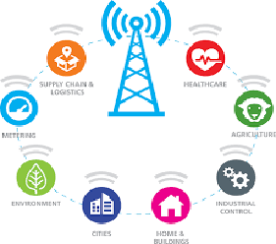

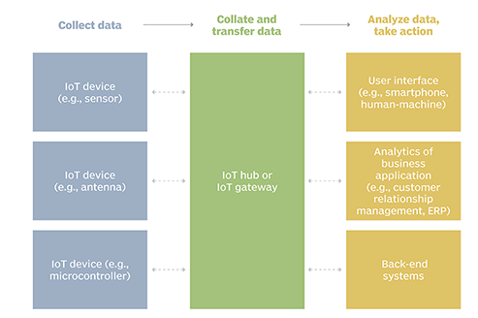

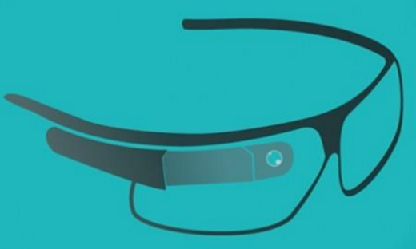

**Intelligent spectacle**

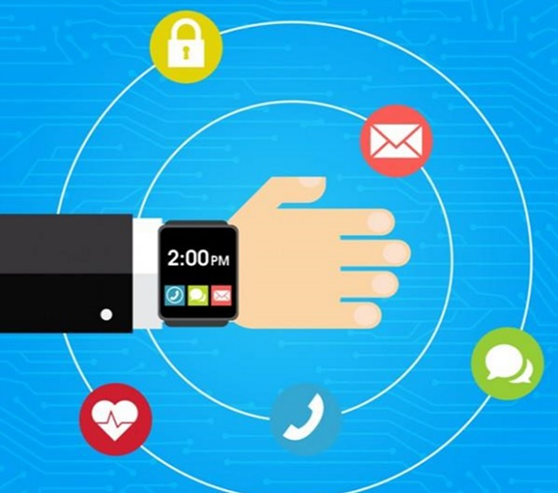

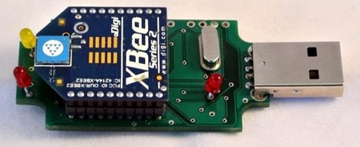

**IOT INTELLIGENT REVOLUTIONIZED CONNECTIVITY**

**It resulted to the introduction of intelligent sensor, wearable electronics, intelligent inspect able.**

**Wearable Electronics**

**IOT Sensor**

**IOT Sensor**

* It improves productivity
* Help us to stay connected with each other.
* Control power system in the house remotely.

**Wearable electronics**

* It measures the temperature and provides update on the changes.
* It connects to emails, phone or mobile phones and used to lock doors.
* It used for detection of danger and measure temperature of the surrounding.

**Intelligent Spectacles**

* Convey update information gathered to the data for effective analysis and application in the real business.

**Internet of the Things (IoT) provides effective away of connectivity and intelligent data collection for business analysis**

# Bibliography

Meghanathan, N., Sharma, S., & Skelton, G. W. (2010). On Energy Efficient Dissemination in Wireless sensor Networks using Mobile Sinks. Journal of Theoretical and Applied Information Technology, 19(2), 79- 91.

Rouse, M. (2019). Internet of the Things. *https://internetofthingsagenda.techtarget.com/definition/Internet-of-Things-IoT* , 2-15.

Sharma, S. (2016). Expanded cloud plumes hiding Big Data ecosystem. Future Generation Computer Systems, 59, 63-92.

Sharma, S. (2016). Concept of Association Rule of Data Mining Assists Mitigating the Increasing Obesity. International Journal of Information Retrieval Research (IJIRR), IGI Global, 2016.

Sharma, S., Gadia, S., Kumar, N., Narayanan, V., & Zhao, X. (2010). Climate Analysis in IOWA Using XML and Spatio-Temporal Dataset-NC94. Int. J. Database Manage. Syst, 2(3), 82-93.