Effects of Peaceful Music on Anger
Student’s name
Institution
Date

Method and Results

The quantitative research method was used to complete the study. Quantitative research is regarded as the exploratory research. The experiment design was used to complete to obtain the data and for the analysis of the data obtained as well. In the study independent variable was the type of music (peaceful and none), and the dependent variable was anger.

Participants

In order to effective complete the study, a total of 60 participants of 30 male, 30 female; ages 20 - 40, mean = 30; 60% Caucasian, 20% African American, 10% Hispanic, 5% Asian, 5% Other were used for the study. The participants voluntarily participated and most of them were reached through social media and email address from Southeast Coast states.

Measures and Materials

In this study, peaceful music is operationalized through Bizet’s Intermezzo from the Opera Carmen. Anger is operationalized through a self-report, pencil-and-paper anger survey, the State-Trait Anger Expression Inventory -2 (STAXI-2).

Procedure
Participants met separately with the experimenter in the same quiet room. They sat at a desk in a cushioned chair with the room at a comfortable temperature. The Informed Consent Form was signed first. Next, participants were asked to think of an anger episode until they reported that they were at least moderately angry. Participants were then asked to fill out the STAXI-2 to get a baseline anger level. After filling out the measure, participants listened to the peaceful music (or no music, depending on the condition to which they were randomly assigned), and filled out the STAXI-2 once more. They were then thanked and debriefed.

Results of the study
The result indicates that there is significant different between the two groups in regard to anger. It is established that music calm people and also the different types of Music react different with people.
- Heartbeat rating when different type of music is played.
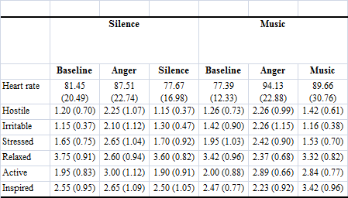
Table 1: Means and SDs for heart rate and PANAS ratings
- Mean heart rate of the participants at interval in music and silence condition
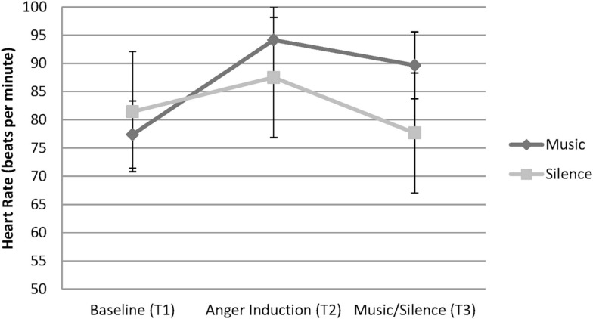
Graph 1: mean heartbeat rate of participants

