The force table
Student’s Name
Instructor
Course Code
Date

Abstract
The main purpose of the experiment is to obtain understanding of sector addition. This lab report put a lot of focus on analyzing difference forces to investigate the concept of vector and equilibrium. This is done by using the Force Table and different masses and three different experiments to get more complexity with the goal of getting necessary vector. In this lab experiment, vector addition was examined using a force table. In order to examine the vector addition, the equilibrant force was determined to balance other forces. However, in the real world application of vector addition, for example football players, and a GPS, the vector is applied for navigation form one point to another location, and creating of balance. It is therefore; important to point out that force table plays essential role in navigation of people hence it facilitates various activities in the real world.

Background
The vector quantities are regarded as physical quantities which are both direction and magnitude. Good examples vector quantities are the people playing football and the wind velocity. The wind can blow to any direction, at a certain speed.

EQUIPMENT & OUTLINE
Equipment
The equipments which are used to conduct the experiment are as listed below on the table
In Kit – Return to Kit! | In Drawer – Return to Drawer! | Available in the Lab
4x Force Table Pulleys | Protractor | Digital Scale
Rings & Strings | Compasses | Tables of Alloy Densities
3x Force Table Legs | Rulers | Triple Beam Balance
4x 50-gram Mass Hangers | Masses | Force Table Top
Torpedo Level
Center Pin

OUTLINE
Part A: Components of a Vector
In order to complete this experiment, a force table and the concept of equilibrium was used to demonstrate that a vector can be broken into component vectors.
Part B and C: Adding Two Vectors
The algebra and geometry were used to calculate two vectors and then the force table was used to verify the experimental result. According to the setup of the experment vectors are the combination of direction and magnitude and therefore, they cannot be added the same scalars are added. Their direction must account and the magnitude as well. This can be done well using geometric and more proficiently by the use of algebraic method.
Setup
The force table was built using three legs and four pulleys (A through D) where the pulley was attached and tightened below not above the force table. After that, the center pin was inserted into the force table top. The feet located at the end of the legs of the table were then adjusted so that force table is level to the ground. The complete set of rings and strings was then weighed. The rings and strings were not dissemble and were also not allowed to entangle. The average mass was then calculated by dividing the set’s total by five (5) and the rounded to the nearest gram. In the experiment we ignored the mass of the string as its contribution is negligible. However, we included the large, central ring increases the average mass of a ring.
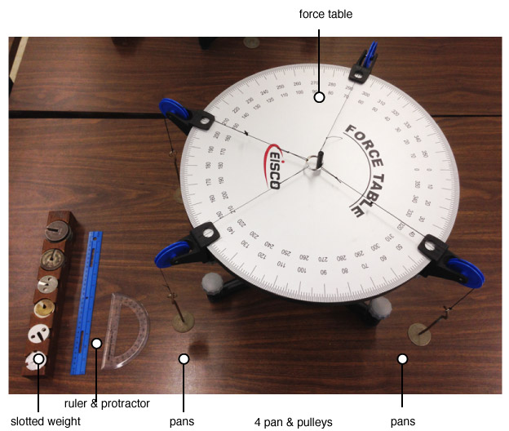
Diagram 1: Experiment table

PROCEDURES
In this laboratory experiment, different vectors and force table exercise was conducted in order to determine the impact of vector addition. An interaction task was performed where by the vector was manipulated to show that the wind speed was traveling at a speed of 10 mph and was going to the northeast direction. This was used to represent the force of magnitudes and this was done to achieve the addition of vector graphically. The answer was obtained by making the vector 45 degree north of east, while keeping the speed at 10 mph. In the second exercise the sensitivity of the force table. The arrangement was done where two pulley system were arranged at different angles 1 at 0 degree and the second one at 180 degree. In the pan 1 and 2, 50 grams we placed and then weight was continuously added to the second pan. In the part B, 80 grams to a 50-gram mass hanger & hang was added at 45 degree. Again 130 grams to a 50-gram mass hanger & hang was also added at 150 degree. And then it was called F2 & F3 respectively.

The weight was added continuously to pan 2 in order to determine the maximum mass which is required to get equilibrium.

RESULTS
Experiment 3: Obtaining a function
Angle | Mass of the pan system
10 | 215
15 | 210
20 | 200
25 | 198
30 | 195
35 | 180
40 | 175
45 | 169
50 | 160
55 | 155
60 | 140
65 | 90
70 | 85
75 | 70
80 | 60
85 | 45

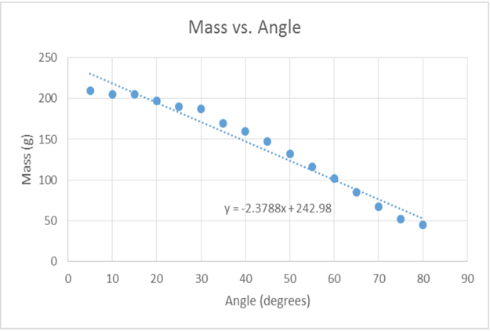

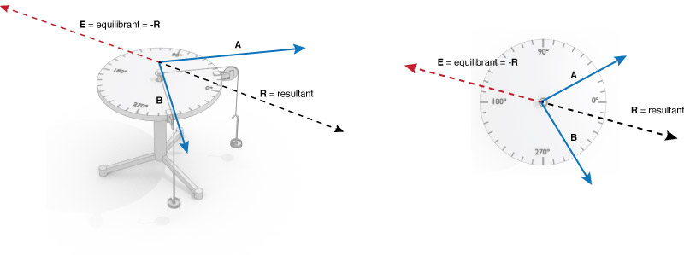
Diagram 3: Resultant vs. Equilibrant

Conclusion
We managed to complete the experiment and the whole process was a great experience. We keep tightening the pan because the string kept tangled. But we figured out how to hold the force table so that it can rotate without interfering with tangling to provide accurate vectors. Calculation done in lab based on my data for experiment three indicates that the angle increases 5 to 80 degrees. It therefore, means that less mass is required to be used in pan 3 in the pulley system to get to the equilibrium. Furthermore, for the purpose of experiment one, it was discovered that the sensitivity of the instrument is 107 g. In the lab experiment two, applying the numbers which were generated for the two directions and masses, the system was set up for these values for success calculation and drawing of graphs. We discovered that 70g were required for pan 3 to be able to balance the system. For the success of experiment four the mass for A, B and C generated was use to decide on the absolute value of the y and x component. However, in vector D, we obtained 425.098 for the y component and 101.08 for the x component. It is also important to point that there could be some error obtained in the experiment. First, we could have simply used some wrong amount of grams on the pans. It could also be possible that we turned the pans wrongly or to a wrong degree which gave a different or wrong information. Nevertheless, it is in my belief that I have acquired an outstanding knowledge and understanding of vector addition and force tables as well at the end of the experiment.

