Author’s Name
Subject
Date

Business Continuity
Modern life spins around various elements of technology and therefore it has become an indispensable part of our lives. To ensure a company’s survival it is mandatory to have an effective business continuity and disaster recovery plan. In recent years it has been observed that many organizations have suffered from multiple data breach issues due to which they have lost important and confidential data of their organization (Luftman). Thus, hindering their organization's survival in business.
To mitigate security issues and improve the chances of business continuity several software solutions are available that facilitate in not only automate but orchestrate business continuity. Spanning Backup is a software solution that provides backup and recovery for mail, contacts, and office 365 with unique capabilities ("Cloud-To-Cloud Saas Backup: G Suite, Office 365 And Salesforce"). It is the best solution for SaaS application administrators as they are responsible for maintaining compliance with intricate audit demands.
Automated and On-Demand Backups
- With spanning backup, the data is automatically backed up daily in the background.
- The data is backed up in its original state while also the point-in-time snapshots of folder structure are maintained.
- Additional backups are performed if needed.
Usability
- Not only admins but end users can also find and restore the data
- Spanning backup offers unlimited storage facility along with multiple backup versions.
Transparency
Spanning backup for office 365 gives admins complete visibility and control so that they can manage the backup of all data of all their respective organizations.
Restore functions
- Point-in-time restore: Spanning backup software can easily access all the historical snapshots and restore with 100% accuracy.
- Cross-user restores: The software also enables administrators to restore data easily from office 365 to another.
Additional features
- Strong encryption: 256-bit AES and 128-bit TLs encryption
- 99.9% service level agreement.
- HIPAA compliant
- SSAE SOC 2Type ll complaint
- Application-level authentication (O AUTH 2.0)
Screenshots
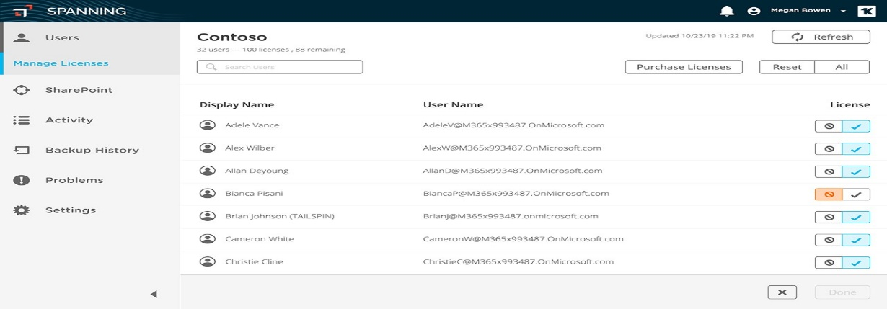
Source: https://azuremarketplace.microsoft.com/en-us/marketplace/apps/spanningcloudappsllc.spanningbackupforoffice365
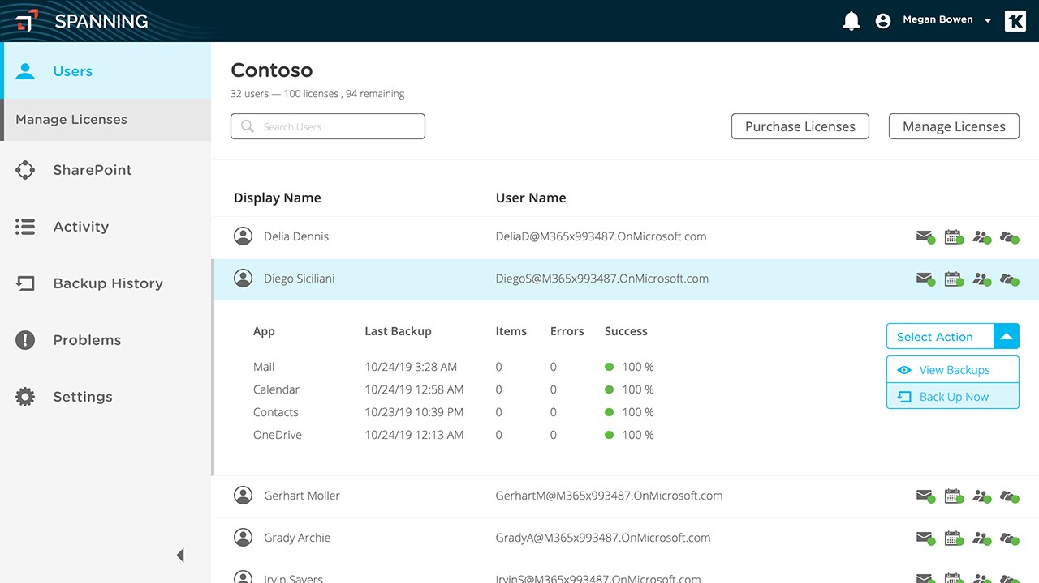
Source: https://azuremarketplace.microsoft.com/en-us/marketplace/apps/spanningcloudappsllc.spanningbackupforoffice365

Works Cited
"Cloud-To-Cloud Saas Backup: G Suite, Office 365 And Salesforce". Spanning, 2019, https://spanning.com/.
Luftman, Jerry, Rajkumar Kempaiah, and Eduardo Henrique Rigoni. "Key issues for IT executives 2008." MIS Quarterly Executive 8.3 (2009).

