Week 2 Assignment
Your Name (First and Last)
Institution or School name
Question and Answers
Answer Number 1
The two advertisements that I chose to explain the needs described by Abraham Maslow are as follows:
Dasani by Coca Cola
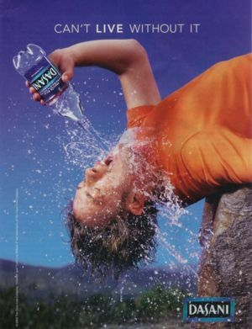
This advertisement by Dasani waters is representing the psychological need as per Maslow’s Hierarchy. The tactic that is being depicted by this ad is the fact that water is of great importance and it is next to impossible to survive without the its consumption. This ad is befitting in the psychological need level of Maslow’s model, because of the fact that water is a necessity. The consumption of water is essential for survival and, people will always get thirsty, and water will always be their need. It can be seen very well through the ad that when a person gets very thirsty, they just want water. No other beverage is given preference.
Mercedes-Benz
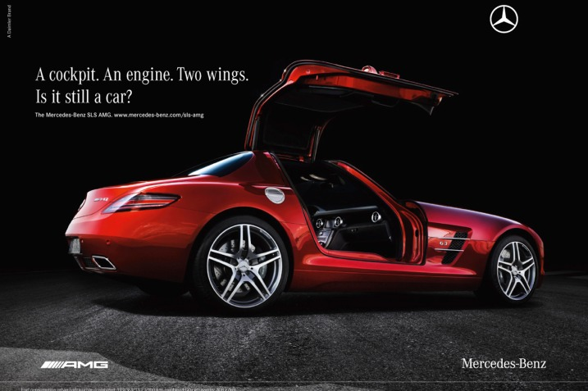
This ad by Mercedes-Benz is depicting the esteem need from the Maslow’s model. The strategy that is being used in this ad is the use of smart comparison. They are comparing their car with a plane. The catchphrase depicts that the car is good enough to pass as a plane due to its design and engine (Fallatah & Syed, 2018). The ad is depicting esteem needs; people would want this car because it will make them feel prominent. They will also feel that the car will give them high status as it is as good as a plane.
Answer Number 2
Let us first discuss the Dasani water by coca cola ad. Just by looking at the advertisement it can be seen that it is simple to understand, the concept of the ad is very prominent. The usage of colours and natural environment with the inclusion of a very thirsty man proposes that even after a tough day of site seeing one can refresh themselves with Dasani water. However, when it comes to the target market, I believe it is targeting every single one. Thirst is something that is experienced by every being in existence, so there is no set segmentation present, everyone is the target. This blends very well with Coca Cola's mission statement as well. According to Coca Cola's mission statement; they want to refresh the world, to invoke happiness and to create value and differences. It can be clearly seen in the ad, as they really are targeting the whole world and telling that how refreshing their product is (Anable et al., 2016). The natural scenery and the person in the ad represents optimism and happiness. They are providing a psychological need that everyone requires, is what differentiates the product and gives it value. Can people stop drinking water? Will they stop getting thirsty? So this is something that Dasani understands very well that thirst is inevitable for people. However, there are many brands that are present in the market who provide bottled water, because of that reason they are trying to be as creative as possible with their ad.
Now when we look at the Mercedes-Benz ad, right of the back it looks very chic. The presence of the car in the darkroom portrays exclusivity; the catchphrase depicts status and comparison to a high class. The car itself has an intricate design and shows luxury. It is very obvious that the customer segmentation will be done on the base of an individual's bank balance and love for luxury. The niche market is being targeted over here, which is why it is on the esteem level of Maslow’s model. Further, with regards to the mission statement, they want to delight the customer. The idea is not to fill a need but give the customer a status symbol. Their mission is to give a high-quality product with constant improvement. The brand is targeting a niche market because of the quality that they provide. In order to sustain and maintain quality, the material that they use for their products is expensive and good standard. The concept is to give the targeted audience, the best of the best. Another thing that should be kept in mind is that a fancy and expensive car is not a need, it is basically a want.
Answer Number 3 and 4
A more international advertisement that I noticed used by Dasani was in Spanish. In this advertisement a woman is in a way is walking in the water, and the catchphrase is "Mueve tu water" which means move your water. This ad was targeted towards people who have a Spanish background. In this ad, there is a lot of colours used which depicts the Spanish culture very well. It is a good way to target a larger audience. It can also be seen that the model has tan skin depicting that she might be Hispanic, the girl seems to be dancing in a way (Steinberg & Greene, 2015). This will immediately make the target audience connect and give a sense of belonging. In the other ad of Dasani, we can see that it is just trying to portray thirst and refreshment. This ad, on the other hand, is very festive and trying to project fun to the consumers. The clothes of the girl in a way are sporty, and she is running in water, this depicts that one can take Dasani water out for running for refreshment. The mission statement is still evident in this ad as well.
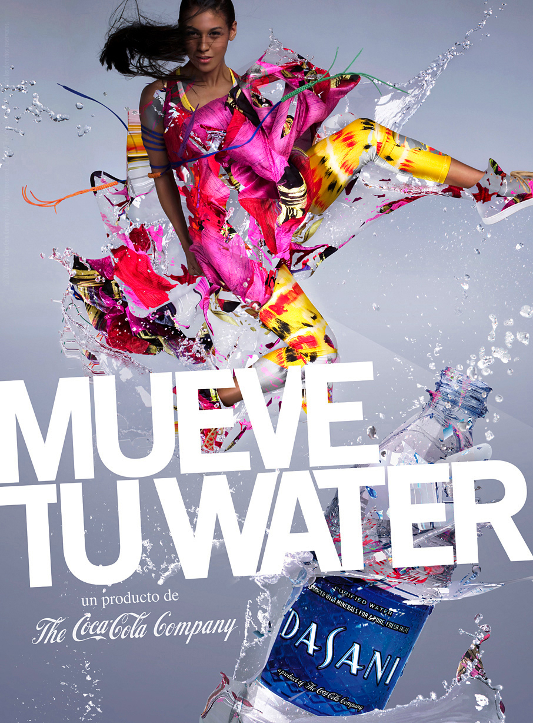
References
Fallatah, R. H. M., & Syed, J. (2018). A Critical Review of Maslow’s Hierarchy of Needs. In Employee Motivation in Saudi Arabia (pp. 19-59). Palgrave Macmillan, Cham.
Anable, J., Kinnear, N., Hutchins, R., Delmonte, E., & Skippon, S. (2016). Consumer segmentation and demographic patterns(No. PPR769).
Steinberg, M., & Greene, S. (2015). Conceptualizing the Cultural Concepts in Marketing and Consumer Behavior. In Proceedings of the 1988 Academy of Marketing Science (AMS) Annual Conference (pp. 175-178). Springer, Cham.

