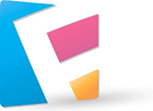

2020 Flanagan Software

Company Getaway
The Flanagan Software Company Getaway Team has been meeting over the last two months to plan this year’s getaway. We have been studying your survey responses and talking to you about how to make this year’s activities as productive, vibrant, and fun as they were last year.
The overwhelming consensus is that the workshop sessions were a big success. Most people also appreciated having the opportunity to participate in many types of activities, from challenging outdoor experiences to relaxing walks and casual small group interactions. We are planning to offer the same range of activities this year (but no more trust falls or motivational speakers—that came through loud and clear!).
The 2020 Flanagan Software Company Getaway will be held at the Snake River Lodge and Resort in Grand View, Idaho, on June 8–11. The focus this year is on recharging and connecting with each other and our guests. The attached overview provides details about the Snake River Lodge and the activities we are planning. Highlights of this year’s plans are the Flanagan spa, which is designed to recharge participants, whitewater rafting for the adventurous, and Iron Chef–style competitions.
Let us know what you think—the plans have plenty of room for changes.
Flanagan Software Company Getaway Team
info@fsgetaway.cengage.com

2020 Flanagan Software Company Getaway

Recharge and Connect

T
his year’s getaway is shaping up to be one of our best retreats yet, combining work with play and plenty of opportunities for creativity, physical activities, and making connections with each other, our customers, and our inspiring guests. The event will be held at the Snake River Lodge and Resort in Grand View, Idaho, over four days:
Monday, June 8: Arrivals and greetings
Tuesday, June 9: Work and play
Wednesday, June 10: Workshops and explorations
Thursday, June 11: Wind down and departures

(Note: The office will be closed for foundation fundraising on Friday, June 12.)

Why are we getting away?
It’s time to recharge! Flanagan Software is composed of mostly virtual teams with offices scattered across the United States. Our entire staff gets together only twice a year—and the company getaway is one of those times. We want to take advantage of being together to brainstorm in person about Flanagan Software and its culture, products, and customers. For the second year, we are inviting customers to join us at the getaway so we can connect with them and show off our new apps and planned features. We are also inviting inspiring people from diverse fields—sports, art, film, technology, and science—to tell their stories and help us rejuvenate in new ways.

What’s new this year?
Much of what Flanagan Software does involves social media. We want to use our own products to connect with customers who cannot join us in person. The idea is to set up a blog before the getaway and then use our Flick app to update the blog from Idaho. Customers can keep in touch using their favorite social networking app or they can try Flick and leave comments on the blog. We can post photos, screenshots, videos, and the usual mix of fun and work-related posts.

What are the goals?
We are setting goals in two categories: company goals and product goals. The company goals are personal—we want to relax and get to know one another in a setting other than our office and video conferences. It’s been a busy year with many stressful deadlines, and we want to reward ourselves for releasing apps and updates on schedule. We also want to figure out what’s next.
The product goals are to show off Flick and other apps and to use the apps as customers do—to connect with each other. The company getaway is a perfect time to test our own products for real and in public. We hope this exercise will help solidify our relationships with our current customers and attract new ones.

Activity Snapshots
Your survey responses recommended combining work and play, so we are planning lots of fun activities. Professional event organizer Shelley Cohen will be on hand to keep things running smoothly.

Outdoor recreation
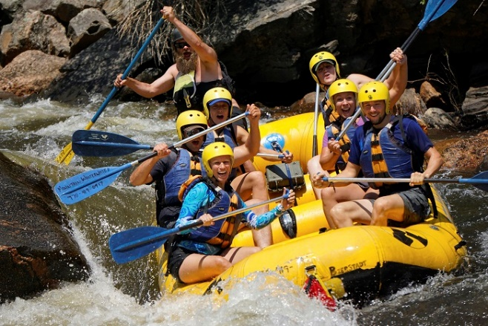
The Snake River has mild to wild rapids for river sports. Whitewater rafting trips will be led by experienced guides for two to three hours through breathtaking gorges and woods. Kayaks and tubes are also available for paddles and floats on the middle fork of the Snake River, which flows past the lodge. Well-marked trails lead up and through the Snake River gorges, providing stunning vistas. All of the outdoor recreation activities are optional.

Flanagan Software day spa
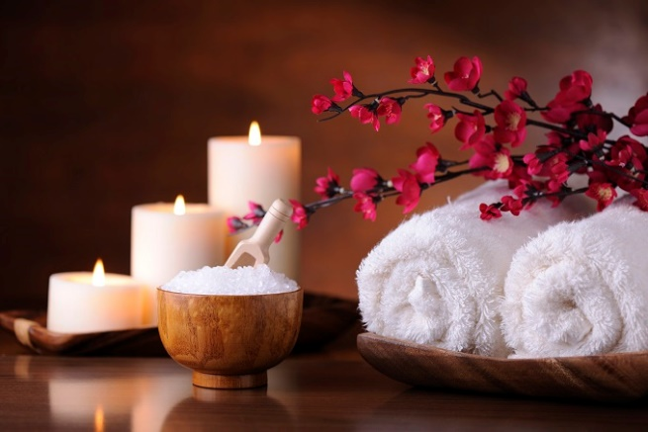
The Snake Lodge has a full range of spa facilities, and we plan to take advantage of them. The spa provides massage therapies, facial treatments, and waterfall cleanses. The day spa is connected to a yoga and meditation center and offers classes for beginners and advanced practitioners. In a nearby fitness complex, you can play tennis and other racquet sports, join a kickboxing class, use the strength-training equipment, or work with a personal trainer.

Competitions
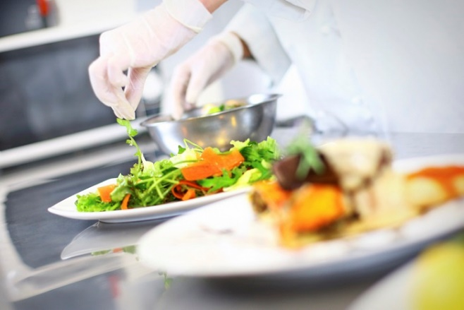
All in the spirit of fun, Shelley Cohen is organizing daily competitions, including an Iron Chef–style team cooking competition with secret ingredients and surprise mentors. Customers will be the judges. Shelley is also preparing a Battle of the Airbands, complete with costumes and props, back-to-back drawing competitions, and a trivia contest. (What was the name of our very first customer? Winner gets a company t-shirt—just kidding!)

Lodging
About the Snake River Resort
Location: The Snake River Lodge and Resort is situated on the banks of the Snake River in the Magic Valley, about 40 minutes from Weiser, Idaho.
History: Early settlers in the area-built dams and canals along the Snake River, dramatically changing an arid plain into fertile valley. The dams created reservoirs that attract wildlife and campers today.
Natural attractions: Deep canyons, high bluffs, unusual rock formations, and even lava flow make the Snake River area one of the most ruggedly beautiful parts of the country.
Directions from the Idaho Falls Regional Airport: Take Skyline Drive to US-20E, and then turn right on Lewisville Highway. Turn left onto N Yellowstone Highway – the resort is on the left.
The resort also runs a shuttle from the airport every 30 minutes.
The Snake River Lodge and Resort has a variety of lodging options. In the next week, we will be posting a form on which you can rank your top three choices for accommodations and request cabin mates if you are saying in a cabin. Complimentary Wi-Fi is available throughout the resort.
- Rustic log cabins: These handcrafted cabins are built from high-quality, dead-standing lodgepole pines using the traditional building techniques of the Northwest. Each cabin has two bedrooms, a convenience kitchen, at least one fireplace, and luxury bathrooms.
- Large cabins: Using the same materials and construction as the rustic log cabins, the large cabins also have expansive wraparound porches with built-in hot tubs. Each cabin has four bedrooms, a well-equipped kitchen, at least one fireplace, and luxury bathrooms.
- River Tower rooms: The River Tower features midsize rooms with wall-to-wall windows looking on river and mountain views. Amenities include signature king-size or queen-size beds, private dressing areas, gas fireplaces, and in-room refrigerators.
- Whitewater suites: Each suite has at least 1,500 square feet of space with views of the river and the mountains. In addition to the amenities offered in the River Tower rooms, whitewater suites have separate bedrooms with king-size beds, soaking tubs, and spacious balconies.

Flanagan Software Corporate Giving
The Flanagan Software Foundation (FSF) takes seriously its responsibility as a member of the worldwide community. We began in 2014 by funding literacy programs around the world. Today, the Flanagan Software Foundation gives dozens of grants to nonprofit organizations to support opportunities for youth, community service, literacy, and access to clean water. When we return from our company getaway, you are invited to head to the Pathways for Youth Center and participate in the Great American Grill-Out to raise funds for youth programs.
FSF is a charitable organization that receives funding from Flanagan Software and private donations. The foundation has been supporting community organizations and programs since 2014.

Supported Organizations
Grants made in 2020 | Organization | Contribution
 | Pathways for Youth | $150,000
 | Heart Family Services | $75,000
 | DEA Literacy | $50,000
 | Youth Leadership Grants | $250,000
 | Clean Water Pipeline | $80,000

Customers Participating in the 2020 Flanagan Software Company Getaway:

Advocates for Youth
Alicia Knapstein
Anita Wang & Associates
Antonio and Marijo Sommers
Benjamin Egan
Braxton Design
Brian and Belinda McNelly
Camille Lafontaine
Dale Beckenbaugh
Darren and Chris Taylor
David and Barbara Robertson
Donovan Enterprises
Dustin and Julie Hatcher
Ernesto Padilla
Harry and Candace Tham
Jaspar Chakilam
Jeff and Allison Salazar
Jesse and Terese Malkowski
John and Paige Piper-Hall
Kenny Cao
Min and Amy Huang
Padilla Consulting
Richard and Joy Bachmann
Tito and Monica Salinas
Zimmers Financial

© Copyright 2020. All rights reserved.

