The artworks of Renaissance and Impressionist periods.

[Name of the Writer]
[Date]
[Institution]

The artworks of Renaissance and Impressionist periods.

Introduction
The National Gallery of Art is among the world’s famous museums. It collects and exhibits art works of high scholarly standards. It has a collection of 141000 paintings, prints, photography, drawings, decorative arts , sculptures and media tracing that represent the development occurred in Western arts from the Middle ages till today. The National Gallery of Arts Washington Dc delivers free programs including free lectures, tours, film and concerts. It is located on the National Mall at Constitution Avenue, NW, in between third and Ninth Street. The National Gallery of Art Washington DC features exhibitions that highlights the work of artists ranging from the Renaissance to modern day artists (Washington DC National Gallery of Art, 2019).
It has 900 pieces of sculptures from the original sources in its Sculpture Galleries. Those works belong to 12th century and are preserved by the effect of natural light, which helps to illuminate them. It has one part called the Nineteenth century French Gallery which highlights the incredible work of French artists like, Renoir and Monet. Those paintings are organized beautiful and every eye could be easily impressed of this collection (National Gallery of Art in Washington, DC, 2017).

My Gems (1888):
My Gem is an oil painting done on wood with an overall size of 45.7 x 35 cm. It was gifted to the National Gallery of Art Washington Dc by the Avalon Foundation. It is the artwork of the famous Irish-American Artist, William Michael Harnett (1848 – 1892) who was the great artist of 19th century. He is famously known for his still life paintings of 19th century. He was expert in using illusionist techniques of giving attention to every small detail and presenting it will great creativity .He is well known to create trompe l’oeil effects and this talent made him the great painter of modern and Impressionist periods (Kelly, n.d.).
My Gems is a scattered example of bric-a-brac still life of the artist gloomy days. Harnett’s has beautifully differentiated the texture and that makes this picture very attractive. Such pictures became more popular in the 19th century because of the fact that they reflect material wealth. Historically, still life arts used to remind the death through elements like hourglass, skulls and candles which are snuffed –out. But Harnett’s explanation of human life is more refined. He had shown a lamp, with volume of Shakespeare and Dante, burnt matchsticks, music and spilled ashes and he has displayed them in a scattered way that shows that they are going to collapse (Kelly, n.d.).
The artist has used European antique, worn out books, ink bottle and pen. Which explains
The artist role in the society. According to him music has a great role in the society and he has enjoyed playing musical instruments. The artists seems playing the role of leader who wants to give the message about the current life and the coming days (Kelly, n.d.).
My Gems gives the message of the increasing popularity of Shakespeare work in the 19th century America. It is also a symbol of encouragement for the libraries which are now being replaced by electronic books and it is therefore the artist has displayed them in scattered format just to let people know that they are soon going to be replaced.
This piece of arts describes music and literature and those used to be the important part of Western Culture. He has tried to explain the historical middle class music and the literary work of Dante, Tasso and Shakespeare (Kelly, n.d.).
Well, Harnett art shows the carelessness of the coming generation and their way of dealing with great literary works. It is a reflection of fame and it shows the decline of modesty as the items in the picture are scattered.

The Feast of the Gods:
The Feast of the Gods is among the greatest paintings of Renaissance period in the United States. It is an oil painting done by Giovanni Bellini and later highlighted by Titian. Its overall size is 170.2 x 188 cm. it is date back to 1514-29. The art is an illustration of a scene from the story of Roman poet Ovid. It shows gods holding Neptune, Apollo and Jupiter. The picture shows Bacchus, formally called god of wines giving banquet. It also show the gods of Jupiter, Apollo and Mercury along with their goddesses. The painter tried to prostrate gods as normal people partings in woods (art Cyclopedia, 2014).
The artist role in the society could be understood as he wanted to promote classical subjects and wanted people to know about the ideal of individualism. He wanted to give a message of realism and classism to his people.
This piece of art basically shows a scene from an ancient writer Ovid that discussed Roman holidays and roman gods in his poems. So this picture reflect the historical as well as culture values of Roman peoples. This picture reveals the ancient stories about Roman gods and how people used to portray them. Roman gods are the historical element in this picture.

Conclusion:

The National gallery of art- Washington Dc has beautiful collection of art works, sculptures and photos reflection the period from the renaissance till the modern day. The artworks displayed in the gallery of arts reflects the historical and cultural existent of great societies around the globe. Those art works have helped to capture the modesty of human civilization. The feast of gods and my Gems are among many art works that have long lasting impact on the society.

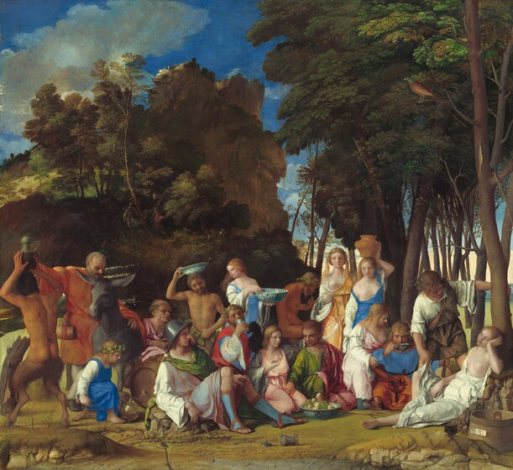

The feast of the Gods (National Gallery of arts)
My Gems (National Gallery of arts)

References
Kelly, F. (n.d.). American Paintings of the Nineteenth Century.
Art Cyclopedia: The Fine Art Search Engine." Art Cyclopedia: The Fine Art Search Engine. N.p., n.d. Web. 14 May 2014
Visiting the National Gallery of Art in Washington, DC. (2017). Washington.org. Retrieved 6 April 2019, from https://washington.org/visit-dc/national-gallery-of-art-washington-dc

Washington DC National Gallery of Art. (2019). YouTube. Retrieved 6 April 2019, from https://www.youtube.com/watch?v=ffZEqAC2CTE

