Your Name
Instructor Name
Date
Floods/Oklahoma Floods
Introduction
The water overflow that submerges land is known as flooding (Alfieri 149). Flooding that is caused due to excessive rain is considered as a natural hazard. Several other issues also arise after flooding such as disease breakout and property damage. Specifically, discussing the U.S., floods pose a significant threat to people living in the U.S. According to the report of National Weather Service, there were more than 28000 floods recorded in the U.S. between the years 2007 to the year 2015 that resulted in not only crops and property damage but many people lost their lives as well (Flood Statistics). Recently in Oklahoma, flooding has affected hundreds of homes. Also, many people were injured and had to be taken to the hospital. This paper will present the detail of the Oklahoma floods, its causes along with the flood control techniques, and interventions from both government and local organizations to cope with the damages due to flooding.
Oklahoma Floods
Oklahoma is the 20th largest state of the U.S. The state is bordered by the state of Texas on the south while Missouri on the north. Similarly, Oklahoma is bordered by Arkansas on the east and New Mexico city on the west. According to the report published in USA Today, in May 2019 the torrential rains in Oklahoma over the past two weeks resulted in the increase of water levels in the Arkansas River. The increase in the water level triggered the evacuation of the people to avoid injuries and fatalities. In the past as well, the county has seen several incidents of flooding. Below are the pictures that depict the damages that flood has caused in several areas of Oklahoma.
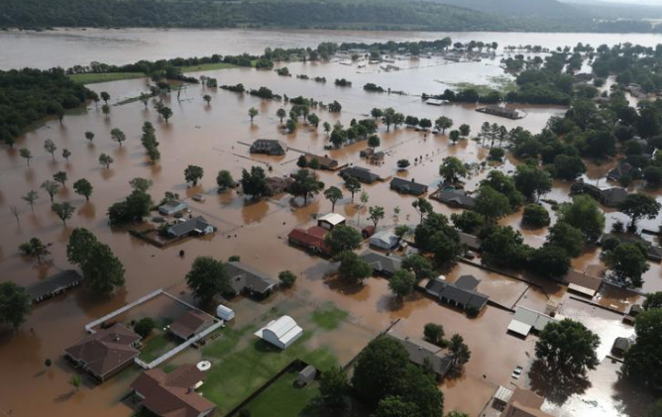
Fig: 1. Aerial view of homes that are flooded near South 145th West Avenue near Oklahoma 51 on the Arkansas River (Source: https://www.tulsaworld.com/news/state-and-regional/photos-that-show-the-story-of-the-oklahoma-flood/collection_b36f02dd-6dfb-5da8-b7d9-21d983f7a337.html#2).
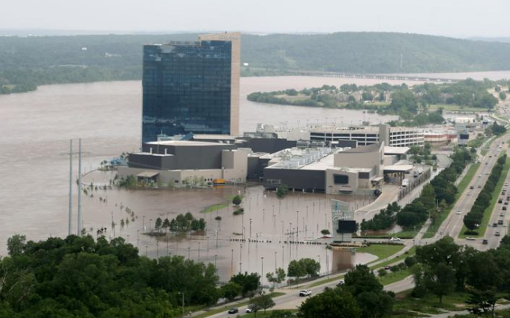
Fig: 2. Image of flood waters that covered the parking area of River Spirit Casino Resort on the Arkansas River. (Source: https://www.tulsaworld.com/news/state-and-regional/photos-that-show-the-story-of-the-oklahoma-flood/collection_b36f02dd-6dfb-5da8-b7d9-21d983f7a337.html#2).
The images above depict how flood can damage property and also restrict people from performing routine tasks.
Discussion
In the U.S., floods are the leading cause of weather-related deaths. This is because in floods, there is an increased risk of diseases spreading due to which the death rate is very high.
Causes
Floods are caused due to several reasons. Although, in many cases, heavy rain is the main reason for flooding yet river overflow, broken dams, Storms Surges or Tsunamis and melting of ice also cause floods. Specifically, discussing the Oklahoma floods, the series of thunderstorms dropped precipitation in the county of Oklahoma, especially in Northern Oklahoma. Owing to the heavy rainfalls, the water ran down not only in the streams but also into the Keystone Lake. As a result, it became necessary to release water from the Keystone Dam to the River Arkansas. However, the very next week another wave of storm hit the county and thunderstorms resulted in a heavy amount of rain along with tornadoes (Alfieri 150).
Flood Control Techniques
In the past, the government and several organizations used to focus more on the control and prevention of flooding. More emphasis was laid on engineering methods to accomplish the goal of flood prevention. However, in recent years the focus is more on the alternative approach that is the reduction of flood loss and also the damage due to the exclusion of damage-prone human improvements from flood-plain areas. This approach highlighted that sophisticated engineering technology is not enough as flood losses occur due to the development of flood-plain areas. Several techniques such as building dams, diversion canals, rivers and coastal defense can be used to limit the flow of excess water that may cause floods.
In the US, flash flooding poses a significant threat to the people residing in the US. According to the report published by the National Weather Service, there were more than 28000 flash floods recorded between the years 2007 to the year 2015 (Flood Statistics). The floods not only resulted in property damage but also as a result of flooding many people lost their lives. In the research published by the author Jonathan along with his fellow researchers, he presented a FLASH project that is a technique utilized in mitigating the flash floods (Gourley 364, 370). The MRMS system facilitates in providing precipitation rate estimates across the CONUS at the range of 1 Km resolution and providing regular updates after every 2 minutes. At the back end of the MRMS, FLASH system is running that facilitates in yielding a suite of rainfall and forecast stream discharge products. These products are developed in providing advanced operational flash flood monitoring system. After implementing the model the authors compared the hydrographs to evaluate peak discharge of the water and the results revealed that the peak discharge shown by the model was the same to the original results. Below is the hydrograph of simulated and observed discharge of water recorded by the FLASH system.
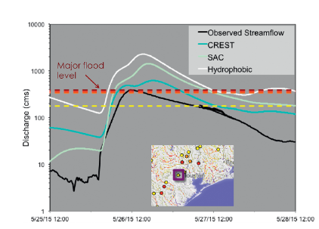
Fig: 3. Hydrographs of simulated and observed discharge in Buffalo Bayou (USGS 08074000, drainage area of 870 km2) (Source: https://journals.ametsoc.org/doi/full/10.1175/BAMS-D-15-00247.1).
The above figure is the hydrograph is of Houston flood. The major, moderate and minor flood stages are depicted by utilizing horizontal dashed lines that are colored in yellow, orange, red, and dark red, respectively. The inset represent stream gauge location. The model simulations correctly forecast peak discharges of all flood stages.
In the context of Oklahoma floods, after the series of severe thunderstorms the water ran down the streams and Keystone Lake due to which to control the floods, the US army had to release the excess water into Arkansas River and Keystone Dam. However, as the rain continues along with tornadoes, the Army had to open the gates of the dam further. However, the increase in the water levels caused floods. To control flood the government utilized the federal government floodplain regulations and emergency program of the NFIP (National Flood Insurance Program).
Conclusion
Floods due to excessive rain is a natural hazard. During floods, lack of communication and improper methods of controlling floods can result in severe consequences. Various techniques are there that can facilitate in controlling floods. However, it is recommended that public information officers disseminate the information by using both the traditional and digital platforms to avoid severe consequences caused by the floods.

Works Cited:
Alfieri, Lorenzo, et al. "A global network for operational flood risk reduction." Environmental Science & Policy 84 (2018): 149-158.
Flood Statistics. https://www.floodsafety.com/national/life/statistics.htm. Accessed 9 Nov. 2019.
Gourley, Jonathan J., et al. "The FLASH Project: Improving the tools for flash flood monitoring and prediction across the United States." Bulletin of the American Meteorological Society 98.2 (2017): 361-372.

