Healthcare and Nursing
Your Name (First M. Last)
School or Institution Name (University at Place or Town, State)

Goldzweig, G., Baider, L., Andritsch, E., Pfeffer, R., & Rottenberg, Y. (2017). A dialogue of depression and hope: Elderly patients diagnosed with cancer and their spousal caregivers. Journal of Cancer Education, 32(3), 549-555.
The research question to be solved in the article is what the relationship is between psychological stress, depression, social support and hope in a group of elderly patients diagnosed with cancer and their spousal caregivers at home. The article is a qualitative study because it used the interviews to collect data from elderly patients. The target of the research study is the health care teams that can use the results of the study to address the specific needs of individuals within the dyads of patients and their spouses. The research study demands that a more comprehensive understanding of the patients will give the professionals more insight to improve their communication with patients and their spouses. The research study was not able to sue large sample due to the inclusion criteria, and it is the first step towards understanding the psychological vulnerability of elderly patients (Goldzweig, Baider, Andritsch, Pfeffer, & Rottenberg, 2017). There was no pilot study conducted before the research. The data was gathered between May 2013 and May 2015 and to collect data patients were approached during their regular medical evaluation. Participants were interviewed after getting informed written consent. Data were analyzed statistically using the multiple linear regression model to predict the level of stress among patients and their caregivers.
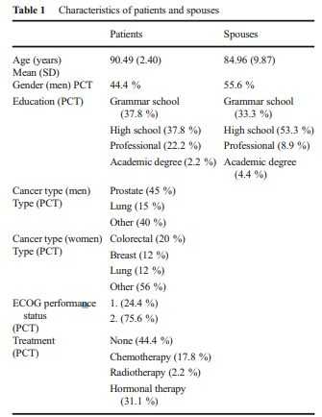
The study focuses on the psychological support for elderly cancer patients to increase hope and reduce anxiety among them. Positive psychological byproducts help cancer patients (Litzelman, Blanch-Hartigan, Lin, & Han, 2017).The article has implication for the medical team including the nurses to gain information about the patient’s life history and look beyond medical symptoms and involve family caregivers and support old patients effectively. It also applies that all the partner’s patients, caregivers, and medical team to involve in decision making regarding patients treatment. Hope acts as a protective psychological factor (Peh, Kua, & Mahendran, 2016).
The research findings have implications for the medical team including the nurses to provide older patients with psychological support. To reduce the impact of this severe illness like cancer professionals have to look beyond medical symptoms and integrate family caregivers to provide effective medical support to older patients. All the partners must involve the parties in decision making.

References
Goldzweig, G., Baider, L., Andritsch, E., Pfeffer, R., & Rottenberg, Y. (2017). A dialogue of depression and hope: Elderly patients diagnosed with cancer and their spousal caregivers. Journal of Cancer Education, 32(3), 549–555.
Litzelman, K., Blanch-Hartigan, D., Lin, C. C., & Han, X. (2017). Correlates of the positive psychological byproducts of cancer: role of family caregivers and informational support. Palliative & Supportive Care, 15(6), 693–703.
Peh, C. X., Kua, E. H., & Mahendran, R. (2016). Hope, emotion regulation, and psychosocial well-being in patients newly diagnosed with cancer. Supportive Care in Cancer, 24(5), 1955–1962.

