Inventory Management System
Introduction
The IMS is a consistent supply data center prepared for partner various stores. This can be used to pursue the supply of a singular store, or to deal with the appointment of supply between a couple of parts of a greater foundation. Regardless, the infrastructure basically records bargains and supply managment information and gives cautioning of low supply at any zone through email at a predefined interim. The goal is to lessen the strain of following instead of arrangement with all store support. Further features may join the ability to make reports of offers, anyway again the translation is left to the administration. Additionally, since thievery does now and again occur, the infrastructure gives answers to insisting the store supply and for changing supply sums.
Overview of Project
IMS is an online programming platform which fulfills the prerequisite of a common Supply Analysis in various supplypiles. It gives the interface to users in a graphical way to deal with the step by step trades similarly as authentic information. Also gives the administration reports like month to month inwards, month to month movements and month to month returns.
This platform keeps up the fused data center so any movements done at a zone reflects immediately. This is an online gadget so beyond what one user can login into infrastructure and use the gadget in the meantime. The purpose of this platform is to diminish the manual effort expected to oversee trades and authentic information used in various supplypiles. Moreover this platform gives an interface to users to see the nuances like the consistently Supply Statements everything considered.
Business Requirement Analysis
It is a Supply Storage office identified which sells extraordinary things to the general population through their retail outlets. Since the organization needs to maintain every one of their items and things at a different storage territory which requires separate division likewise for following the subtleties identified with in and outs all things considered. The in and out's will henceforth be alluded to as inwards also, outwards.
Before storage of merchandise this office needs to manage various storages, itemwise supplys in every storage, inwards and outwards of every storage. It needs to hold the subtleties of all gowdowns like storage id, storage area, limit in quintals, storage manager and begin date. At whatever point a item comes into a specific storage at that point the subtleties like Storage ID, Name of the Supplier, Date of Supply, Item Name, Invoice No, amount, gotten by, receipt no and bill checked by should be stored in the inwards module of the that storage by storage manager.
At whatever point supply turns out from the storage then the subtleties like Storage ID, Item Name, Invoice No, Date of Supply, Date of conveyance, Delivered to, Quantity, Purpose (Deal/Service), Receipt No, Bill Value, Bill Checked by should be stored in the outwards module by the storage manager.
At whatever point a customer restores a supply to the gowdown then the proposal have to check the explanation behind restoring that thing. On the off chance that it is a harm, at that point the subtleties like Item Name, Date of conveyance, date of return, Return Storage ID, Quanity, invoice no, returned by, receipt no, charge esteem and checked by requirements to stored in returns module. On the off chance that the reason is organization dropped then the proposal have to update the supply no in that storage. Checking for specific inwards, outwards or returns passage information takes parcel of time here.
Hence the cycle is rehashed for consistently. As of now all the above exercises are finished manually. The process is a dreary one. To land at the Inwards, outwards or returns for things, data must be accumulated from different sources. As a result of this mistakes are happening in the process, which is prompting postponed conveyances to the customers.
A few times as a result of the blunders wrong items are conveyed which have no requirement and accordingly a ton of financial is being squandered in maintaining the supply. Computerizing such a process won't just take out the mistakes in the process, yet additionally cut down the conveyance times and make the organization progressively focused. So it was chosen that a mechanized system ought to be created to make the entire process less complex and simpler.
Coming up next is the system produced for the above expressed necessities. An underlying achievability think about was performed and an end was touched base at that mechanizing such a system won't just accomplish every one of the things referenced above, however will likewise provide extra Reports which will empower the Management to take a gander at the factual side of the inwards, inwards and returns identified with every storage. This would likewise make an powerful Supply management system, which would diminish the disarray in maintaining the supplys at various storages, hence successfully diminishing the use expenses of the organization. Another preferred standpoint was that the entire Accounts system could be connected to this system in future, which would at last diminish the Overheads of the organization.
System Requirements
The IMS utilizes a web-based interface to show inventory data to the supply manager user. The item will utilization of open-source software essentially because of expense of usage. A JSP (JavaServer Pages) servlet will be facilitated by an Apache Tomcat web server (over any decision of working system, despite the fact that a kind of Unix is prescribe). The primary element of the Supply Manager User web interface part enables the Supply Manager User to see the momentum supply of items, alongside the abilities of seeking and arranging the items. The second element of the Supply Manager User web interface will enable the user to adjust platform settings, for example, the edge for email notices, frequency of inventory examines (day by day at a specific hour, week by week, month to month, and so on.), and security settings. The third component of the Supply Manager User web interface will enable the user to update the inventory amid the supply managment process.
System and Software Architecture
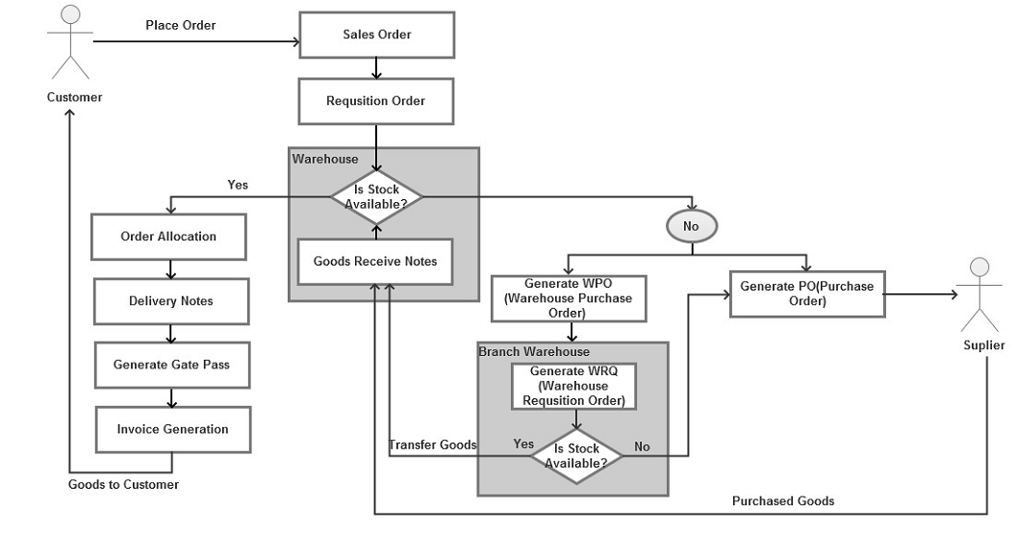
Figure 1: System Flow
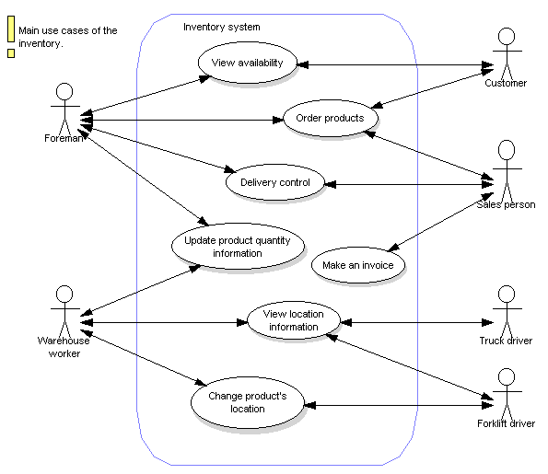
Figure 2: System Diagram
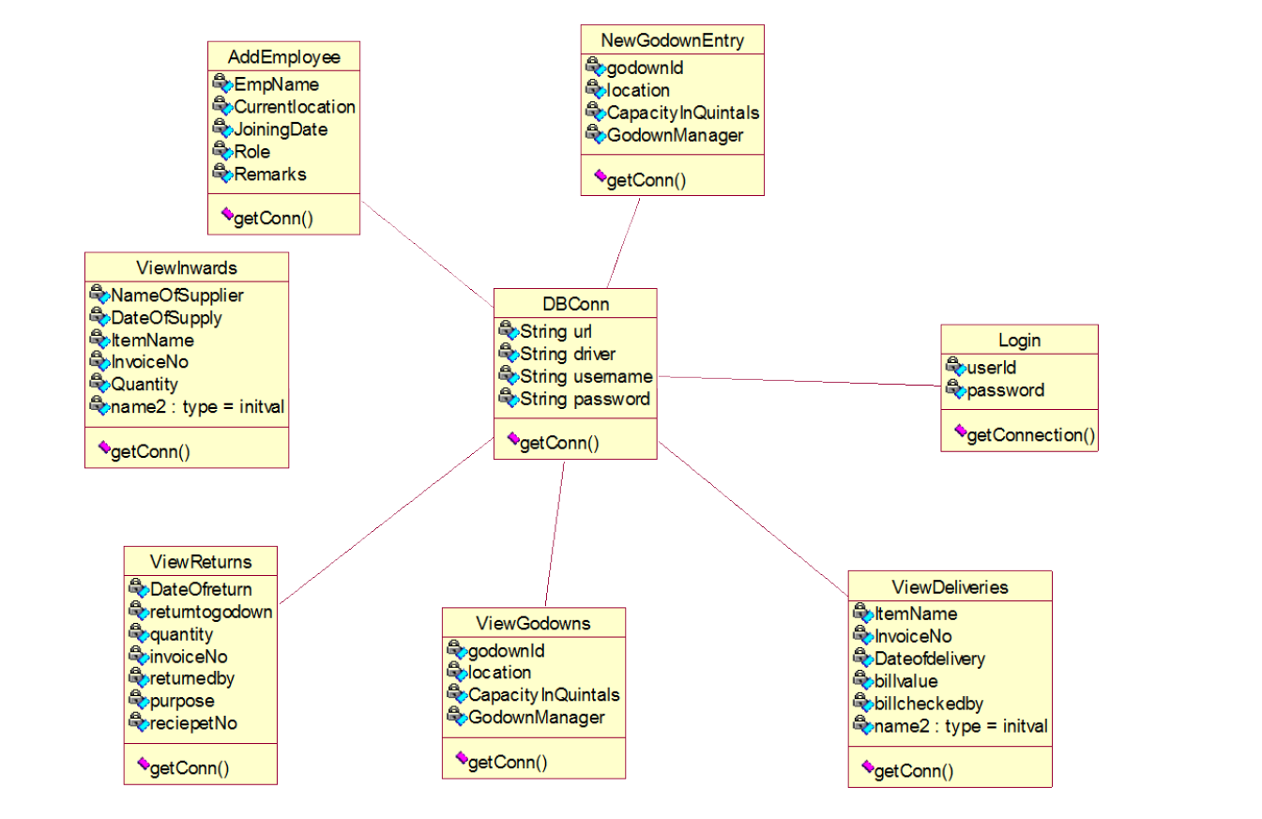
Figure 3: Class Diagram
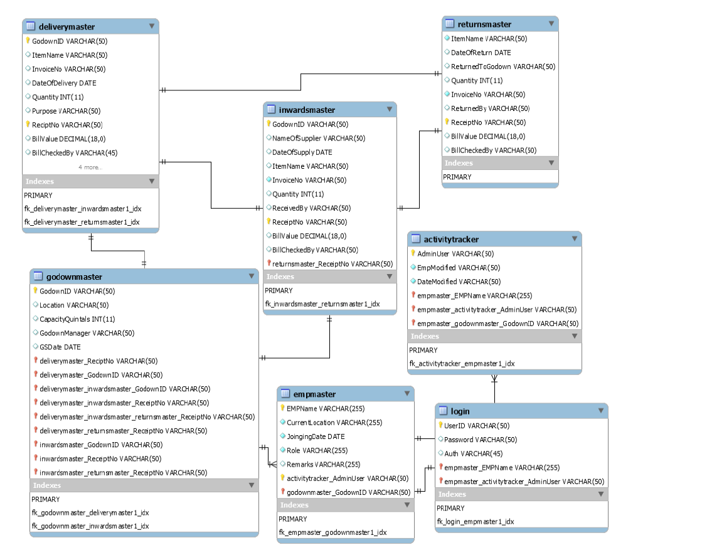
Figure 4: ER Diagram

Lifecycle Plan
- Objectives
The aim of IMS is to ensure enduring openness of arrangements for purchasers. Along these lines, IMS is guided toward owners of little to generous stores and supply supervisors who are equipped for keeping up sufficient items accessible in a retail or assembling business. It can scale from a singular PC running both customer and server programming up to various stores and conveyance focuses.
Rationale
- Assumptions
The above structure should works for the IMS platform. In any case, the proposal are copying a finances modules interface to work with our item by imitating institutionalized label inputs. An undeniably reasonable structure of finances module interface should be conceivable to suit the combination, as the interface does not meddle with the information assembled. The proposal expect that the finances modules customers can refresh their information to the present purpose of offer in case of loss of relationship with the server. The particular supply managment methodology gotten by each store meddles with the feasibility and accuracy of the platform as it doesn't remind the supply chief to refresh the information each time they had done any supply managment. The proposal moreover trust that that the Secure Socket Layer (SSL) is trustworthy in making a safe relationship between a customer and a server.
- Risks
One of the genuine perils verified by this platform is theft breaks synchronization between the supply and the data center. The information could be made by the information put away in this platform. The certainty measurement of trusting information made depends upon the precision of the supply managment strategy. Consequently, the proposal are going up against a threat of irresponsible supply chief who could shortcoming the precision of the information. As of the enduring nature of the encryption, an objectives for this could be by making security layer and electronic statement course of action and setup rules. Also, giving a choice to the user to set the base element of security used by not ignoring the methodology should convince them the unwavering quality of the platform.
Another peril is the test from other Point of Service programming. There are a couple of significant adversaries in this field including an answer from Microsoft; in any case, these will when all is said in done be expensive. IMS will be a straightforwardness game plan basically engaged at more diminutive associations while including the probability of later expansion.
Conclusion
The proficiency of any infrastructure planned to suit an affiliation depends joint effort in the midst of the utilization mastermind and moreover flexibility of the infrastructure to get itself to the affiliation. "Supply Analyzer" has been made to beaten the issues with traditional supply the board in generous scale. Good conditions over ordinary manual infrastructures are on the web platform get to all through all of the supplypiles from a comparable territory, diminishing the manual work, supplypiling the information at a verified united zones and quick time of reports as per our prerequisites.

