Question 4
- Critical path = B-E-G = 7 + 11 +5 = 23
- To complete the project, it will take 23 days.
- Following are the ES, LS, EF and LF of each activity
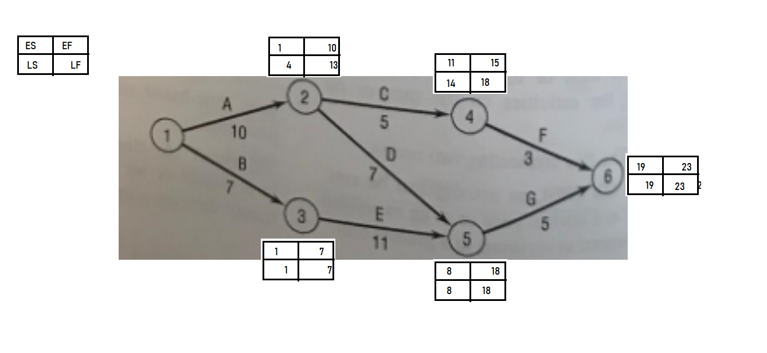
- Slack time of each activity
- Activity 2 = 3
- Activity 3 = 0
- Activity 4 = 3
- Activity 5 = 0
- Activity 6 = 0

Question 12
Network Diagram
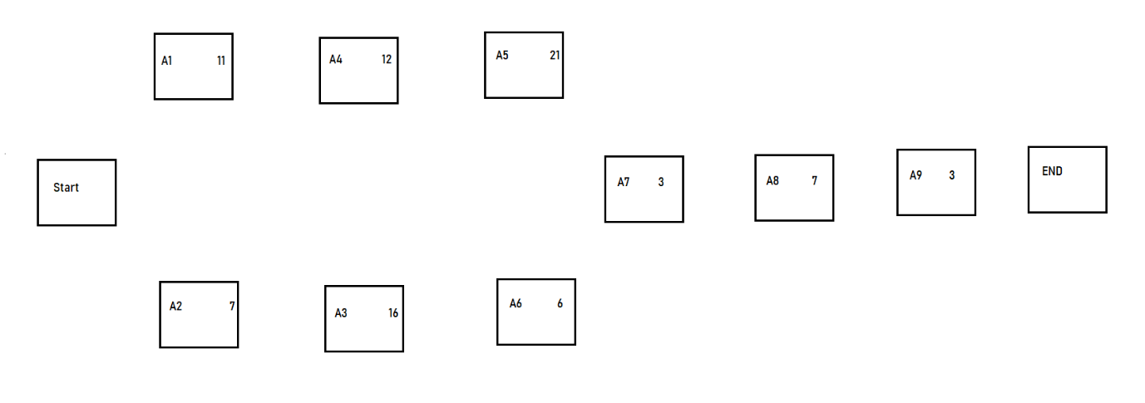
Critical Path = A2 – A3 – A4 - A5 – A7 – A8 – A9
Estimated Completion Time = 69 days

Question 14
The critical path: A – D – G – J
The above activities need to be observed closely.
If activity B is delayed by 2 more days, it will also delay the project by 2 days as the activity G is dependent on both Activity A and B to be completed on time – and are both considered critical.

