**Question 1: Nine Elements**

Statement of Objectives

The objective of this plan is to promote an antiseptic product at earliest possible time.

The subobjectives of this plan are:

* Achieving a 95% product yield having a level of at least 80% full production.
* The full production goal will be of 10 million litres per year.
* The product should be in compliance to FDA, EPA and OSHA.
* The entire process must be documented.

Work Breakdown Structure

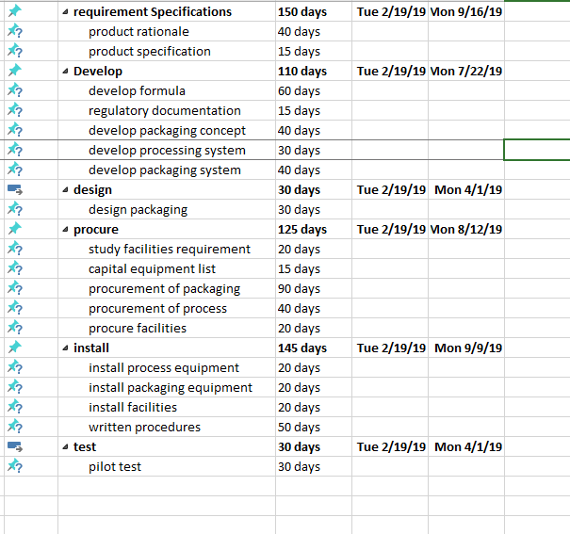

The above presented figure is WBS of the given scenario. The given WBS shows the categorization of the tasks in six main categories i.e. requirement specifications, develop, design, procure, install, and test. The WBS also gives the time needed to complete each module.

AON Network

Based on the given scenario and the time taken for each of the activity as specified in WBS, an AON Diagram is generated using MS Excel as given below:

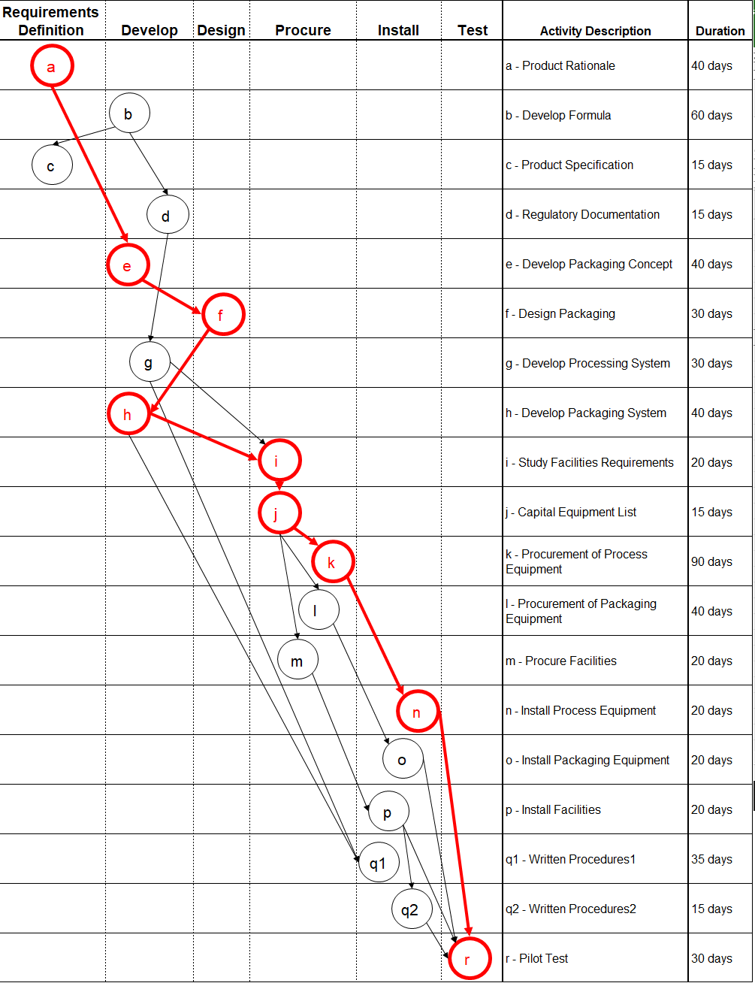

Critical Path and Duration

According to the above given AON diagram, the path 1 highlighted in red color is the critical path. Its duration will be the sum of all the activities included in this path as given below:

Critical path: a-e-f-h-i-j-k-n-r

Duration = 40+40+30+40+20+15+90+20+30 = 325

Early Start Tasks



Period Labour Requirements

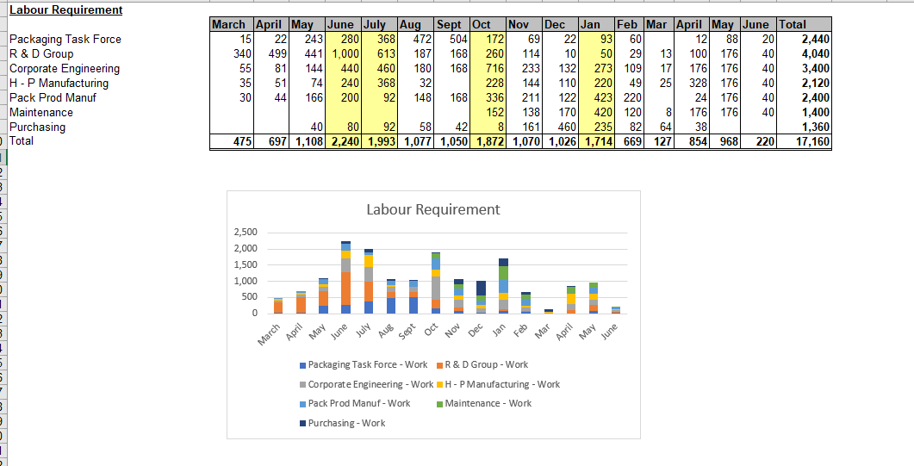

Cumulative Labour Requirement

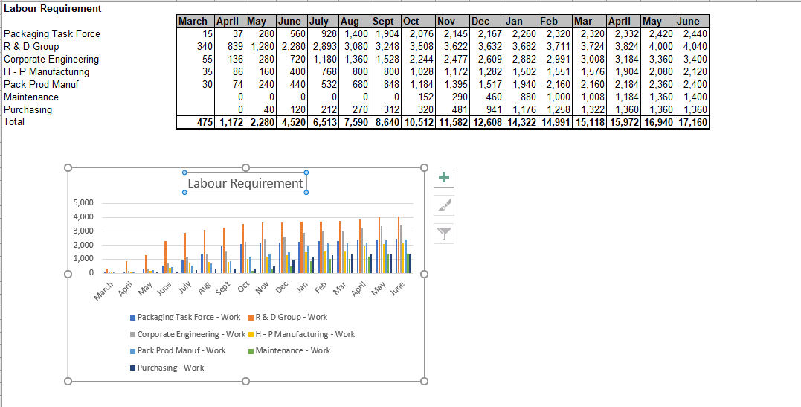

**Question 2:**

The project has a few regions of main issues:

* The interest for R&D staff is very high in initial months.
* The interest in specialists is very high amid the centre of the project
* Both support and obtaining have intense interest toward the closing of the project
* The improvement of the handling and bundling frameworks are noteworthy exercises that could lead towards bottlenecks.

**Question 3:**

This project will harness the benefits impressively from level stacking, accomplishing a noteworthy decrease in the general ring load for assets with a little increment in term. The project plan would profit by an investigation of the potential for colliding with diminish terms.

**Question 4:**

Factors for endorsement are:

* The project plan has a sound premise in ongoing knowledge and gives off an impression of being point by point and well thoroughly considered.
* The risks are known.

Factors against the endorsement:

* Uncertainty in the market for this item

Accordingly, in the event that test marketing of this item shows adequate interest, at that point the committee ought to favor the project.

**Question 5:**

The committee ought to have marketing investigate how time touchy the item dispatch is. In the event that the dispatch would profit by increasing speed, at that point the committee ought to have investigation done on smashing expenses. On the off chance that the dispatch could be deferred, at that point the committee ought to think about extending or postponing the project.

**References**

Turner, J. R. (2014). *Handbook of project-based management*(Vol. 92). New York, NY: McGraw-hill.