Telehealth and Obesity Management
Precis
Batsis, Pletcher & Stahl (2017), in their study titled “Telemedicine and primary care obesity management in rural areas – innovative approach for older adults?” emphasized on the importance of using telehealth technology for fighting against obesity in older adults who have been suffering from other issues such as diabetes as well. Specifically focusing on lack of staff, and accessibility issues for obese and diabetic patients living in remote areas, the authors explained how telemedicine can promote developed of a structured, customize program for the patients as well as promoting primary care that enhances the intensive behavior therapy for improved intervention efficiency as well (Batsis et al. 2017). Giving the examples of various other case studies and scenarios, the authors also explained that the use of telemedicine has been successful in other healthcare contexts as well such as in sanitation and awareness domain (Batsis et al. 2017). However, based on the findings and results derived by the authors, it can be stated that the effectiveness and efficiency of telehealth can be ensured in domain of managing patients having diabetes and chronic obesity. Furthermore, the authors also recommendations for the purpose of extending the benefit’s coverage for the older obese patients to be more inclusive of non-physician team members is needed but also for improvement in reimbursement for telemedicine services for older adults with obesity (Batsis et al. 2017); in this way, the patients will be able to focus on their treatment in a better and optimized manner with out the hassle of travelling long distances to get appointment from the doctor.

Mind Map
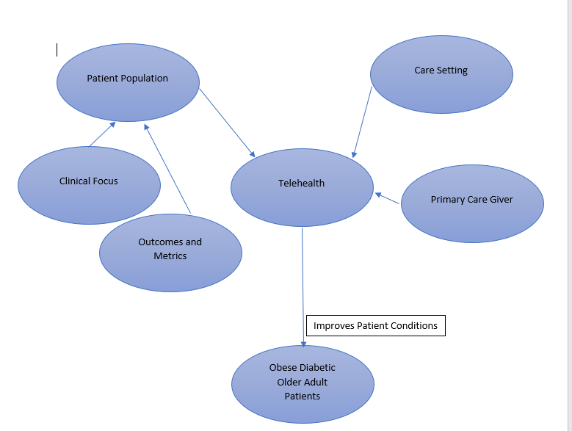
Discussion
The as of late actualized telehealth program for nutrition for Medicaid recipients with obesity can possibly help two hundred thousand individualsto maintain a strategic distance from constant ailment by engaging them to receive more advantageous ways of life. The program is a piece of the Obesity Action Plan, made to address the obesity emergency, where two out of three grown-ups and one out of three kids are overweight or obese.
The program advances joint effort among doctors and dietitians by concealing to six doctor visits and six dietitian visits every year. Doctors can allude grown-up and pediatric Medicaid patients determined to have obesity for healthful advising with dietitians enrolled in the program. This is the first run through nourishment directing for obesity has been secured through Medicaid.
Another prevention is that the Nutrition Counseling Program just covers face to face visits. For patients, especially those in rustic regions, the bother of going long separations to get protection treatment likely demoralizes finish. Telenutrition could evacuate this weight and encourage consistency in follow-up visits.
Research demonstrates that obesity-related therapeutic expenses are ascending alongside the quantity of individuals influenced by obesity. Human services spending on obesity expanded by 29 percent somewhere in the range of 2001 and 2015 (Fleischmn et al. 2016). That number is relied upon to ascend as more individuals are determined to have related ailments. While emergency clinics and insurance agencies need to lessen costs no matter how you look at it, numerous obese patients are likewise searching for effectively available medicinal services treatment that spares them cash (Fleischmn et al. 2016). It's nothing unexpected that many are keen on customized medicinal consideration apps offering weight loss programming (Bala et al. 2019).
Telemedicine for Weight Loss Studies Show Positive Results as the above study has shown that In an investigation utilizing telemedicine for weight loss, members experienced a multi week contemplate where they utilized the technology to follow their sustenance admission and exercise and remote weight loss checking gadgets (Bala et al. 2019). Members were additionally given week after week instructive materials. A few members were given week by week on-on-one instructing telemedicine sessions with an enlisted dietitian. As indicated by the examination, members who were given week by week telehealth for weight loss sessions lost weight (Bala et al. 2019). The control bunch just few pounds by and large. The individuals who got telemedicine sessions additionally lost right around twenty percent of their muscle to fat ratio, while the control bunch just lost around three percent (Bala et al. 2019).
References
Batsis, J. A., Pletcher, S. N., & Stahl, J. E. (2017). Telemedicine and primary care obesity management in rural areas–innovative approach for older adults?. BMC geriatrics, 17(1), 6.
Fleischman, A., Hourigan, S. E., Lyon, H. N., Landry, M. G., Reynolds, J., Steltz, S. K., ... & Ludwig, D. S. (2016). Creating an integrated care model for childhood obesity: a randomized pilot study utilizing telehealth in a community primary care setting. Clinical obesity, 6(6), 380-388.
Bala, N., Price, S. N., Horan, C. M., Gerber, M. W., & Taveras, E. M. (2019). Use of Telehealth to Enhance Care in a Family-Centered Childhood Obesity Intervention. Clinical pediatrics, 0009922819837371.
Shaikh, U., Nettiksimmons, J., Joseph, J. G., Tancredi, D., & Romano, P. S. (2014). Collaborative practice improvement for childhood obesity in rural clinics: the Healthy Eating Active Living Telehealth Community of Practice (HEALTH COP). American Journal of Medical Quality, 29(6), 467-475.
Pulgaron, E. R., & Delamater, A. M. (2014). Obesity and type 2 diabetes in children: epidemiology and treatment. Current diabetes reports, 14(8), 508.

