Integrated Patient Resource Management System
Introduction
The healthcare facility that started as a medium scale organization with the primary objective of catering the patients through their efficient service. The healthcare facility specifically deals with obese patients with the risk of complications such as diabetes. Respective paper will briefly evaluate how the obesity management, lowering of AIC and diabetes management can be made more efficient with the implementation of an integrated Information system, and Patient Resource Management System. As the working for the facility grew, the burden on their employees and nursing staff also grew. One of the primary reasons of this burden was their manual record and management system that was consuming too much time with reduced efficiency. Under such circumstances, the staff was not being able to cater their Patients appropriate. To overcome this constraint and increase the efficiency of the staff of the healthcare facility, it is important that the healthcare facility owners must consider the implementation of an automated information management system.
Problem Statement
The healthcare facility needs to enhance their efficiency and patient experience by implementing an automated Information management system.
Proposed Recommendation
To address the problem, it is recommended that the healthcare facility must implement the ‘Management Information System’ (MIS) that specifically focus on Patient Relationship Management (PRM).
Significance of MIS
Management information systems encompass all the computer systems and networks that organizations use to track their operations (Rainer et al. 2013). Throughout the years, the extent of MIS has expanded past quite recently alluding to accounting applications, and it now covers the full scope of business intelligence applications and can likewise incorporate the equipment that runs them and the staff that keeps them working (Rainer et al. 2013).
Management information systems are about business (Rainer et al. 2013). They gather and process information in a way that ought to help the companies that utilization them to better manage their resources and make development. Be that as it may, underneath the surface, MIS systems depend on science (Rainer et al. 2013). Business, then again, is every now and again given the judgment and intuition of its pioneers, regardless of the possibility that those pioneers utilize information and science to direct their decision-production. This can bring about a social detach (Rainer et al. 2013).
Extensive and complex MIS infrastructures can deal with changing organizational sizes moderately effortlessly, since the contrast between a substantial business and an extremely expensive one is negligible, in light of present circumstances (Pearlson, Saunders & Galleta, 2016). At the flip side of the extreme, systems that keep running on a solitary computer for a private company can likewise serve those organizations well with apparatuses that are anything but difficult to utilize (Pearlson, Saunders & Galleta, 2016). The difficulties come in the center, where an organization is changing in size and scope and might exceed its MIS programming (Pearlson, Saunders & Galleta, 2016).
The force of management information systems additionally conveys the test of getting an organization's specialists to become tied up with them. Moreover, the client relationship management programs that many companies use to manage their business strengths are a fantastic case of this (Pearlson, Saunders & Galleta, 2016). PRM programming permits companies to maintain extensive databases of information on each client and prospect (Pearlson, Saunders & Galleta, 2016).
For management information systems to work, they require well skilled and well-learned staff. Furthermore, MIS requires business professionals who see how to utilize innovation to drive business objectives. Protecting the system running and from intruders takes server chairmen, network engineers, security experts and system support workforce (Pearlson, Saunders & Galleta, 2016).
Significance of PRM
Patient services and their efficiency level is becoming an integral part of the organizational objectives and the success measures. To stabilize the position of the organization in the target market, the managers are investing more energy, time and finances in making their Patients more satisfied and contended with the products or services being provided. In enhancing the Patient satisfaction, the role of virtualized, efficient, flexible and 24/7 available contact centers has been recognized greatly. Based on these specifications of a desirable contact center, our specialty will be the cloud contact center. However, simply deploying the cloud contact center is not enough. To add a spark and specificity to our organizational structure and Patient services, our golden nugget is the integration of elasticity and flexibility within the cloud contact center that is being set up. The reason for declaring the elasticity and flexibility feature of the cloud contact center as the golden nugget is that it enhances the services being provided for the better satisfaction of the Patients.
Patient satisfaction is thoroughly achieved and maintained by the managers only if they can maintain and manage the efficiency of the systems that enable an interactive, reliable and trustable communication between the two. This can only be achieved by the integration of cloud computing with the PRM needs and requirements. Since elasticity and flexibility is one of the key features of the cloud computing, it is easier to transform the very same into the golden nugget of the organization. Inability to meet the Patient care requirements, the organization may eventually.
Integrating the elasticity within the cloud contact centers enables the organizations to create the continent structure with several on-demand accessibility options for the Patients. Not only this, but it also enables the technical stability of the contact center by allowing them to create a shared environment of resources including the servers, storage units, services and the transparent networking options. By having such extensive, flexible and reliable features within the cloud contact centers, the organizations can achieve highest Patient satisfaction level by optimal use of the managerial and other supportive needs. In other words, the feature of elasticity enhances the optimized capabilities of the contact centers.

PRM Initiative Road Map
Before formally devising the roadmap for the PRM plan it is important to consider some important factors that include the sponsorship of the seniors, commitment of the top management, need assessment at the level of the organization and detailed cost analysis. Once done and the PRM plan is agreed to be implemented, following roadmap can be used.
Cost Assessment PRM Road Map

Element for Cost Assessment | Tangible? | Remarks
Project Team | No | Project Team holds a greater importance since it is responsible for the width and breadth of the plan coordination and implementation.
Hardware | Yes | During the PRM implementation, the need for new hardware is inevitable. This must be done in a competitive manner.
PRM specific Applications | Yes | Evaluate these applications for the price, efficiency, and security.
External/internal consultation | Yes | Thorough consultation throughout the planning and implementation phase is essential for quality.
Information System Support | No | IS support staff is needed to align the implemented PRM system.

PRM Plan Road Map
Having assessed the cost of implementation and the components of the PRM, a proper roadmap needs to be implemented that will ensure proper integration of all the current units and systems of the healthcare facility. Following is the diagrammatic representation of the road map that is designed to be implemented. Owing to the enhanced technology support and demand of abrupt response from the Patients, it is suggested to implement the PRM solution over the cloud. Since the current system is not well integrated and holds discrepancies between various non-homogenized systems, the cloud platforms will be a good option to centralize them all at once. Transacting the entire organizational systems over the virtual cloud will require a significant investment regarding hardware, security, and management; yet this one time cost will be beneficial for the long-term Patient service system and support.
Following is the suggested PRM roadmap.

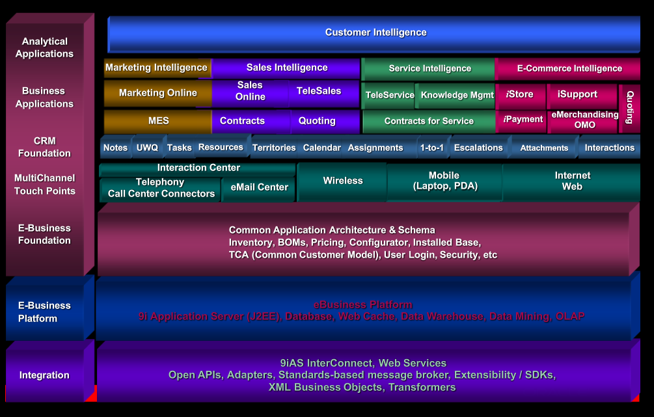

Closely observing the given Roadmap, it can be noticed that it gives a well-integrated approach to all the required components of the organization. This roadmap not only supports virtualization of the existing systems but also supports the customization of applications such as iSupport and eMerchandization. Furthermore, the approach is Patient oriented and creates ease of accessibility and functionality for the naïve Patients.

Selection of the PRM System
While selecting the PRM system, it is important to consider that some of the existing applications are cloud based. Furthermore, the technology and organizational IS are progressing towards the goal of virtualization for the sake of removing demographical and geographical constraints for the organization as well as Patients. Therefore, it is ideal to implement the PRM system that greatly supports virtualization and cloud computing. Based on the idea of our roadmap and the need assessment, the ORACLE PRM suite can be chosen. Following is the diagrammatic representation of the system, which replicates our roadmap scenarios. 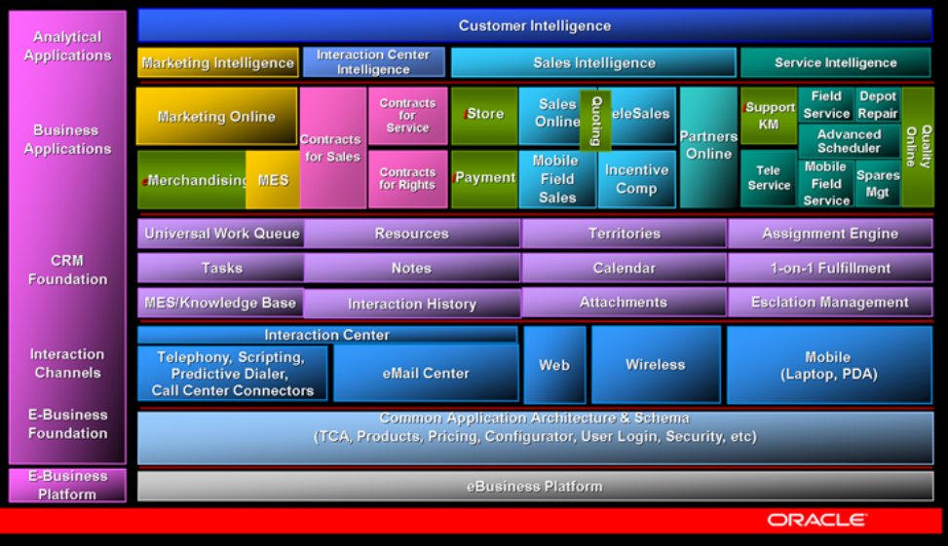

Implementation Process of PRM
For the proper integration, functioning and processing of any software system within the organization's existing body, it is important that it is done through proper channel and medium. Our company has a special focus on the Patient care and relations as it is believed to be one of the essential components to make the company successful and sustainable. For this purpose, we previously had a manual Patient Relation System that was dependent upon self-visits and telephonic communication with the Patients along with manual file handling and management. This was not the very appropriate and sufficient way of dealing with the Patients, and there was a grave need of system upgrade. For this purpose, the company decided to purchase new, automated Patient Relations Management (PRM) software for efficient and productive Patient management.
Now the company was concerned to adopt a medium and the approach that could help them smoothly integrate their system into the company without having any risks of failures and uncertain costs. For this purpose, various life cycle models were considered and evaluated depending upon their weaknesses and strengths. Later, one of them had to be chosen to implement and integrate the new system.
Available Choices
Following three options were considered by the company:
- Iterative Development Model: The Iterative Development Model is the basic combination of the Linear and the Iterative methodologies. This methodology was designed with the principle to focus on the risk factor. That is how the risk has to be assessed and how can it be minimized. This objective is fulfilled by breaking the entire project into smaller modules and carry out them in an iterative manner so that the risk factors are assessed and weighted throughout the life cycle. Each concentric iteration represents each of the following steps: 1. Objectives, alternatives, and constraints of the iteration; 2. Identify the risks and resolve it; 3. Verifying the deliverables; 4. the next iteration.
- Water Fall Model: The Waterfall model is a linear system development methodology. It works by splitting itself into sequential phases that might be overlapping or distinct. The main objective of the waterfall methodology is put a greater emphasize on the phases such as Planning, scheduling, budgeting and the implementation that has to be done once the entire cycle has been completed i.e. at the end. The Waterfall methodology has its very own strengths and weaknesses, whose evaluation can determine when it is feasible to implement it and when not to do so.
- Technology Life Cycle: The respective lifecycle concentrates on the choice of technology to be implemented depending upon the requirements. It requires great research, expertise, and investments. Furthermore, it is more useful for those projects and organizations that require the high level of uniqueness, quality, creativity, novelty or security. Other than that, it only covers the technology aspect of the systems; therefore, it is inappropriate to be implemented in the respective organization for the PRM software system.
Out of these choices, the Iterative Development Model was chosen. The reason for choosing the given model is that it offers modularity, iterative and incremental integration, repeated evaluation, and iterative enhancements. It is also simple to implement and integrate within the current organizational structure, without any hardcore training and investment.
PRM Placement Life Cycle Model
The product will be implemented in a modular manner i.e. if we will replace the entire existing manual PRM at once with the PRM software, it will put a strain and stress on the understanding and productivity of the associated employees. Therefore, the new PRM system will be integrated modularly. In the first iteration, only the front-end of the PRM system will be implemented i.e. only Graphical Interphase and computer based Systems where the employees could enter the data of the Patients and produce their print outs. This will be part one of module 1. In part 2 of module 1, the risks, problems, and issues of the same module will be analyzed and removed. In part 3 of module 1, feedback and evaluation for determining the success of module 1 will be produced. And in part 4 of module 1, documentation will be produced giving a green signal to the next module.
Repeating the same steps, the system will be implemented in four modules i.e. Module 1 is Front End Implementation; Module 2 is Implementation of database to save and manipulate Patient data; Module 3 is Online system for PRM i.e. online and web-based portal, and Module 4 will be designated to implement any changes or alterations that were found in part 2 of each module. This will ensure that the entire system has been integrated without any work stress or additional pressure over the resources of the organization.
Efforts to Extend the System
In case, the company intends to extend, upgrade or enhance the new system, it will not be a challenging task and could be done through additional modules and iterations. This will involve little cost and workload for the managers.

Conclusion
The new system, since it is automated and integrated slowly will enhance the productivity and capacity of the current Patient relation manager. The acquisition of the new system will require the additional cost of the training of the employees, but in return, it will enable the company to acquire a 360^{O} view of their Patients and interact with them rapidly and promptly. Assuring satisfaction of the employees will also ensure the success and sustainability of the company. Therefore, it can be said that the investment will be worth it. Furthermore, the Iterative Development Model gives another advantage here i.e. in the case of any problem or defect in any of the module; it can be caught early and removed without creating a negative impact on the change in the rest of the modules of the system. Late identification of the issues requires more cost in debugging and replacing it.
In the case of the new PRM system being implemented through Iterative Development Model, the financial investment will be only required for the acquisition of system and employee training. The cost of debugging will be reduced. Therefore, the ROI would start coming in as soon as the new PRM system is implemented and the trained employees have started working on it efficiently.
Future Considerations and Expansion of MIS System
Since the healthcare facility aims to grow and develop further in future, it is important that it must gradually adopt more efficient and productive aspects of MIS as well. PRM is one of the primary requirements for the automation of healthcare facility management system. For more efficiency, I would recommend, that the management must consider the implementation of DSS (Decision Support System) as well. The DSS is the type of MIS that helps in establishing Business Intelligence and promote better decision making for more profitability, efficiency, and optimization of the organizational processes.

References
Ward, J., & Peppard, J. (2016). The Strategic Management of Information Systems: Building a Digital Strategy. John Wiley & Sons.
Stair, R., & Reynolds, G. (2013). Principles of information systems. Cengage Learning.
Al-Mamary, Y. H., Shamsuddin, A., & Aziati, N. (2014). The Role of Different Types of Information Systems in Business Organizations: A Review. International Journal of Research, 1(7), 333-339.
Rainer, R. K., Cegielski, C. G., Splettstoesser-Hogeterp, I., & Sanchez-Rodriguez, C. (2013). Introduction to information systems: Supporting and Transforming business. John Wiley & Sons.
Pearlson, K. E., Saunders, C. S., & Galletta, D. F. (2016). Managing and Using Information Systems, Binder Ready Version: A Strategic Approach. John Wiley & Sons.
Khodakarami, F., & Chan, Y. E. (2014). Exploring the role of Patient relationship management (PRM) systems in Patient knowledge creation. Information & Management, 51(1), 27-42.
Hollensen, S. (2015). Marketing Management: A Relationship Approach. Pearson Education.
"VanguardSw." (2013). Decision Support Systems Software. Vanguard Corporation.
http://www.vanguardsw.com/solutions/application/decision-support/

