Purpose
The purpose is to present a proposal for the Course project and get it accepted by the instructor.
Target Audience
Our target audience will comprise of Small and Online Business Holders.
Problem Statement
The paper is focused to describe the most appropriate business models of the online networking. These models are efficient enough to align the roles and opportunities for all the actors involved in the business and offers equal share of opportunities for every direct or indirect actor that may involve the IT vendors as well as the VARs (Small Value Added Resellers). Some of the problems they face are shown in the following figure:
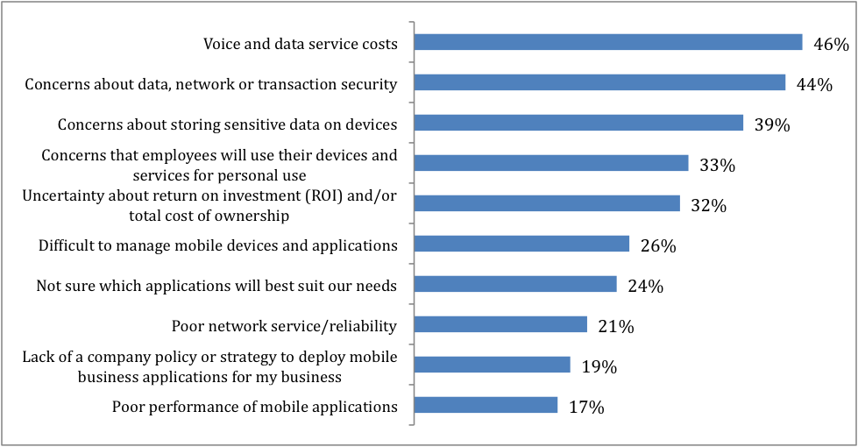
Justification of Proposal
The proposal is formulated to present an overview and solution of the problem being faced by small and medium business holders to find their place of opportunity over the cloud platform. In the contemporary age of Information Technology and communication, Online networking has become extremely expansive yet disruptive technology for the business arena. The business organizations have been transferring over to the "cloud" since it fulfills their requirements of being affordable, acquisition of high bandwidth, approaching the computational power of Moore's Law, and the integration of virtualization with the reduced cost and expenses. The very same properties of the online networking have enhanced its level of business disruption specifically for the small and medium business holders and vendors. Rapidly changing nature and simplified structure of the online networking has created a common perception for the small and medium business holders that they may not have an equal opportunity of providing the services over the cloud.
Methodology
With the problem being identified and described briefly, it is worth considering the approaches in which the problem can be resolved benefiting all the involved actors. If the problem has to be viewed from the aspect of the business, economy and opportunity, there is a grave need to formulate a code of ethics and business morals for the efficient and just use of the online networking for the financial purposes. The small and medium sized vendors and resellers must be identified properly and their space must be allocated over the cloud in such a way that they are not overshadowed or over-casted by the large online service providers.
However, the same problem can be resolved with more efficiency and feasibility if the IT professionals and the vendors are also consulted in order to understand the basic structure, skeleton, models and formation of the cloud. Once the Cloud has been understood properly and then it is specialized for the effective use of the business holders and the financial purposes, it will produce greater satisfaction.
Therefore, it is worth considering here that the proper understanding of the cloud and integrating the technology for the boost and uplift of the business has to be understood by the IT managers of the organizations and the IT channel vendors.
Phases of Project
General Evaluation of the Organizations
The objective of the paper is not to focus on a particular company but rather focus on a generalized concept of a company (ABC) that represents the Small and Medium Business (SMBs) that are trying to make their place over the cloud. The ABC will further represent the pain points of the SMBs over the cloud and how can these threats or problems be resolved with properly integrated technical and business knowledge.
SMBs can be described as the organizations or the companies that have initiated themselves with comparatively lower investments, have comparatively lower profit and reduced headcounts. These organizations are the ones who are taking the risk over their cost and investments to make their place over the cloud. These organizations often have very marginal risk management and maintenance cost, therefore, the slightest hitch can cause them big problems. The SaaS, although seems to be the ultimate solution for the SMBs while offering the reduced cost and flexibility to approach various customers, it also is becoming one of the biggest dreads for the SMBs for the already mentioned reasons. For this purpose there is a grave need to formulate the policies and more importantly and business oriented architecture of the Online networking where these issues can be systematically reduced and catered.
Identifying the Challenges
Online networking has become the phenomenon that is expected to take over the business and economic world to the new levels in next few years. It has numerous advantages to its credit. As the adoption and transitioning of the Online networking is increasing with the passage of time, the consumers and the providers are reporting several issues and problems being faced by their online networking environment. In addition to the worst, these problems are usually legal and architectural issues threatening the future and the reputation of the consumers, providers and the online networking itself on the whole. There is a serious need to take measures against these problems to make the online networking more efficient, reliable and trustworthy source of marketing and business.
Once the problems have been identified the project will focus on:
- Proposing the Solution and Recommendations;
- Formulating a safe criteria and infrastructure for the companies to conduct online businesses;
- Evaluating and standardizing the infrastructure and security recommendations for effectiveness and efficiency;
- Identifying the benefits;
- Considering online Sustainability options.

References
Alberts, C. J., & Dorofee, A. (2002). Managing information security risks: the OCTAVE approach. Addison-Wesley Longman Publishing Co., Inc..
Denning, D. E. R. (1999). Information warfare and security (Vol. 4). Reading, MA: Addison-Wesley.
Jain, A. K., Ross, A., & Pankanti, S. (2006). Biometrics: a tool for information security. Information Forensics and Security, IEEE Transactions on, 1(2), 125-143.
Dhillon, G., & Backhouse, J. (2000). Technical opinion: Information system security management in the new millennium. Communications of the ACM,43(7), 125-128.

