Hotel Simulation Software’s
[Name of the Writer]
[Name of the Institution]

Hotel Simulation Software’s

Introduction
With the different business tools at the disposal of the business, it has been assumed that the business decision making has become a lot more easier these days. Specially if one talks about the simulation tools that are being used around the world by the business as well as the students to make sure that some insight is developed regarding how the business management is supposed to be done and what are some of the particulars that are needed to be kept in mind when business decision making is needed to be done. The hospitality industry is the one where these tools are being used for a long time. These tools are quite useful as they tend to give insight about the revenue model, costing methods, pricing rationale and other technical aspects of the business. On the other hand, there are people who are of the point of view that these tools are not useful in the real world scenario’s due to the fact that they do not tend to provide valuable analysis in terms of real world scenarios, in this paper, it is going to be seen what are some of the advantages, drawbacks of these tools and how they can be used in a better manner.

Good Decisions Made by Using HOTS
There are many good decisions that can be taken when it comes to the way hotel simulation software’s are going to be used at the broader level. The kind of technicality that they tend to offer goes a long way towards making sure that the self evaluation of some of the concepts of the hospitality industry are integrated well in these simulation tools. As is the case in our usage, there were many instances where these tools were quite useful when it comes to the way broader decision making is supposed to be done. For instance, they provided an ease and advantage in terms of how the revenue model and the pricing rationale for the hotelling industry is supposed to be done. The technicalities and the in built costing mechanism made sure that the pricing model that was determined was such that provided lot of valuable insight as far as the way broader hospitality planning is supposed to be carried out. The other thing that it really helped during the course of the analysis was that it made sure that the underlying costing model was prepared in the appropriate manner and it further eased out the process through which the technology integration is supposed to be carried out in the broader business model. The other thing were it came really handy was when the costing was supposed to be carried out. It really made it easier in terms of how the broader planning is supposed to be done at the particular point of time. The other thing that is quite important during the course of the whole process is to make sure that how the determinant of the policy making is supposed to be done at the broader level at the given point of time and how the financial and costing model is going to be prepared. The way it is going to be quite helpful is by ensuring that it provides the proper cost rationale through which the asset management is supposed to be done. The direct and the indirect costs are specified quite easily and it breaks down each and every cost into its proper rationale that allows the ease through which the planning is supposed to be done at the particular point of time. So all these things go a long way towards making that there is indeed value for the prospective user if the hotel simulation tools are being used in an appropriate manner and careful thought and consideration are being taken care off during the course of the whole process. Thus following are some of the decision making that the simulation tools has helped with.
- Revenue Management
- Costing Model
- Management of the Finances

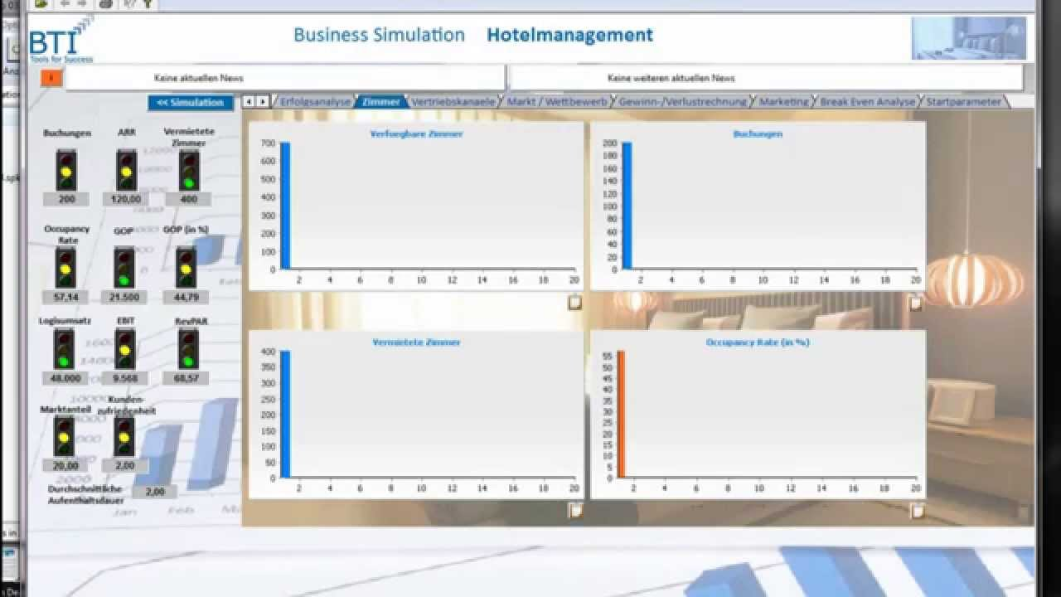
The Hotel Business Management Training Simulation simulates real competitive market conditions for hotel operations. It provides a virtual marketplace where a number of hotels compete against each others. At the beginning of the simulation, all competing hotels are exactly the same. Once management teams start making their operational decisions for their hotels, the Hotel Business Management Training Simulation utilizes both operational decisions made by the management team for their hotel and operational decisions made by competing hotels to determine demand and revenue for each hotel. Operational decisions includes, but not limited to, capital investment, operating expenditures, marketing expenditures and pricing strategies. The external factors such as day of the week, demand patterns, etc. are also factored in the simulation.

Bad Decisions Made by the Simulation Model
Despite the fact that there are many thing that this tool is quite useful for, there are instances when broader understanding of how the market is supposed to be working is quite important when the business decision making is supposed to be done. The same is the case here as there are instances when the way model and the tool is supposed to be working was not quite useful. There is nothing wrong with the tool but the way hospitality industry works is quite complex. The consumer behaviour is quite tricky in terms of how the decision making is supposed to be done in the given instance and the idea is to ensure that how it can be made sure that the prospective users are in the position to make sure that the right rationale is developed in terms of how the broader decision making is needed to be carried out by the particular decision maker at the given point of time. The tool was not able to predict some of the broader market changes that were happening in the given point of time and thus there were instances when the usability of the tool was diminished. Furthermore, the tool was not useful when it has to be made sure that the understanding of the external and internal factors are needed to be determined that are likely to affect the consumer prospect but the way business planning was needed to be done. The other thing were the simulation fell short was how the staffing was supposed to be done. The major problem and the key concern with the staffing is that it has to be made sure that what are going to be some of the cost constraints, how it is going to be made sure that the labour laws and the minimum wage constraints are going to be taken care off. There is also the concern of how the labour laws are going to be amended and how the diversity issues are going to be managed. The marketing is again a critical thing where one has to be quite adaptive and flexible to the changes in the likes and preferences of the customer. Keeping those aspects in mind, following are some of the decisions that turned out bad due to the usage of this tool. The Hotel Business Management Training Simulation enables participants to manage hotel in a competitive virtual environment without any financial risks. After making decisions, results are made available to all management teams so that they can see how their actions and their competitors’ actions impact the performance of their businesses.
- Staffing decisions
- Marketing insight
- Consumer Development
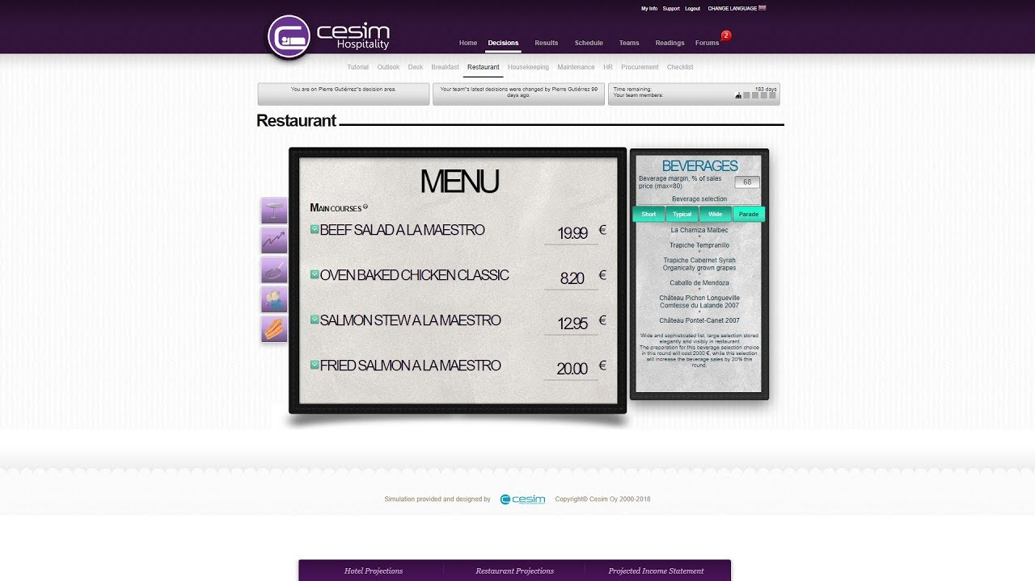

Development of the Training Program Using HOTS
When it comes to the development of the training program, one of the key thing that is needed to be done is to make sure that all the stakeholders who are part of the decision making -process must be made to involved and they should have insight about how this simulation is supposed to work. They can learn how the costing and pricing is supposed to be carried out. What are some of the technical aspects of the decision making in the hotelling and resort industry. The other thing that they are going to be quite able to learn well is that they would develop insight about how the hotelling industry’s finances are supposed to work and how they are supposed to make sure that by using the insight and knowledge that is provided by these tools, they can bring about a change in their decision making.

Conclusion
Technology has really made it easier for the stakeholders to make sure that they are making the easier for the decision makers in terms of the way broader decision making regarding how the hospital management is needed to be done. The nature of the business is such that the consumer insight is hard to come and is very important and for any simulation tool to make sure that they completely mirror each other in terms of the way decision making is supposed to be done. The other reason that the simulation might not turn out well is due to the fact that there are instances when the external and internal factors that are affecting the business are changing at a very rapid pace and due to that, the business has to be quite instinctive with regards to how they adopt to these changes.

References

Baker, T. K., & Collier, D. A. (2003). The benefits of optimizing prices to manage demand in hotel revenue management systems. Production and operations management, 12(4), 502-518.
Dalton, G. J., Lockington, D. A., & Baldock, T. E. (2008). Feasibility analysis of stand-alone renewable energy supply options for a large hotel. Renewable energy, 33(7), 1475-1490.
Douglas, A., Miller, B., Kwansa, F., & Cummings, P. (2008). Students’ perceptions of the usefulness of a virtual simulation in post-secondary hospitality education. Journal of Teaching in Travel & Tourism, 7(3), 1-19.
Feinstein, A. H., & Parks, S. J. (2014, March). Simulation research in the hospitality industry. In Developments in Business Simulation and Experiential Learning: Proceedings of the Annual ABSEL conference (Vol. 29).
Hale Feinstein, A., Mann, S., & Corsun, D. L. (2002). Charting the experiential territory: Clarifying definitions and uses of computer simulation, games, and role play. Journal of Management Development, 21(10), 732-744.
Rotimi, A., Bahadori-Jahromi, A., Mylona, A., Godfrey, P., & Cook, D. (2017). Estimation and validation of energy consumption in UK existing hotel building using dynamic simulation software. Sustainability, 9(8), 1391.
Sargent, R. G. (2008, December). Verification and validation of simulation models. In 2008 Winter Simulation Conference(pp. 157-169). IEEE.
Schmucker, K. (1999). A taxonomy of simulation software. Learning Technology Review, 40-75.
Swain, J. J. (2011). Simulation Software Survey-A brief history of discrete-event simulation and the state of simulation tools today. OR/MS Today, 38(5), 56
Xing, J., Ren, P., & Ling, J. (2015). Analysis of energy efficiency retrofit scheme for hotel buildings using eQuest software: A case study from Tianjin, China. Energy and Buildings, 87, 14-24.

