[Name of the Writer]
[Name of Instructor]
[Subject]
[Date]

Tokyo Tax Hike
a) The policy that is being talked about here is that fiscal policy. The idea is to make sure that how the taxation structure can be changed to make sure that the fiscal burden that has been faced by the economy can be taken care off in an appropriate manner. Furthermore, it is going to allow them to ensure that they take advantage of the better taxation reforms at the particular point of time.

b) One of the major issues with the policies is that the Japanese economy at the moment is facing considerable changes, and due to that, it is imperative that they take short term steps to ensure that the necessary degree of control can be brought into the economy.
c) As discussed, Japan has to make sure that they take the right sort of trade off when it comes to making sure that the right tradeoff is determined in terms of how the economy is supposed to be run. The change in the monetary policy would follow with great degree of inflation which is a big issue for economy.

d) As there is going to be major change in terms of the change in the taxation structure, what is going to happen is that the AD curve might started to shift towards right thus bringing about an increase in the real GDP and would bring about a decline in unemployment rate at the given point of time.

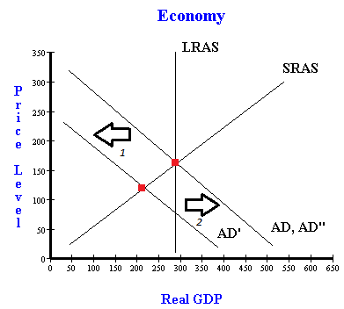

e) The likely effect of the spending towards change in the spending pattern as well as making sure that the quality of labor is going to be increasing at the particular point of time. At the same time, social spending would also mean that there is going to be improvement in terms of how the social spending is going to be carried out.

Work Cited

https://www.bloomberg.com/news/articles/2019-05-15/japan-s-abe-aims-to-prop-up-domestic-demand-as-tax-hike-looms

