Visual Analysis of Joan of Arc saved France
Submitted by
Affiliation
Date
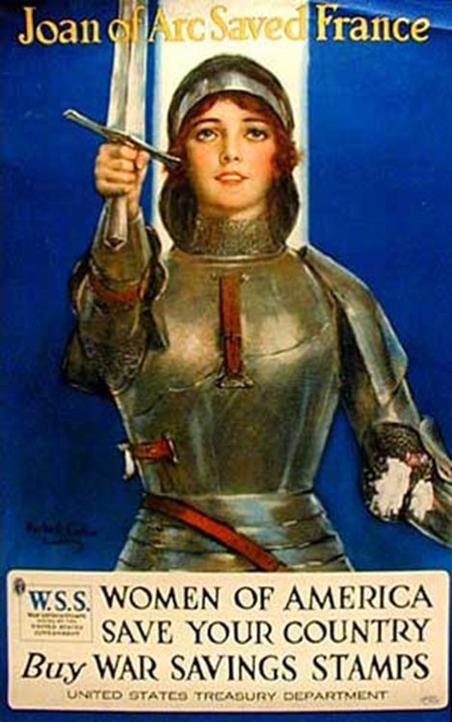

Author: Haskell Coffin (1878–1941)
purpose: This poster from World War I issued by the U.S. Treasury encourages women to buy military savings brands to help fund the war.
Audience: The audience for this poster are all women.
Context: The program for the production of military savings brands was aimed at strengthening civil patriotism and attracting additional funds.
Where : by the U.S. Treasury
Tone: emotional/persuasive
Genre: war time poster
Methodologies : The poster of Joan of Arc (circa 1412–1431) reveals a Frenchwoman who led the battle against the British in the Hundred Years War, whose image traditionally serves as an example of patriotism and martyrdom.
Effectiveness: The United States Post Office ensures the distribution of these vouchers of a small amount from the end of the year 1917. These individual stamps report a little less than 1 billion dollars, half of what was planned, which allow financing 3.5% of the country's total war debt.
This picture depicting a young and beautiful Jeanne raising a sword was made by the American artist Haskell Coffin (1878–1941), The Saturday Evening Post, McCall's Magazine, The American Magazine, Redbook, and other weekly and monthly magazines. There are two Joan of Arc. The heroine of a medieval epic first, which mixes the most energetic religious feeling and the nascent patriotism in a France cut in two by the Hundred Years War. A daring adventure that will earn him the stake, after a trial of five months whose meaning is still discussed. Jeanne is then our contemporary. A figure of legend resurfaced in the heart of the nineteenth century, an issue disputed between the Church and the Republic, she could serve as a standard-bearer for the worst excesses of nationalism. Analysis of a French passion
Rhetoric tools
In this poster, ethos and pathos are used to persuade their audience and raise funds. The pathos used in the form of women image who is a Frenchwoman who led the battle against the British in the Hundred Years War, whose icon traditionally serves as an example of patriotism and martyrdom. This image shows the similarity as Joan safe country with her sword in the same way US women can safe their country and fight against envy. It is historically significant because the war was going on and everyone was disturbed due to fighting in that case women were not allowed to join the army, but this poster shows that women can do that as Joan did for France. This persuades the audience that how French women are struggling to fight against the British with her sword and for that she needs funds. By using ethos as the text states and using the image of Joan of Arc and giving similarity with American women creates ethical appeal to persuade the audience to buy stamps.
Text: there is a very little text added in this poster by saying that women of American can save your country buy war saving stamps. This shows that if you want women to fight for a country, then you need to purchase stamps in this way, they can get money and fight for you and your country.
Colour: there are few colors used in this poster the background is vivid blue with an image in copper colour showing wartime attire and little red color to enhance features and it cause more positive and less saturated emotions. Blue is the color of friendship and peace. The color of harmony and trust. It helps to present everything in a global, holistic way and with a favourable outcome. It can help focus on the issue. Such color will well emphasize creativity. It stimulates brain activity and helps to solve creative problems. Can be used in advertising products for creativity, unisex clothing, bedding. It has a powerful effect, so it can only be used in small areas and in combination with other colors.
Font: The text is in the bold and soft gold color to enhance the writing and message. At the top there is a caption of a poster that says Joan of Arc saved France . and at the end of the poster it states that "Women of America save your country -buy war saving stamp". Different fonts and script used in text to make it attractive. The word" Buy" is enhanced with different script and italic to force and show the reason for this poster.
Image: the image used in this poster is of Joan of Arc, a French woman. The case of the "Joan of Arc symbol" is indeed rather thorny and perfectly illustrates the debates and contradictions that agitated nineteenth-century France. Maleficent for Shakespeare, burlesque for Voltaire, a feminist before the hour for the suffragettes, but especially incarnation of the French people for Jules Michelet, the national saint for the former Bishop of Orleans.
Placement" the text is added in the uppermost corner of the poster, and then the image is added at the most area of sign and at the end again text added which is an actual message of this poster.
Concludingly, this is a very creative wartime poster by Haskell Coffin, an American artist. It is a wartime poster to persuade and motivate people to buy war stamps to get funds, and for that, the image of French women used. The color, text, image, placement, rhetoric tools all work in the making of this poster, and this is an excellent example of how various elements can make an excellent piece.
Bibliography
Meltzer, F., 2003. Joan of Arc in America. SubStance, 32(1), pp.90-99.

