Week 3 discussion

Question 1: Monumental Architecture and Sculpture

India
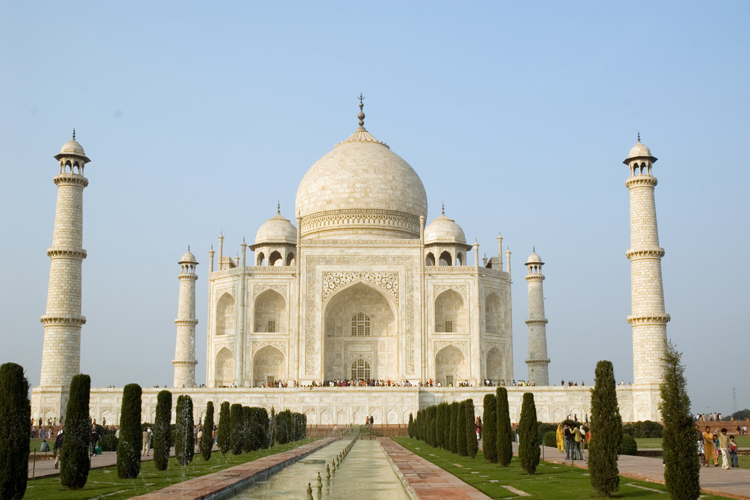
Taj Mahal India
China
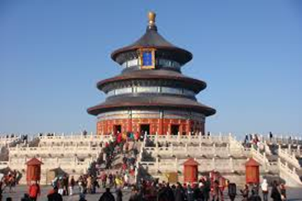
Temple of Heaven monument china
Japan
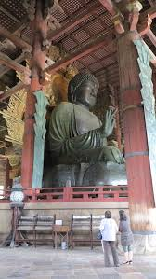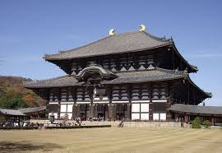
Todai-ji Temple Nara Japan

Taj Mahal India
The building of the mausoleum creates a unique architectural ensemble in combination with a park, which is divided around it. The entire structure is made of snow-white marble, the semicircular niches penetrate the square facade, and thanks to this it looks as if weightless, despite its massiveness. The impression of “soaring” is also created by the reflection of the facades in the canals of the gardens that surround the mausoleum (Singh, 2016). And the most amazing feature of this building is the ability to change its color depending on the time of day and weather. In the rain it looks like translucent, glows pink in the morning, and casts gold when sunset. The inner walls of the mausoleum are decorated with painted tiles and inlaid with precious and semiprecious stones and pearls. The luxury of the Taj Mahal used to be even more impressive: the front doors were made of pure silver, but like many other valuable pieces of furniture, they were stolen. Nevertheless, the Taj Mahal still impresses with its luxury and rich decoration.

Temple of Heaven monument china
Only the emperor had the sacred right to make sacrifices to the supreme deities - Heaven and Earth -. For these rites, the Tiantan, or Temple of Heaven, was built. Its construction began in 1406, that is, immediately after the capital of China was moved from Nanjing to Beijing and lasted 14 years . Initially, the temple was dedicated to Earth and Heaven, but then a separate sanctuary was erected for the Earth. For 500 years, three times a year, emperors, considered the Sons of Heaven, visited the temple and prayed to the supreme deity for the rich harvest and prosperity of the Celestial Empire (Jim, 1999). The temple is conditionally divided into two parts - heavenly and earthly. The square palace, located in the western part of the complex, resembles a small Forbidden City - another famous landmark of Beijing. The heavenly part includes the rounded prayer hall and the round Altar of Heaven. Previously, in China it was believed that the earth is square, and the sky is round - precisely on the basis of these concepts, and the main buildings of the mansion were completed.

Todai-ji Temple Nara Japan
Todaji, "Great Western Temple") is one of the most famous and historically significant temples and attractions of Nara. The temple was built in 752 and was considered the main temple of all provincial Buddhist temples in Japan. The influence of the temple grew so much that the capital was moved from Nagaoka to Nara in 784 in order to reduce the influence of the temple on public administration.
The main hall of the Todaiji temple, Daibutsuden (Big Buddha Hall) is considered the largest wooden building in the world, despite the fact that during the last reconstruction of 1692 the size of the newly built building was only two-thirds of the original temple. The largest building in Japan houses the largest bronze statue of Buddha (Daibutsu). On both sides of the 15-meter seated Buddha Vairochan are statues of two bodhisattvas. (Japan,2014)
The Nandaimon’s large wooden gate leads to the temple, guarded by two fiercely looking statues. The gates and statues depicting the two guardians of the gates of Nio have been declared a national treasure of Japan. Visitors to the temple can meet deer from the nearby Nara Park, asking for special cookies for shika-sambei deer, which can be bought here for 150 yen.

Question 2: The Function of Art Objects

The Taj Mahal is a white marble palace, one of the most grandiose monuments of Indian architecture with chic interior decoration and an amazingly beautiful park. This is the last gift of the Mughal Emperor Shah Jahan to his late wife Mumtaz Mahal, as well as the main and most popular attraction in the country, which is visited annually by thousands of tourists.
In ancient times, in China it was believed that the emperor is a messenger of heaven and that is why there must be a special connection between earth and sky. This connection was maintained and strengthened by the annual solemn prayer, which was performed on the day of the winter solstice. For almost five hundred years, emperors arrived at a special temple to bring generous gifts to Heaven after a strict three-day fast. It was believed that only emperors can turn to heaven with prayers and requests for the well-being and prosperity of the state.
In the ancient capital of Japan , the city of Nara , majestic and not at all timid deer roam the parks. According to legend, the Shinto god Takemikazuchi came here riding a deer to establish a city - since then these animals are considered sacred here. For the smelting of the bronze deity, a nationwide subscription was organized. According to the records, more than 2 million people participated in the creation of the statue. She was smelted and brought to Nara in parts. The resulting figure was more than 16 meters high and weighed more than 500 tons. After the "opening eyes" ceremony, it turned out that not a single piece of bronze was left in all of Japan - all the metal went to the statue.

References
Japan, Kansai, Nara, Todai-ji Temple, Nigatsu-do hall. (2014). Bridgeman Images: DeAgostini
Library. Retrieved from https://search-ebscohost-com.southuniversity.libproxy.edmc.edu/login.aspx?direct=true&db=edscrc&AN=edscrc.15666612&site=eds-live
Jim, A. M. W. (1999). Inside out: new Chinese art. Parachute, (95), 48–49. Retrieved from
https://search-ebscohost-com.southuniversity.libproxy.edmc.edu/login.aspx?direct=true&db=ofm&AN=505821444&site=eds-live
Singh, R. P. (2016). The contestation of heritage: The enduring importance of religion. Graham
and Howard, 125-142.

