Your Name
Phone:
Email:

Health Status and Health Care Services in Australia
with comparison to the United States

HCA 302 Healthcare Organization
Date submitted:

Table of Contents
Introduction 3
Population and Health Status…………………………………………………………………………………………..
Demographic characteristics of population
Mortality, Infant mortality data, causes of death
Other data of health status
Related information (such as on quality if life); analysis
Availability of Health Services
Basic organization/general description of services institutions, providers of care
Issues related to access
Utilization of services (data, if available)
Other related information/analysis
Expenditures
How are health services paid for; any roles for the government here
Data on total expenditures
Other related information/analysis
Macroenvironmental influences on the health care system
Political
Socioeconomic
Cultural
Technological/Other relevant influences
Summary comments
Problems
Opportunities
Other related comments regarding this country's health care services
Comparison to the United States: what works better, what is not working as well………………………………….
Concluding comments: Lessons learned for the U. S., other countries………………………………………………
References (required)………………………………………………………………………………………………….

Introduction
In this research Australian health care will be compared with USA health care in terms of population and health status, availability of services, expenditures and macroenvironmental influences.
Us health care system is one of Responsibility for the health of the nation lies with the US Department of Health and Human Services , led by a secretary (minister) who reports directly to the president. The ministry includes 10 official representatives in the regions (“directors”). It should be noted that in the United States, the Department of Health plays a very modest role due to the small share of government participation in the industry. Among the main tasks are control over the medical system and the implementation of social programs, control over medical science, monitoring and reporting to the authorities the situation in the field of health, welfare and social security of the population. The US health care system is pluralistic, resulting in a lack of a single centralized management and numerous types of medical facilities. But absolutely all institutions provide medical services exclusively for a fee. For a number of categories of citizens who are treated for free, the costs are compensated by the state or special funds.
Australia is one of the countries with a developed health system. The state healthcare structure includes a number of general medical, specialized, prehospital and hospital medical, paramedical and other components. Most of the state’s modern large hospitals are located in specially constructed complexes. Previous experience in operating multidisciplinary multi-unit hospitals has shown that the most appropriate system for the construction of medical institutions is centrally-block. Such a system provides a clear functional separation of several interconnected blocks - multi-storey wards (the basis of the internal layout is 30-bed ward sections), manipulative-diagnostic and office rooms, natural lighting of all the wards, doctors' offices, most of the diagnostic and office rooms. In hospitals, zoning of the territory is also provided, including the presence of a hospital garden zone. (Antony, Palsuk, Gupta, Mishra & Barach, 2018).
In contrast to this approach, while retaining the idea of ​​a centralized-block system, the development and internal layout of most large multi-unit hospitals in Australia are implemented with significant differences. In many hospitals there is no clear separation of the ward sections and other services.

Population and Health Status

Demographic characteristics of population
According to CDC,2018 data ,the America’s estimated population is 327,167,434 out of which 50.8 % are women. nearly 16% are people over 65 years old and with 10% people without health insurance.

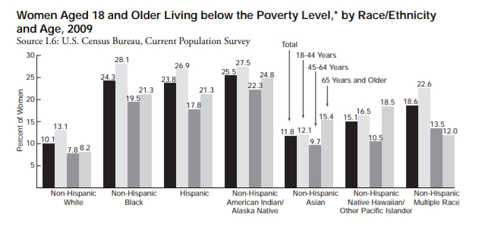

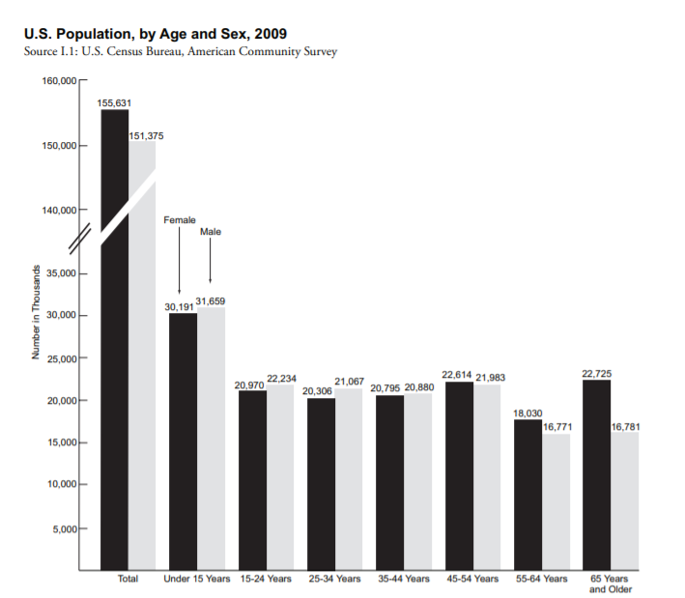
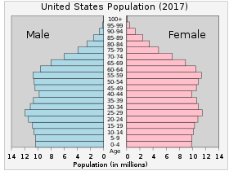

On the other hand, according to world population , the population of Austria in 2019 is Approximately 25.20 million, out of which 12.2% to 15.7%.are those who are over 65 years old.

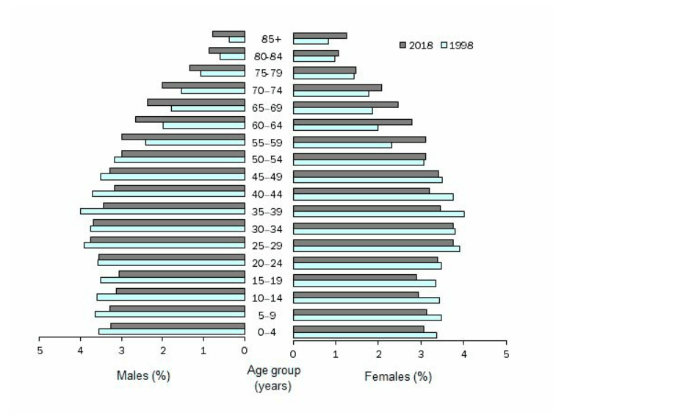
Source(s): Australian Demographic Statistics, June quarter 2018

Mortality, infant mortality data
The current death rate for U.S. in 2019 is 8.782 deaths per 1000 people, a 1.12% increase from 2018.
In 20198-2019, the total deaths registered in Australia are 158,493. (Australian Bureau of Statistics,2019)

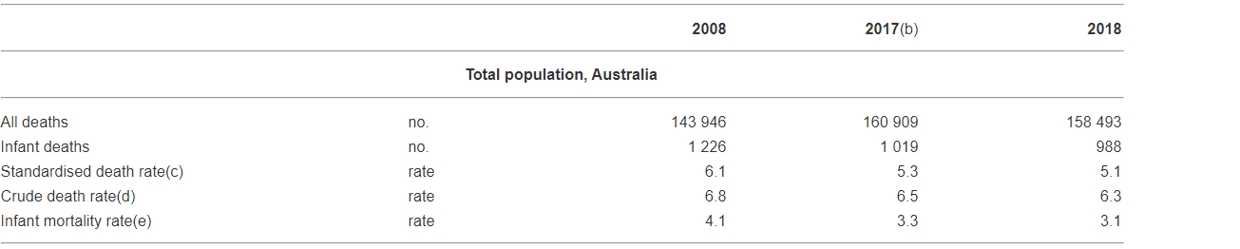

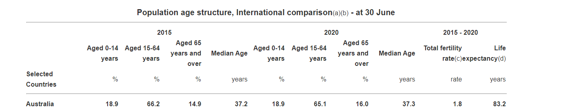

Causes of death
In USA , the three major causes of death according to CDC data are
647,457 due to heart related problems, 599,108 from cancer and 169,936 due to accidents. Whereas according to Australian Bureau of Statistics the major causes of deaths in Australia, is due to heart attack. Approximately 17,533 in 2018, those who die of cancer are 8,586 and from Diabetes are 5,420. (Australian Bureau of Statistics,2019)

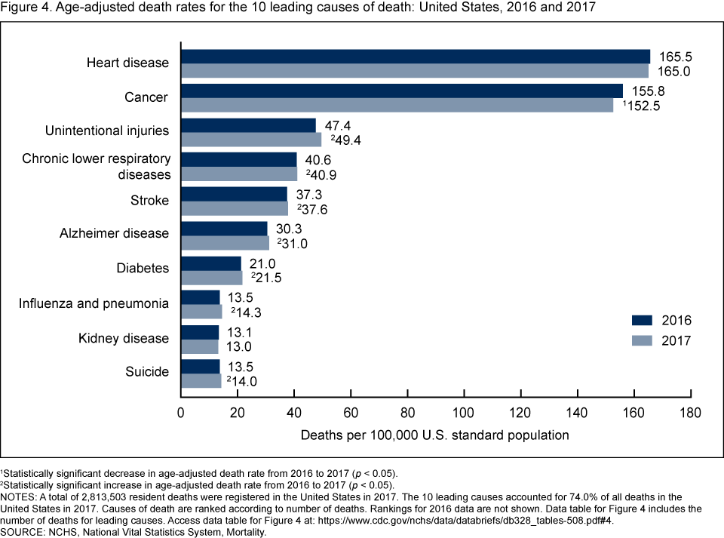

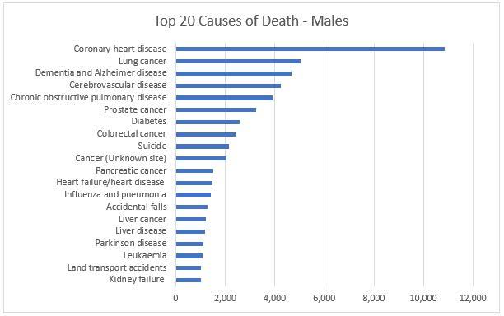

Other relevant data

In Australia, the hypertension, coronary heart disease, other cardiovascular diseases, acute infections and chronic respiratory diseases, diseases of the gastrointestinal tract (reflux esophagitis, gastritis, cholelithiasis and peptic ulcer disease, colitis, etc.), kidneys, prostate gland, allergic pathology, rheumatic fever, etc. As in a number of other countries, in Australia, the leading cause of mortality remains cardiovascular diseases. Approximately 5.5% of the population is sick with manifest and latent forms of diabetes mellitus, while there is a tendency to an increase in the incidence in childhood and adolescence. Diabetes patients are frequent guests in the GP office. Many Australians are overweight,
Otolaryngologic diseases, of the central and peripheral nervous system, and outpatient surgical pathology occupy a significant place in the frequency of primary access to GP. Even in large cities, where there is no shortage of specialized specialists, GPs often perform small outpatient surgeries under local anesthesia. It is known that Australia is a leader in the number of malignant neoplasms of the skin. This pathology, like other oncological diseases, is also primarily diagnosed by GP.

Related information, such as on quality of life
Analysis of trends
According to recent estimates, 16% of GDP is spent on health care financing in the US. Health system costs are expected to increase and reach 19.5% by 2017. Over the past 30 years, cost increases have been achieved through government programs that could seriously undermine the country's financial stability. In the US, about 84% of citizens have health insurance, 64% of whom are employers by insured, 9% - have bought it themselves, 27% of citizens received insurance by the state programs. Certain national programs allow access to medical care for people with disabilities people, the elderly, children, veterans, and people on low incomes. Also these programs ensure that all residents, regardless of their type, receive first aid solvency. More than 45% of public expenditure goes to financing such programs. USA the government is the largest insurer of the people. (Antony, Palsuk, Gupta, Mishra & Barach, 2018).
Surprisingly, in Australia the issues being treated are the same in primary health care, despite different circumstances. The Western lifestyle is similar, and morbidity follows. Diabetes, obesity, memory and multiple illnesses are also employed there. Sunshine produces melanomas, but with no particular panic. General practitioners have effective check-up routines and prevention efforts. Health promotion has been integrated as part of the hospice business.

Availability of Services
In the United States, not all citizens have access to public health care. Health care is partly regulated by the federal state and partly regulated by the states. The health sector is diverse in the United States, and there are large differences between state and city. Most of the population is covered by some form of health insurance, but some are completely outside. Hospitals are legally required to treat all patients in emergencies, but once the acute risk of death has ceased, the obligation to care ceases. In the United States, health care is free only for American retirees and those receiving Social Security benefits.
The Australian Department of Human Services is responsible for health insurance in Australia. You can find the contact details for Medicare offices by region on the Department of Social Affairs website. The office will also provide you with the Medicare card you need for treatment.

Basic organization/general description of services institutions, providers of care

The American system includes a breakdown into for-profit and non-profit hospitals. However, Brill points out that in reality, for-profit is often just a facade behind which hospitals collect huge profits and pay their managers salaries equivalent to those of the private sector. In addition, they receive significant tax breaks. In public debate, these hospitals are often seen mainly as charities, although charitable income accounts for only a few percent of their income. Indeed, these local concealment agencies are often very profitable businesses and large employers. According to Brill, the specialty of the US health care system is that it is these hospitals that actually make the best profits.
Australia is one of the countries with a developed health system. Most of the state’s modern large hospitals are located in specially constructed complexes. Previous experience in operating multidisciplinary multi-unit hospitals has shown that the most appropriate system for the construction of medical institutions is centrally-block. Such a system provides a clear functional separation of several interconnected blocks – multi story wards (the basis of the internal layout is 30-bed ward sections), manipulative-diagnostic and office rooms, natural lighting of all the wards, doctors' offices, most of the diagnostic and office rooms. In hospitals, zoning of the territory is also provided, including the presence of a hospital garden zone. (Antony, Palsuk, Gupta, Mishra & Barach, 2018).
In contrast to this approach, while retaining the idea of a centralized-block system, the development and internal layout of most large multi-unit hospitals in Australia are implemented with significant differences. In many hospitals there is no clear separation of the ward sections and other services. U.S. Census Bureau QuickFacts: United States, 2019).

Utilization of services
In the United States health care costs are rising rapidly, which in turn gives rise to polygonal social debate. In the United States, the sector is growing rapidly, and it is projected to double its workforce by 2020. In spite of the recession, healthcare equipment sales have remained strong with many large companies such as General Electric and Siemens. Equipment sales margins are also exceptionally high - up to 75% - when compared to other high-tech products. For example, Apple has a 40% margin in its main product range. (U.S. Census Bureau QuickFacts: United States, 2019).
Hospitalized patients are placed in 1-, 2-, 3- or 4-bed wards. Wards with a large number of beds are rare, mainly in hospitals of the old buildings. In the wards, designed for two or more people, there are inter-flush partitions that allow you to visually create an isolated space for each patient.
The internal improvement of the chambers also has a number of differences. Some of them are provided with city telephones, but in case of their absence, the patient is given the opportunity to contact through a landline telephone installed in another room of the department. Patients are allowed to use individual portable devices - a laptop, player, TV, mobile phone, provided that their work does not create inconvenience to other patients. (Australian Government Department of Health, 2019).
Problems
The rocky road to The Patient Protection and Affordable Care Act, or more familiarly the Obamacare, began in January 2014. Its ambition is to bring all citizens to health care and to bring recent examples to history. More specifically, within the law, more and more Americans are receiving health insurance, and further efforts are being made to improve the quality of care and reduce the cost so that personal bankruptcy is not always threatened with illness. Among other things, the law obliges insurance companies to provide a minimum coverage to anyone who applies for insurance. Also, the cost of insurance should not be affected by any previous illness or gender. Every citizen is also obliged to obtain insurance and fines for those in financial distress.
A major problem in primary health care in Australia is visiting a patient at home. Australia does not practice calling a doctor at home (unlike the countries of the former USSR). Even if, by way of rare exception, the doctor agrees to visit the patient at home, then for an additional fee not covered by state insurance. This is one of the reasons for the overload of emergency departments of state hospitals, where patients are often forced to go, unable to call a doctor at home.

Other related information/analysis
With regard to health insurance, the price discourse is very strong and there is a ghost of a sustainability gap. Hospitals often claim that public health care is unprofitable. However, it is difficult to believe that the requirement for profitable operation would require a 90% difference between chargemaster and Medicare prices. For proven hospitals, not every Medicare / Medicaid patient can make a loss.
In fact, a patient funded by the public sector is always a more reliable source of income because the state pays more than individuals. For the same reason, hospitals are actively promoting themselves to these client / patient groups. If hospitals were to make a loss for patients covered by public health insurance, there would be no justification for promoting services targeted at them. In addition, these so-called loss-making patients have not significantly slowed down the growth of the healthcare sector. . (The U.S. Health Care System: An International Perspective ,2019).

Expenditures

How are health services paid for, roles for the government in financing care?
US researchers estimate that as much as one-third of current government spending on health is unrelated to the quality of care outcomes. According to David Cutler, a professor at Harvard University, the US health care system is made more expensive especially by astronomical administrative costs. There is a real need for bureaucracy to operate the machinery. Cutler gives an illuminating example of Duke University Hospital, with 900 hospital beds and 1,300 office actresses. Most office clerks work out how to bill different insurance companies according to the procedures they require. Similar work in Europe has been eliminated because in many states the state and municipalities bearing the insurance company reference are mentioned. So in the United States, the people are being made to pay more, to maintain the rigidity of the system. One cannot help but wonder why the system still wants to run through private insurance companies? (Health Insurance, 2018).
Primary and secondary care for the Australian population (especially retirees) is funded by the state. To do this, there is a system of state medical insurance Medicare, which is formed both from the budget and other deductions, including from wages (within 2%).(Australian Government Department of Health, 2019).
For holders of Medicare cards (all adult citizens of the country have them) and their minor children, treatment in state medical institutions (including hospitals) and in most cases when applying to private GPs is free (covered by state medical insurance). However, hospitalization, as a rule, has to be expected for months.
Data on total expenditures
There are two public health insurance systems in the United States (Medicare: Social Security for People Over 65) and (Medicaid: Low Income Health Insurance). These costs are lower because they have politically regulated treatment costs. Often they also reject chargemaster invoices that are obscure. According to the article through the private and public sector payments which pass the bills could be as high as 1:10 differential for the benefit of the public side of the price regulation of thanks. In other words, the price of a chargemaster falls to one-tenth of the original when the federal government sets an acceptable price level. For this reason, the health industry is strongly lobbying for higher prices in public insurance programs. (Bitter,2019)
Thus, in the US, publicly regulated insurance programs are clearly cheaper for the client than most private health insurance policies. They are also clearly cheaper for society. Indeed, in the eyes of the customer and the taxpayer, market regulation, unlike the general dogma of a free market economy, appears to be a competence. . (The U.S. Health Care System: An International Perspective ,2019).
About half of Australians have private health insurance, which makes it possible to use the medical services of private hospitals. In such hospitals, most wards are mostly single or double, many of them are not inferior in comfort to single rooms in expensive hotels. Private medical institutions, as a rule, do not have significant advantages in providing medical care in comparison with state ones, although an important point is the patient’s ability to choose a doctor himself in a private hospital. It is worth noting that many patients, despite having insurance, prefer treatment in state hospitals that have modern, expensive medical equipment, round-the-clock medical supervision is provided, and highly qualified specialists of various profiles work. (PrivateHealth.gov.au,2019). In addition, at the request of the patient for an additional fee, you can get a ward, the arrangement of which is not inferior to the ward of a private hospital. Patients with severe stages of the disease, as a rule, are hospitalized in state hospitals. (Australian Government Department of Health, 2019).

Other related information/analysis
The Australian Medical Association (AMA), which unites 27 thousand doctors, pays great attention to the interaction of hospitals and general practitioners. In 2006, the AMA issued a special statement on this subject. The document emphasized that, since continuity is one of the key principles of medicine in Australia, AMA proceeds from the assumption that “most episodes of hospitalization begin and end with the participation of a general practitioner.” (Population demographics,2019)
In USA, the Health care reforms are painful, and major health care reforms are so painful that they may not be possible at all. Obama's care is probably a step in the right direction, although there will undoubtedly be problems with the deep-seated root system of the system. (U.S. Census Bureau QuickFacts: United States, 2019).

Macroenvironmental Influences
Cultural
In the United States health care costs are rising rapidly, which in turn gives rise to polygonal social debate. In the United States, the sector is growing rapidly and it is projected to double its workforce by 2020. In spite of the recession, healthcare equipment sales have remained strong with many large companies such as General Electric and Siemens. Equipment sales margins are also exceptionally high - up to 75% - when compared to other high-tech products. For example, Apple has a 40% margin in its main product range. (Population demographics,2019)
Technological/Other relevant influences . (The U.S. Health Care System: An International Perspective ,2019).
In a private clinic, an appointment with a specialist does not require a long wait, but the services provided are paid for by the patient (state insurance covers them only partially). The patient’s expenses are also partially compensated during treatment in private clinics, but the share of such compensation (especially when treating in private hospitals) is much lower than the patient’s actual expenses. An alternative is insurance in one of the private health insurance funds (the right to state is still retained), which opens up a very extensive list of various medical services, including dental. However, this type of insurance due to the high cost is not available to everyone.
Analysis
Thus, in the US, publicly regulated insurance programs are clearly cheaper for the client than most private health insurance policies. They are also clearly cheaper for society. Indeed, in the eyes of the customer and the taxpayer, market regulation, unlike the general dogma of a free market economy, appears to be a competence. According to Brill's private sector insurance costs increase by the fact that insurance companies are losing concentration because of health in terms of bargaining power management of prices. Hospitals still need an insurance company to cover the cost of treatment, but larger hospital conglomerates can now dictate to insurance companies the price of their treatments. It is thus a discursive contradiction as to how the objective price in the US hospital actually is formed. (The U.S. Health Care System: An International Perspective ,2019).
Summary Comments
In the US system, overpricing benefits not only the hospitals themselves, but also, for example, pharmaceutical companies, equipment manufacturers, insurance companies and so on. Indeed, there is a certain concentration in the industry on large groups of players, some of which may appear, at a superficial level, to be separate players. It is pointed out that health care costs are also easy to get out of those who have health insurance. Expenses have grown higher than what insurance will cover. Health insurance should prevent personal bankruptcies caused by hospital charges in the United States, but according to Brill, this is no longer the case. Sickness insurance cuts the cost to the client, of course, but the private sector can naturally pay for this benefit in the form of ever-increasing premiums.
Comparing the United States with Australia, or other countries, the researchers said: "Health care in the United States is relatively poor, such as infant mortality and life expectancy at age 60." The United States has the highest mortality rate that can be dealt with by health services, it has also calculated it with the smallest reduction in the last decade. Even though it has spent almost twice as much as a number of other countries, the performance of the United States is still lacking.

References
Antony, J., Palsuk, P., Gupta, S., Mishra, D., & Barach, P. (2018). Six Sigma in healthcare: a
systematic review of the literature. International Journal of Quality & Reliability Management, 35(5), 1075-1092.
Australian Government Department of Health. (2019, August 7). The Australian health system. Retrieved from https://www.health.gov.au/about-us/the-australian-health-system.

Australian Bureau of Statistics, Australian Government. (2019). Retrieved from https://www.abs.gov.au/.
Australian vs United States Health > Quality of health care system Stats Compared. (n.d.).
Retrieved from https://www.nationmaster.com/country-info/compare/Australia/United-States/Health/Quality-of-health-care-system.
Bitter Pill: Why Medical Bills Are Killing Us. (2019). Retrieved from
https://time.com/198/bitter-
pill-why-medical-bills-are-killing-us/.
Population demographics (2018). Retrieved from https://www.abs.gov.au/Population.
PrivateHealth.gov.au - Australian Health Insurance Information. (2019). Retrieved from https://www.privatehealth.gov.au/.
U.S. Census Bureau QuickFacts: United States. (2019). Retrieved from
https://www.census.gov/quickfacts/fact/table/US/PST045218.
Health Insurance. (2018). Retrieved from https://www.usa.gov/health-insurance.
The U.S. Health Care System: An International Perspective. (2019). Retrieved from https://dpeaflcio.org/programs-publications/issue-fact-sheets/the-u-s-health-care-system-an-international-perspective/.

