Stress Among Mothers of Autistic children
Roseline Sylvestre Auguste
Purdue Global
PS504 Advanced Research Methods
11/16/2019

Abstract

Parenting autistic children is considered difficult and can cause a heavy burden for parents and family. Not only can parents experience difficulties in understanding dyadic interactions with children, but also have difficulty carrying out their roles widely. It can cause parents who care for children with autism have high stress levels. Parents who experience stress need to be supported so that their resources increase. One way that can be used to increase parental resources so that they are able to adapt positively is by implementing group-based parenting support .Children with autism usually experience complicated problems that include social, emotional, and behavioral aspects. Mother’s stress is one of the effects that may occur in parents due to caring for and raising an autistic child. Some of the burdens that can cause stress in parents with ASD children includes; child behavior problems, cost issues and parental career choices, difficulty looking for a good education, l imitations of social interaction and the amount of time for therapy. The Parenting Stress Index - Short Form is used to find out the stress level among mothers. PSI administered to mothers and they were allowed to fill time in one hour but in one sitting. After data collection the results proves the hypothesis.

Introduction
Background
Thousands of children have not received qualified diagnostics and assistance. Autism is About 1 in 59 children have been identified with autism spectrum disorder (ASD) according to estimates from CDC's Autism and Developmental Disabilities Monitoring (ADDM) Network. (Baio, Wiggins, Christensen, Maenner, Daniels, Warren & Durkin, 2018). No one knows the exact cause of Autism. Scientists have come to agree that there is a natural trigger that produces Autism. Science is developing - just as Autism is on the rise, so is the amount of scientific work.
Autism is a complex developmental disorder with a different perception of the environment, attention to detail, and social and communication difficulties. A child, in a way, expresses emotions. Despite medical advances, prenatal care, and testing, living conditions are improving - autism disorders are diagnosed more and more each year. After reviewing different studies, it is proposed that there are environmental and genetical factors behind the occurrence of Autism in Children. Stress in mothers is one of the effects that may occur in due to caring for and raising an autistic child .

Literature review
The concept of "autism" was first introduced by E. Bleyer in 1920 as a symptom in severe disorders of interaction with reality in adult patients with schizophrenia. Early childhood autism described by Leo Kanner (1943, Kanner syndrome). Then one of the definitions of Autism sounded like "a disconnected person from the outside world." This disease affects not only mental functions (speech, intelligence, thinking), but also affects the child's perception of a holistic picture of the world. The main problem of Autism is a misunderstanding, a person's non-perception of events happening around.
Collier et al. have pointed out that approximately 64 percent of females surveyed in the US have an infection throughout their pregnancies. It does not lead to Autism or any other neurodevelopmental disorder in most cases. (Amaral, 2017). Further analysis of the study showed that the lower the parental stress of the mother of autistic children with lower family income, the more the parental pressure gradually decreased with the accumulation of rehabilitation time. The study also found that as the severity of the disease increased, the pressure on the parental staff increased; as the degree of social support increased, the pressure on the parental job decreased.
There are a number of studies that compare paternal and maternal stress and conclude that in most cases mothers are more likely to reach significant stress thresholds. It is important to note that other studies have shown that fathers and mothers of children with ASD have comparable levels of stress. Studies of families with children with DD have indicated that the severity of the child's impairments are important factors related to parental stress. More specifically, in autism, stress and depression that have been reported by families are related to cognitive ability, language, social, emotional and behavioral problems, and the severity of ASD in general.
Mothers, who have acknowledged a current diagnosis of ASD for their kid and who are at the beginning of services, are in a particular period of stress. This reveals the status of providing official support to families throughout this perilous period. That is, in the interval between the diagnosis and the beginning of treatments.
An exciting finding of this study is that mothers described a higher level of stress connected to their parental roles and not to the child's features. This shows the fact that parents who have just received their child's diagnosis and are waiting for the start of treatment should obtain support throughout this time, as they must acquire to describe their role as the dad of a kid with ASD. Mothers would profit from working out on diverse topics correlated to the features of autism, effective parenting practices for kids with ASD, and data on accessible services.
Besides, some diseases and abnormalities can contribute to the development of autistic traits. So, for example, with hearing, speech, attention deficit disorder, some chromosomal disorders (with Rett syndrome), signs of Autism accompany the primary pathology due to distortion of perception in the child. (Baio, Wiggins, Christensen, Maenner, Daniels, Warren & Durkin, 2018). More recently, it has been shown that about 5-10% of cases have minor genome changes (copy number variation) that can be detected with genomic analysis techniques. As with other multifactorial disorders, the risks of recurrence of Autism are based on empirical estimates, i.e., by direct observation of anomaly recurrence in several families.
Landrigan (2010) proposes in his study that, “Indirect evidence for an environmental involvement to autism derives from studies representative the sympathy of the developing brain to peripheral acquaintances such as lead, ethyl alcohol, and methyl mercury.” Another study shows that Autism is also more common in males by a four to one ratio. (Amaral, 2017).
Proposed research questions
What are the causes of Autism?
What kind of stress do mothers of autistic children feels?
What are the reasons of stress among mothers of autistic child?
How mothers of autistic cope with stress?
In the past, the International Health Classification (ICD) established by the World Health Organization (WHO) and the American Psychiatric Association's Psychiatric Diagnosis and Statistics Manual (DSM) is autistic under the category of pervasive developmental disorders along with Asperger syndrome. The diagnosis of the symptom positioned. In DSM-5, published in 2013, the autism disorder name abolished and integrated under the autism spectrum disorder/autism spectrum disorder name. Symptom manifestation in classic cases of Autism and Asperger's syndrome occurs before age three and persists into adulthood. For example, it is common to have limited, or no verbal communication reduced the ability for social interaction and a repetitive behavioral pattern. Symptoms and degree of impairment vary, even when considering only one of the spectrum classes. About one-third of autism cases occur in association with other clinical manifestations, such as those resulting from chromosomal alterations or that are part of a known genetic disease.
In Autism, we experience marked difficulties in three areas: social interaction, communication, and interest. They have trouble getting in touch with others; they isolate themselves; in a group, we see them absent from others. Often their eyes are fleeing. Even when they are interested in others, they do so inappropriately and strangely.
The second reason is the dissemination of information about the disease. Those forms of the disease that were previously attributed to the "oddities of the child," shyness, isolation, introversion, and sometimes schizophrenic conditions, are now registered as ASD. Well, the third reason is overdiagnosis, especially from the side of parents. The reasons for the increasing incidence of Autism are unclear: "No one in the world has fully answered why Autism is on the rise. As with many causes of developmental disorder, the leading cause of Autism is that the brain develops differently during pregnancy than healthy children. The cells that are supposed to die at birth and become dysfunctional are redundant - not forgotten in Autism. There is no established cause that some of the circumstances would cause Autism after the birth of the child.
Method section
Material (subsection)
The purpose of this research is to find out the level of stress among mother of autistic child. To conduct this research ,a sample of 50 families having at least one autistic child selected.
Sample
The sample of this study are 50 families (at least one autistic child). The data is selected from different areas, health centers and autism prevention centers. The ages of mother fall between 24-45 years old with kids aging 4-16 years old both boys and girls. Around 30 mothers are single parent 19 are married and 1 is divorced. All families belongs to middle class and mostly mothers are educated at least high school.
The middle-class socioeconomic status of women. The autistic children have been diagnosed by independent specialists according to diagnostic criteria address at the time of the formulation of this study (for example, DSM-5, or ICD-10, WHO,2000). Four children was followed in therapy (3 times a week). Thirty-four children with autism attended schools or special education classes for autism (84%), two followed therapy (3 times a week), and five were staying at home without any therapeutic or educational program. Two children use to go school, but they left and now at home and one is doing a small job at CVS.
Procedure
Initially, the consent of the participants was taken so that the data collected for the research can be published on public forums. Participants were given a briefing about what the test was about and were then sent a link of the online test to be filled. Participants were advised to give clear statements as answers to the questions regarding the matter at hand so that during the tabulation phase of the result making process, no ambiguity pops up. This is the initial step for the participants in the research. Apart from this, a proper examination of the participants is planned to use many assessments. These assessments are detailed and will cost a lot of time since these are based on deep extensive psychological investigations. In the procedure section, we will also elaborate on each of the assessments which we are going to perform.
Sample is purposefully selected from special school; health centers and autism help centers. It is must to have mother with at least one autistic child age from 4 years to 1 years old. The mothers need to be in between 24-45 years old with at least high school education. The Parenting Stress Index - Short Form is used to find out the stress level among mothers. The PSI-SF consists of 36 items taken from the PSI which include three scales:
Parental Distress,
Difficult Child Characteristics, and
Dysfunctional Parent-Child Interaction.
“ It is recommended that all PSI-SF handlers to reflect using the regular PSI certain can safe 10-15 minutes is not worth the loss of the information from the PSI subscales, each of which have established validity. Given the range of the variables measured by the regular PSI's subscales, treatment effects are more likely to be identified and treatment planning is facilitated”( Abidin, 2012).
PSI administered to mothers and they were allowed to fill time in one hour but in one sitting. After data collection the results will be prepared to check the hypothesis.
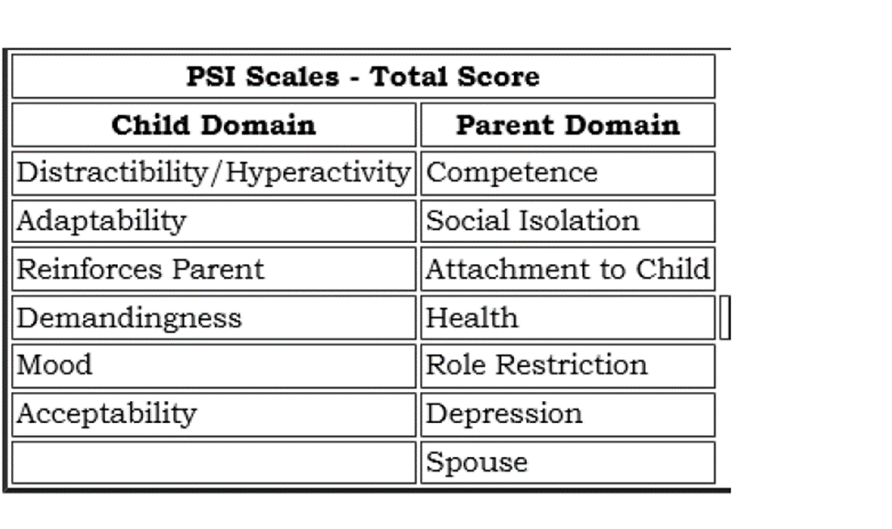
Measures
The dependent variable is stress and independent variable is mothers of autistic . The PSI-4 is generally used as a showing and triage measure for assessing the child-care system and recognizing problems that may lead to difficulties in the child’s or parent’s ++conduct. This information may be used for designing a treatment plan, for setting priorities for intervention, and/or for follow-up evaluation. Other common settings for administration of the PSI-4 include medical centers where children are receiving medical care, outpatient therapy settings, pediatric practices, and treatment outcome monitoring (Johnson, 2015).
“Convergent validity of subscales was supported by correlations with measures of theoretically related constructs, including maternal depressive symptoms, maternal parenting practices, and infant behavior”. (Barroso, Hungerford, Garcia, Graziano, & Bagner, 2016).
“Reliability: Child subscale, .78-.88; Parent subscale, .75-.87.Reliability coefficients for the two domains and the Total Stress scale were .96 or greater, indicating a high degree of internal consistency for these measures. Test-retest reliability: After 1 year, Parent .70 and Child .55; after 3 weeks, Parent .71 and Child .82”( Abidin, 2012).
Results : The results obtained from the total respondents were 50 families. Most respondents had mild stress levels (59%), followed by moderate stress (35.9%), and experienced the least severe stress (5.1%).
Conclusion : Although it is found that the stress experienced is relatively mild, parents of children with Autism still need support from the environment to be able to provide good care for their children
Limitations
Looking back at this research , we have found that the vast majority of research is based on a certain area, survey sampling and sample limitations are very large (there are dozens to hundreds of families), even based on an autism rehabilitation institution, Lack of nationwide large-scale investigations and analysis. To promote the treatment and rehabilitation of autistic children in China, it is indispensable to understand the basic data of autism. In the future, we should conduct a nationwide large-scale investigation and truly understand the facts. On this basis, it is possible to establish a social support system for children with autism that meets their needs.

Discussion
When we talk about autism and individuals who have it, we are talking about a bunch of similar variations, but the display varies significantly in amount and type depending on every individual, from a high-functioning type of autism known as Asperger's syndrome to being able to have serious limitations. It is proven that the mothers of kids with developmental disabilities such as autism tend to suffer more stress and have a more deteriorated health
Physical and mental exhaustion is a reality that many mothers of people with autism go through. When comparing the stress level of mother of children with autism spectrum disorders (ASD) and parents of children with developmental difficulties, several studies have shown that the mothers of people with ASD have higher levels of stress than mothers whose children had intellectual disability and Down syndrome, among others. Stress among mothers of autistic children is due to many reasons’ others than disorder e.g. , the cost of treatments is often not 100% covered by social or prepaid works and families must manage a disability certificate to claim reimbursements, and to enforce the rights of the person with ASD at the health and inclusive education.
On the other hand, there is the look of society that is not entirely friendly. As people with autism do not have any characteristic phenotypic trait on their face, these boys are usually regarded and judged as impolite, capricious or aggressive, instead of considering that many of their behavioral responses may be being generated or reinforced by the context in which that the person is (school, classroom, home, birthday, plaza, cinema, restaurant). These stress levels will decrease as long as the people who are within the spectrum of autism, and their families, perceive a friendly environment, that they do not feel judged, nor thrown out, that they feel accepted and loved .
Other causes of stress
The determination to improve the quality of life of their children at any cost, makes many parents of people with autism suffer high levels of stress. One of the most common attitudes is hypervigilance, which is generated by remaining in a constant alert state .
These parents develop new senses: they are more attentive, trying to prevent possible threats and dangers for their child, they try to reduce sounds or noises that could deregulate it, in addition to thousands of strategies to make the dream as harmonious as possible for the whole family. And, although they are not therapists, they are very committed to their child's different learning opportunities, overcoming opportunities to play, to teach how to communicate. For example, it is very common to ask professionals for tips or suggestions on how to teach sphincter control, enhance communication, language, handle difficult behaviors, ask how they can promote socialization with schoolmates. That is why the level of stress in mothers of children with ASD is compared with the exhaustion and stress of many soldiers who returned from the war . And when it becomes chronic, the comparison is much more alarming: the experience is comparable to the stress presented by soldiers in combat, according to latest research.
Ethical considerations
Participants volunteered independently to be a part of the research. In any case, if a person feels uncomfortable and not satisfied with the results, he/she can leave at will. Participants are required to show up every time when they are called for assessments and experiments. It is important to attend all the exercises in order to be considered as a participant at the end of the research.
The issue of confidentiality is central when it comes to ethical considerations. Personal information of the participants are kept confidential, however, there are some information which are not confidential and will be used for research purposes, the details of which will be given to the participants prior to the start of the research activities and candidate’s endorsement is required for that.
It is the responsibility of every participant to provide accurate information to the best of their knowledge. In case any violation occurred, and we get to know this, the process of research will terminate with the offender. Also, there are requirements of confidentiality from researchers too. In cases, researchers want to keep the work confidential before publishing it on different forums which means participants should not disclose such information if researchers have issues.

References
Amaral, D. G. (2017, January). Examining the causes of autism. In Cerebrum: the Dana forum
on brain science (Vol. 2017). Dana Foundation.
Abidin, R. R. (2012). Parenting stress index, (PSI-4). Lutz, FL: Psychological Assessment
Resources.
Abidin, R. R., & Guarino, A. (2008). PSI: Parenting stress index. Firenze: Giunti OS.
Baio, J., Wiggins, L., Christensen, D. L., Maenner, M. J., Daniels, J., Warren, Z., ... & Durkin,
M. S. (2018). Prevalence of autism spectrum disorder among children aged 8 years—autism and developmental disabilities monitoring network, 11 sites, United States, 2014. MMWR Surveillance Summaries, 67(6), 1.
Barroso, N. E., Hungerford, G. M., Garcia, D., Graziano, P. A., & Bagner, D. M. (2016).
Psychometric properties of the Parenting Stress Index-Short Form (PSI-SF) in a high-risk sample of mothers and their infants. Psychological assessment, 28(10), 1331.
Landrigan, P. J. (2010). What causes autism? Exploring the environmental contribution. Current
opinion in pediatrics, 22(2), 219-225.
Johnson, A. O. (2015). Test Review: Parenting Stress Index, (PSI-4).
Pellicano, L., Mandy, W., Bölte, S., Stahmer, A., Lounds Taylor, J., & Mandell, D. S. (2018). A
new era for autism research, and for our journal.

