[Name of the Writer]
[Name of Instructor]
[Subject]
[Date]

Climate Change - Trump is wrong
Intergovernmental Panel on Climate Change (IPCC) is continuously stressing on the dangerous increase in the earth's temperature. According to this panel, the earth is now about 1C warmer than it was in pre-industrial times (Trump Says “Climate Change Goes Both Ways”). Scientists all over the world are trying to keep this increase below 2C. However, in recent years, it has now changed to below 1.5C. This is human emissions-induced warming and top scientists, as well as agencies, have already issued warning about this global temperature increase. If these warnings are neglected, then there will be serious implications for the planet. This essay will analyze the role of Trump administration in dealing with global warming and climate change issues and its effects on the world environment.
US political agenda incorporated climate change in the late 1980s. At that period, the administration showed reluctance in engaging the efforts of combating global warming. However, with time, the US administration played an active role in this movement and one prime player of this was Obama. After his presidency, US President Donald Trump's role has been mostly negative in this endeavor. During his first year of operation, the Trump administration's action included a refusal of the Massachusetts vs EPA decision (Collomb). Climate scientists are recurrently claiming about the rise in global surface temperatures. Conversely, US President Donald Trump is denying to believe that global warming is human-related. He considered climate change as a trick and political agenda by different countries of worlds such as China, India, and Russia. He opposes the use of wind turbines, as according to Trump administration, these cause cancer. Thus, he expresses his desire of having a good climate for the nation but at the same time denunciates other nations for cumulative pollution. According to Trump, China, Japan and all of Asian countries must check their emissions and keep their environment clean. US climate is already clean but every other place on Earth is more polluted comparatively. This view has strongly been criticized by prior democratic presidential candidate Hillary Clinton. The exit from the Paris Accord by Donald Trump is harmonized with his Democrat forerunners, Ronald Reagan.
Moreover, he has also swept away over numerous US climate laws regardless of forewarnings from his organizations. For instance, in 2017, he stepped down from one of the milestones in this regard, known as the 2015 Paris climate agreement. He was saying it was damaging to the US workforce if they have to retain global temperatures upsurges below 2C. President Trump has expressed his views about his country's preferences and said he was chosen to serve the voters of Pittsburgh and not Paris (Collomb). The US backing away from the Paris climate agreement has provided the dogmatic cover for other countries to also move out from their obligations. Nevertheless, many countries have felt their duties and have promised not to go back.
Furthermore, Trump also dismissed a 2018 report that was threatening of distressing economic significances as a result of climate change. Similarly, he and his administration are also famous for the cut back of lots of environmental and climate protections as well as winding-up rules on oil puncturing and coal plants. This has made copious amounts of dirtiest fossil fuel projects more striking to financiers. In 2016, investments in the coal sector in the USA experienced a drop of 38% after the Paris agreement took on. On the other hand, after President Trump's withdrawal, the investments rose again by 6% in 2017 (Trump Says “Climate Change Goes Both Ways”).
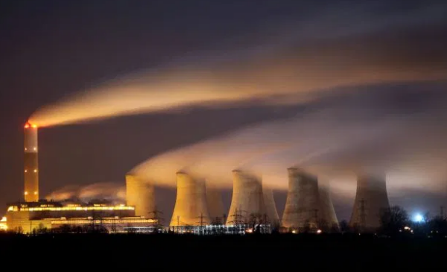
Fig. 1 coal job creation “Christopher Furlong”
When there is relaxation in fuel efficiency and greenhouse gas emissions benchmarks, then this will generate thoughtful concerns for the planet. For example, in the US economy, there is more blame on transportation for producing greenhouse gases than any other sector. This is going to be the worst situation under the Trump administration. Nevertheless, Americans are also aware of these scientific facts that Trump management denies and some automakers are not on the same ship with his decisions.
Likewise, Trump is also replacing Obama's Clean Power Plan (CPP) to lift electrical efficacies along with fraught coal business. CPP is related to enforcing lithe confines on carbon dioxide releases from power plants and it has successfully lessened the CO2 secretions from power generators by 32 %. Trump has replaced it with the Affordable Clean Energy rule by permitting states to establish their own discharges canons for founding coal-fuelled power plants. Accordingly, this replacement has to pay hard in the form of stern concerns for the health of humans as well as the planet. Affordable Clean Energy rule can cause 1,400 more premature deaths by the end of 2030 than the previous ruling.
In addition to this, Trump is no more assisting developing countries in confronting and acclimatizing climate change in the form of the UN Green Climate Fund (GCF). Previously, Obama devoted nearly $3 billion for this purpose. In the context of this fund, the US has already paid $500 million. It was a very crucial fund as the world's largest economy was at the forefront of playing its role in controlling global warming.
On the same grounds, the US has gone in the opposite direction concerning keeping fossil fuels in the ground. It has recently opened wide stretches of land as well as water offshore to oil and gas puncturing. One such effort was the decline of an area of Utah's national monuments such as Grand-Staircase Escalante National Monument and Bear Ears and use of this area for oil and gas development. Moreover, it is also no more asking oil and gas companies to install monitors that have a purpose to sense methane leaks from new wells and pipelines.
Hence, Trump is considered in the list of global leaders who have pliably grilled the science of climate change as he is more of an opportunist then an ideologist. He is forcing different agencies such as the Environmental Protection Agency to stop its findings and endeavors related to understanding the reasons and significances of a hazardously roasting globe. Thus, in his administration, the federal government is no more able to work and report on the imminent effects of a speedily reheating earth. He is further requiring the administration to not only alter the climate assessment’s approach but also interrogate its inferences by making a new environment evaluation panel. For this purpose, he has also not publicized loads of government-funded evaluations on climate change. The buried reports were very significant for the USA as these were increasing the voicing for many years related to the social cost of carbon.
One of the reports was issuing a notice to agriculturalists on the decrease of quality grasses that are vital to nurturing cattle. With these assessments were also covering the deterioration of allergy seasons owing to climate change. Overall, the investigations were covering the widespread effects of the increasing amount of carbon dioxide, temperatures as well as covering the causes of volatile weather. These studies were not biased and there are no questions regarding their authenticity as these were peer-reviewed by scientists and agricultural research service also cleared them.
General recognition of climate change among Americans has been growing and many companies have reacted against Trump pullout from the Paris Agreement (McGuire p.209). They are cutting down their emissions regardless of president action. Among these companies some famous are; Apple, Google, Microsoft, as well as Facebook (Farber p.10). They are making vigorous efforts to cut their carbon secretions. According to the Climate Disclosure Project (CDP) report in 2016, nearly 638 companies in the USA were getting into proactively planning concerning climate risk (Farber p.10). Thus, they are outstripping their administrations in thinking forward.
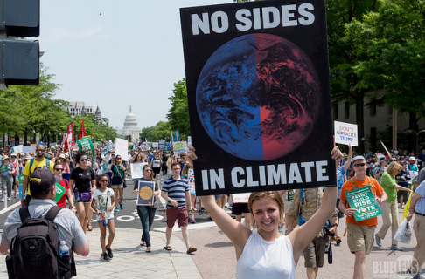
Fig. 2 US protest against Trump action climate change (CARO)
With this, many cities at the state level are also planning to take strict actions regarding climate change. They although have no regulatory powers but still they are making plans and working on explicit sides of emission reduction. This is forcing city governments to also take action regarding urban planning and land use control(Farber p.10). One such effort is the use of building codes by cities to go for energy-efficient buildings. Correspondingly, there is now also less zoning restrictions for the use of renewable energy that was previously delaying the use of rooftop solar (Farber p.10). Similarly, they are also enhancing the standard of their public transportation to lessen fuel consumption.
Climate change is explicitly a result of human-induced activities that have also exacerbated it. However, the world powerful leader, President Donald Trump's arguments and movements are limiting international exertions to stop these human activities that cause this increase. The Trump administration is chasing a pro-fossil fuels agenda and not willing to cut down the usage of carbon. Thus, other world countries are also getting the political advantage of Trump's actions and Russia, Turkey, Australia and Brazil already nullifying the agreement supporting US actions. Although the EU, China as well as India have shown their commitment towards the Paris agreement, it is also a fact these countries cannot take main ladders without the partaking of the US. The resolution also sent a message to the remaining world that the world superpower is no more interested in this effort of preserving the environment.
Moreover, many other actions and strategies of the US government are expressing Trump's marvelous disbelief about the presence of climate change. He has promised to increase the U.S. production of fossil fuels such as oil, natural gas, and coal. Thus, he is revoking many of Obama’s movements and strategies. On the whole, the Trump administration is disdaining science and stopping agency scientific teams from decision-making for global warming. This is indeed a serious issue for those who take climate change as a somber threat to the world. Researchers have presaged about significant and dangerous changes that will come to the world if care is not taken regarding climate change. With rising sea levels there will also be substantial changes in ocean temperatures and acidity. The final result will not be only the less production of food, illnesses but also the destruction in all life forms with an extreme rise in earth temperature.
Trump Administration is going for reverting and policy hitches for climate change. Consequently, environmental and political uncertainty are urging people to go for collective action to get the desired results. Local initiatives once started will eventually be more effective than the federal climate plan. People and institutions must be as forceful as possible with the aim of conserving the world environment. the private sector is already playing an effective role but this role now needs to be more effective. Some companies are already taking measures for reduce the level of carbon emissions. There are also different sustainable technologies in operation that guarantee energy conservation and new sources in action. With this, the Trump administration must also feel its responsibility and continue its citizens and local government policies for preserving the environment for its future generations.

Works Cited
CARO, CÉLINE-AGATHE. Climate Change Policy in the Trump Era. 2017, https://www.kas.de/c/document_library/get_file?uuid=55fabcb3-ec2f-35de-0eda-1662f2d80594&groupId=252038.
Collomb, Jean-Daniel. "A Worthy Heir: Donald Trump, the Republican Party, and Climate Change." Revue LISA/LISA e-Journal. Littératures, Histoire Des Idées, Images, Sociétés Du Monde Anglophone–Literature, History of Ideas, Images and Societies of the English-Speaking World, vol. 16, no. 2, 2018.
Farber, Daniel A. “US Climate Policy: Obama, Trump, and Beyond.” Revista de Estudos Constitucionais, Hermenêutica e Teoria Do Direito (RECHTD), vol. 10, no. 2, 2018, p. 10.
McGuire, Chad J. “Uncommunicating Climate Change in the Trump Era: Influencing Public Policy by Attempting to Control the Message.” Environmental Justice, vol. 10, no. 6, 2017, pp. 209–12.
Trump Says “Climate Change Goes Both Ways.” 2019, https://www.bbc.com/news/world-us-canada-48531019.

