Life Book: Valerie’s Life

Author Name

[Name of the Institution]
Life Book: Valerie’s Life
Introduction
Humans are complex creatures, we tend to have a number of characteristics which define our personality. The reason behind this complexity in our nature is the presence of wisdom and the ability to think. Humans, unlike animals, have been bestowed upon with the capability to think, analyze and then make a decision for the best outcomes. Hence, humans have also been kept at a higher rank than all the other creations of the world.
In order to understand the complexities of the nature of human beings, a subject was introduced by the name of psychology. Psychology is the study of nature and behaviors of different individuals. In short, psychology can be defined as the study of the human mind. It is a broader field that includes a number of sub-fields like sports psychology, clinical psychology, social behavior, and cognitive processes. Every aspect of the human mind and every action by an individual can be defined and explained in the light of various psychological theories. From birth to death, psychology can shed light on every aspect of life.
A very prominent theory in this respect is Eric Erikson’s 8 stages of development. Erikson explained that a human mind develops in a predetermined order, from birth to death or old age. At every stage of life, an individual experiences a psychological crisis, which plays a defining role in their personality development. This crisis poses either a positive or negative impact on the personality development of the individual. These crises can be categorized under the umbrella of psychology as they are both psychological as well as social in nature. If a person fails to complete a stage, he or she will have a reduced ability to complete any further stages. The following Life Book will elaborate on different stages of my own life, with respect to Eric Erikson’s 8 stages of psychological development and how they have proven to be meaningful in defining and understanding my attitudes and behaviors at different stages of my life.

Discussion
The following details will discuss different stages of my life in light of 8 stages of psychological development defined by Eric Erikson. They will explain how I managed to cross every stage of psychological development as a normal, and in fact, a psychologically healthy, human being. Although I have not experienced all the stages explained by Eric Erikson, as I am still a young adult and have not gone through those stages that are experienced by the individuals in their late thirties or forties, so this Life Book will be limited to the psychological development stages that were experienced by the young adults or people in their twenties.
Birth
Birth is the time of life where an individual is born. He or she comes into this world and gets their first introduction with all the worldly affairs and relations. The newborn baby knows nothing and is completely dependent upon his or her caretaker, whether it's their mother, father, sibling or guardian. He or she learns each and everything, especially the basic things from the caretaker/gaurdian and learns whom to trust and whom to not.
Trust vs. Mistrust
According to Erikson, the first and foremost stage of a human’s psychological development is “Trust vs. Mistrust”. This stage begins from the time of the birth of an individual and continues until the first 18 months of age. This is a time in which the individual remains uncertain about his/her surroundings, his/her circumstances, and the world in which he or she is living in. The individual looks toward the primary caregiver or caretaker, for acquiring stability and providence of care. A child learns whom to trust and whom not to, rely upon at this stage of life.
In my case, the primary caregiver was my mother. She used to take care of all my needs including food, water, clothing, shelter, etc. However, my mother was a working woman, so she could not stay at home all the time to look after me and my needs, so my parents hired a part-time nanny, who would take care of me while in the absence of my mother. At this stage of life, I learned to develop trust over certain people like my mother, father and the nanny, who used to care for me.

Early Childhood
Early childhood is the period, starting from the birth of a child until 8 years of age. This period is defined as a period of remarkable growth, with the factor of brain development at its peak. An individual is highly influenced by his or her surroundings and the people with whom he or she grows up with.
Autonomy vs. Shame and Doubt
The second stage of Eric Erikson’s 8 stages of development is “Autonomy vs. Shame and Doubt”. This stage is onset from a time period of 18 months until 3 years of life. An individual is focused on developing a sense of self-control over physical skills and the quest to acquire personal independence.
If I recall my childhood, I remember that I also learned many meaningful skills of my life at this stage that came in handy throughout my life. At the top of these skills come eating and using the toilet. Moreover, I also tried to come out of the crib and do many things alone like walking, playing and grabbing certain things.
Initiative vs. Guilt
The third stage of Erikson’s 8 stages of psychological development is “Initiative vs. Guilt”. The child accepts challenges and responsibilities at this stage and tries to indulge in daring acts. However, he is she also has a conscious voice at the back of their mind that if something goes wrong, their parents will punish them. It is a time period of great learning both in sense of physical as well as cognitive aspects. According to Bee (1992), it is a “time of vigor of action and of behaviors that the parents may see as aggressive."
I remember that I was a very naughty child and tried to indulge in all forbidden acts. Sometimes I used to get scolded by my mother at this, but this never changed my habit of mischief. I used to get feelings of guilt and shame when my mother used to scold me in front of my friends, but this was a very short-lived feeling.
Middle Childhood
It is a very important phase of any child’s life. Middle childhood is usually defined as the period between the ages of 6 to 12 years. A person learns many important cognitive and functional skills along with the art of making social relationships. Moreover, the person learns a lot about his or her society, in which they are living, and its complexities.
Industry vs. Inferiority
A person may encounter Erikson’s fourth stage of psychological development in their middle childhood i.e. “Industry vs. Inferiority”. In my middle childhood, I learned to do sums and solve little problems. Teachers played an important role in my life and I found my role models in them. I found new friends and looked for self-esteem by winning approval for demonstrating different skills.
Adolescence
This is the turning point of a person’s life. Adolescence is an age when an individual moves from one important phase of their life, childhood into another, adulthood. It is a very important transitional phase that includes growth and development both in terms of mental and physical aspects. According to the World Health Organization (WHO), the age of adolescence is between 10 to 19 years.
Identity vs. Role Confusion
“Identity vs. Role Confusion” is the fifth stage of Erikson’s stages of psychological development. I encountered this stage after 12 years of my life. To be very honest, it was a very confusing stage in my life, as I was looking for meaning in everything. Especially in life. I was looking for a sense of self and personal identity, which also made me look into different aspects of my life like personal values, goals, and beliefs.
Young Adulthood
The period of young adulthood in a person’s life, ranges from the early twenties until the mid-thirties. This time is usually the most meaningful period of a person’s life, as they achieve a number of things in this phase. This time period is filled with lots of exciting memories and achievements. A person achieves a number of milestones during this period and starts new relationships during the time. An individual may complete his or her graduation, start a new job, find the love of his or her life or even get married and have kids
Intimacy vs. isolation
It is the sixth stage of Erikson’s 8 stages of psychological development. Intimacy vs. isolation, is the stage of psychological development in which a major conflict occurs between forming social relationships with each other. This mostly applies to intimate and loving relationships. I also experienced these stages in my life, which proved to be very difficult and confusing time for me. The confusion arises due to the fact that a person does not know whether they should trust someone or not, or whether a specific person will be suitable for a long-term relationship or not.
The following images illustrate Erik Erikson’s 8 stages of psychological development in a little more detail:
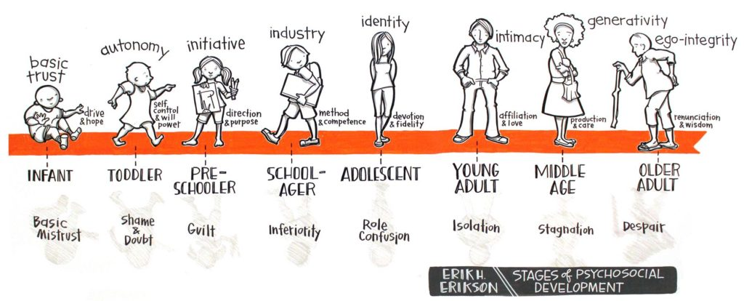

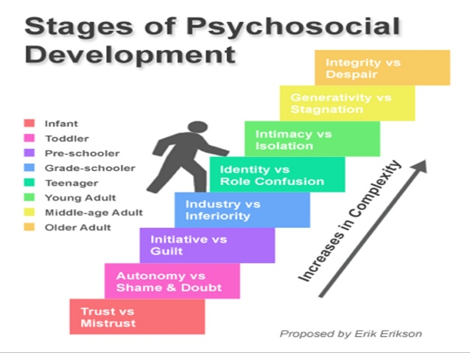

Personal Opinion
Erikson’s stages of development are interesting but I would like to take into consideration, the ideas of other theorists as well. I consider Erikson’s work a general framework for reference and don’t think that any person or psychologist can pinpoint stages of development so accurately. Some people go through psychological development in a different order, some never reach actualization in a particular area. Although I like philosophy as a system to make sense of the world, I would like to be more realistic when it comes to development, and the mind of a child is not the same as that of an adult. I’ve found it very interesting to watch myself, my siblings, fellows and my juniors growing up, and observing how accurately it has been to anyone's theory on development. Moreover, I have also keenly observed the very real physiological differences between boys and girls when it comes to language acquisition and learning style.

Conclusion
Furthermore, it can be concluded that Eric Erikson’s 8 stages of psychological development play a meaningful role in defining the various psychological stages of an individual. A person’s nature, attitude, thinking, and behavior can overall be predicted using these 8 stages of development. Moreover, the actions and reactions of a person can also be clearly justified in the light of these stages. The same happened in my case; when I got a little bit of knowledge of Erikson’s 8 stages, I learned more about them and analyzed my whole life in the light of these stages. I found out that my whole life, until now, could completely be defined under the umbrella of these stages. However, I would like to consider other theories and frameworks of psychological development as well, in order to define the behavior of a person.

End Notes
- Papalia D. Experience Human Development. McGraw-Hill Education; 2014

Papalia D. Experience Human Development. McGraw-Hill Education; 2014.

