This week we are focusing on the tools that these models may employ to bring about improvement. We will walk through the attempts a hospital made to improve the discharge process. This is an exercise so you are not penalized for choosing a “wrong” answer, but rather you can use it as a test of your understanding of the concepts.
You will recall Carla's story that we read at the beginning of this class. For this exercise we will spend time thinking about the events related to Carla's Discharge.
The hospital had an established discharge process which included:
- Nurse reviews the written discharge instructions with the patient
- Follow up care is arranged with primary care physician. (In Carla's case the initial plan was to have Carla follow up with her PCP to monitor her INR to make sure Carla is on the right dose of medication)
- Discharge Summary is sent to Primary Care Doctor
This process did not meet Carla's needs so the nurse and the social worker had to improvise alternative plans.
- As it was inconvenient for Carla to see Primary Care – plan to have it done at dialysis as Carla will be there
- When it was realized that Carla had not been evaluated by a nutritionist to advise Carla on what foods to avoid when taking warfarin, a referral was made to the nutrition department.
It is clear there were several failures associated with Carla's care including:
- Carla lost the written instructions given to her and there was no alternative means for her to find the necessary information
- No communication with dialysis doctor who was to assume responsibility for checking Carla's INR
- No monitoring of INR was performed
- Carla did not have nutrition consult.
Using the information we have learned in the course thus far, let us see how perhaps some of these issues could have been avoided using a Quality Improvement Approach.

1.Carla's initial discharge plan involved Carla following up with her primary care physician rather than with provider that would be more convenient. Carla had often noticed that it seemed care was arranged for the convenience of her providers rather than her needs. Which of the six dimensions of quality does this issue represent?
Safety
Efficacy
Patient Centeredness
Timeliness
2.The IOM specified that care should be Patient Centered, that is respectful to patients’ values, preferences, and expressed needs. Scheduling an appointment for Carla that did not take into her needs is an example of care not meeting the patient's preferences.
Carla was also discharged without a clear plan to monitor her INR. Carla had written information, which was misplaced, and no one informed the physician who was to assume responsibility for her care.
Which of the IOM six dimensions of care was this related to?
Equitable
Efficient
Patient Centered
Safety
3.The IOM describes the quality dimension of safety as avoiding harm to patients from the care that is intended to help them. The failure to have robust processes that led to a failure in the management of Carla's warfarin is a safety failure.
The hospital had recognized this failure a few years earlier, when there had been several incidents of patients admitted with elevated INRs after being discharged on warfarin without an appointment to get their INR checked. At that time, the quality department decided to do a quality improvement project to manage this issue.
A team was assembled which included a "warfarin nurse," a representative of the medical staff, a quality advisor, and a few other stakeholders. The team decided the aim of their project was "to improve the handling of warfarin."
That was an acceptable aim statement
True
False

To improve the quality of process involving patients with elevated INRs.

4.That AIM statement as written provides a very general overview of the project, but an AIM statement should be more specific. It should include clear goals about what is to be accomplished and by when. And, as Don Berwick has noted, "some" is not a number and "soon" is not a time.
The team decided to gather some information to get a better description of the problem. The hospital had a process whereby any patient who was started on warfarin was to receive a consult by a warfarin nurse who would educate the patient about warfarin use and arrange for appropriate follow up to monitor the INR. Parts of the referral forms were to be completed by the ordering physician, other parts by the ward nurse. The referral form also included advice on how to dose warfarin based on best practice guidelines.
Referral forms were reviewed by a clerk and incomplete forms were sent back to the referring provider for additional information. Often, no action was taken on these returned referrals and therefore patients were not seen by the warfarin nurse.
To get a better understanding of the problem, the team decided to perform an audit to determine how many forms were incomplete and what elements were missing.
This audit is an example of a qualitative tool.
True
False

5.The team prospectively audited all referrals over three weeks and identified the number of complete and the number of incomplete referrals. This is an example of quantitative data, that is it provides numeric measurements.
The team reviewed all the incomplete forms. During the audit, it was also noted that many of the referrals contained dosing errors that were not consistent with the dosing algorithm that had been developed by the hematology department and pharmacy. It was decided that dosing errors were outside the scope of this QI project, but the team made a note of the finding with the idea this could be addressed in a later project.
The rationale for using a three-week time period was that this was a sufficient sample size from which to calculate a statistically valid p-value.
True
False

6. This is false. Remember getting a sample size sufficient to obtain a p-value is usually associated with a research function. For an improvement project like this, the goal is to get "just enough" data.
Speaking of which, the team completed the audit and documented the missing elements from the incomplete referrals. 53% (24/45) had major omissions. The team further quantified which elements of the form were incomplete

Patient Name and Address | 8
Contact Phone | 19
Ward | 1
Consultant | 4
Prescriber detains | 5
Indication | 2
Desired INR | 1
Desired duration | 12
Underlying Medical Conditions | 17
Medications | 16
Date of next appointment | 22
Creatinine, Weight, Aspirin | 20

The best way to visualize this data would be in

A fishbone diagram
A bar chart
A scatter diagram
A line graph
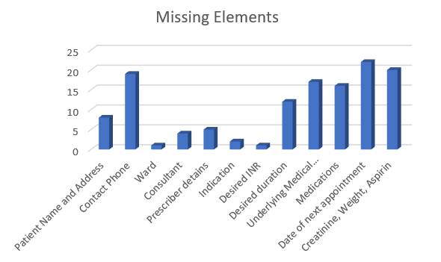

7.A bar chart is the best way to display this data as it allows a quick visual comparison of different types of data.
The team was also interested to see if there was a pattern as to who was not filling out the forms correctly. They were hoping to concentrate their efforts in that area in order to separate the vital few from the trivial many. The best type of tool for this issue is independent
A line graph
A pareto chart
A scatter diagram
A survey
8. The chart that shows you the "biggest bang for your buck" is the Pareto Chart. This chart shows that 80% of the problems were on the acute medical ward, the neurology unit, the pulmonary and cardiology ward. The team decides to focus their efforts there. They decide to survey the providers in these units to see if they could identify some of the barriers to providing complete information. A survey is a qualitative tool

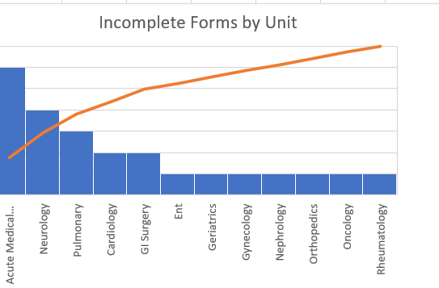
True
False

A survey can be qualitative or quantitative, the one discussed above is qualitative

9. Surveys are qualitative tools that can be used to generate ideas, determine problems, and clarify processes. The feedback from the providers included a number of qualitative statements:
- No training on use of forms
- Unclear who was responsible to complete different parts of the forms
- Forms included information on the back were used for the prescribing of loading and maintenance doses- but the information was in text format that took time to understand.
- No formal teaching on process for managing patients beyond issue of dosing. (no information on nutrition consults)
- Form had too many sections- takes too much time to complete
- Providers don’t have access to some information required- for example providers have no way of knowing who will be checking INR
- Transferring medication list to form too time consuming
- Too much information required
The team decided they needed a structured brainstorming approach to categorize the problems that were being identified. A good tool for this purpose is

Surveys
Scatter Diagram
Fishbone diagram
Pareto chart
10. A fishbone diagram (or Ishikawa diagram) helps focus brainstorming into categories and helps identify where improvement efforts might be focused.
After discussion, the team decided the forms were poorly designed- creating a lot of wasted effort. They wanted to implement an improvement plan. What model might be the most helpful in eliminating waste and streamlining processes?
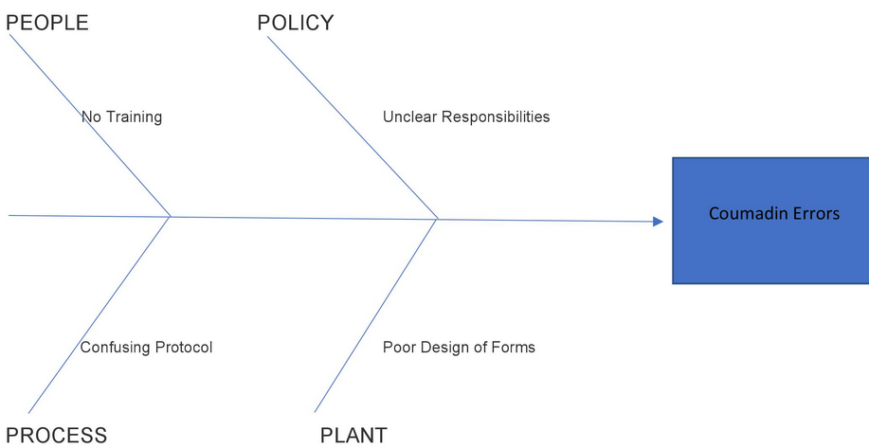

Six Sigma
Lean
5 Whys
PDSA

improve the capability of their business processes.
11. The goal of LEAN is to eliminate waste, defined as any action that does not add value from the customer's perspective. The customer in this instance would be the providers completing the form. The team, working with the providers re-designs the form to make it easier to complete. In addition, the team re-designs the dosing flow chart-- eliminating the text and putting it the form of a flow chart. Additional information is added including important drug-drug, drug-food interactions. Now that the team has a new form, they should immediately share it with the entire hospital.
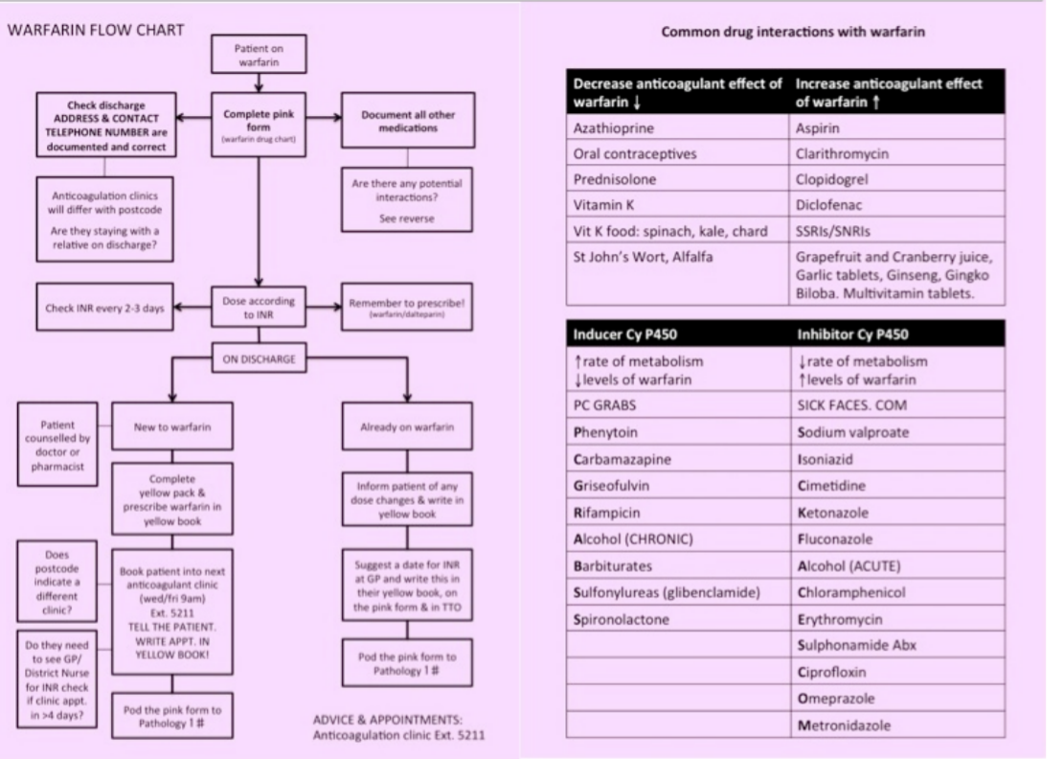
True
False
Pilot testing, to check for suitability and improvements

12. Although the team may be excited about the new form, there may be additional improvements that can be made. Therefore, before implementing the new forms in all areas of the hospital, the team will want to run a series of tests to see if additional improvements can be made.
This type of approach is referred to as rapid cycle improvement.
True
False

13. A rapid cycle test allows the QI team to make a series of small changes and test them quickly.
After several iterations of the form, the staff then conducted an audit. They again looked at 3 weeks’ worth of referrals and documented the missing elements on the incomplete chart. The data this time looked appears below. The results suggest that the new form was an improvement over the old form because there were fewer omissions.
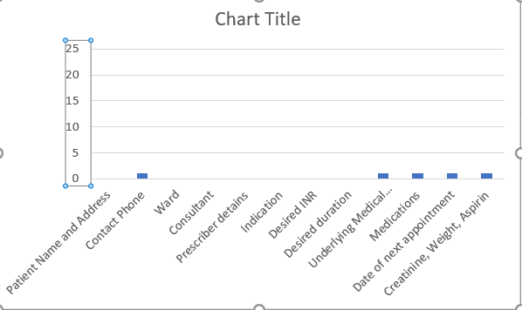
True
False

14.After Carla's tragic outcome, members of the hospital patient safety committee reviewed the "warfarin nurse" referral process to try and learn why Carla did not have a consult by the warfarin nurse. They learned that a referral was never sent. The committee realized that there was a subset of patients who were not included in the quality improvement project because the measure chosen only addressed patients who had had a form completed. Therefore, although the measure of monitoring incomplete referral forms improved the process of obtaining information on patients referred for a warfarin nurse consult, it did not "catch" patients who were started on warfarin and needed a consult but did not have a referral sent. Therefore, the measure chosen did not completely measure the quality failures associated with warfarin management.
This is a problem with measurement...
Reliability
Specificity
Validity
Sustainability
15. Validity refers to the fact that your measure is capturing the information that you believe you are measuring. Looking at referral forms is a valid measure of how well the forms are completed, but, as the patient safety committee learned, it is not a valid measure of how well all patients who were started on warfarin are being treated. The patient committee began considering how they could work with pharmacy to create a process whereby all patients started on warfarin would have a referral by the warfarin nurse.
The patient safety committee also noted that there were several instances of communication failure in the discharge process that they felt were related to readmission rates. The committee evaluated several of those failures to see if there was a relationship between the type of failure and the readmission rate
The best tool to demonstrate a relationship between 2 variables is
a driver diagram
a fishbone diagram
a pareto chart
a scatter diagram
16. A scatter gram identifies correlation between 2 variables. A scatter gram revealed a positive correlation between the time it took providers to write a discharge summary and the 30 day readmission rate. Although the scatter gram cannot say that the delay in writing a discharge summary was the cause of the readmission, the committee noted the average time for a discharge summary to be written was 29 days. The committee learned that this was because the cut-off day for writing a discharge summary was 60 days and many providers did not consider it a high priority. As part of a quality improvement project, a benchmark goal set the expectation that the discharge summary would be completed within 24 hours after discharge.
The best tool to monitor the progress of this improvement project would be
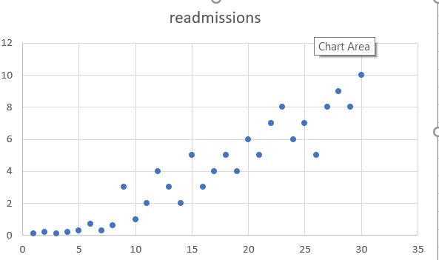

A fishbone chart
A line chart
A bar chart
A pareto chart
17. A line chart shows illustrates a measurement over time. Next week we will be looking at 2 versions of the line chart-- that is, a run chart and a control chart.
Please check true below to indicate you have completed this assignment and to get credit

True
False

