Operation Plan
[Author’s name]

Operation Plan
Introduction
Business organizations are consisting of different forms of considerations as there is a need for proper management of different departments operating to achieve organizational objectives. It is critical and viable for management of the business organizations to develop a proper operation plan to ensure the proper alignment of working of all departments in an organizational setting. There is a need for a proper understanding of the concept of operational planning when organizations are interested to achieve desired outcomes. Operational planning (OP) is explained as the systematic procedure of planning all the strategic goals and objectives in the strategic form of action (Annarelli & Nonino, 2016). When it comes to the consideration of operational plan than it is established as the detailed strategic plan that provides necessary direction to the entire team about the overall functioning of the organization. consideration of proper operational plan makes it easy for all the stakeholders to understand that what is required from them to achieve overall organizational goals. It is interesting to consider the perspective of any specific organization to critically discuss different aspects of the concept of operational planning. Here the focus is to consider the fictional organizational company of footwear to critically examine different domains of the broad idea of operational planning.
Discussion
The idea of operational planning is linked with different practical measures of considerations. It is one of the core responsibilities of the management of the organization to focus the actual strategic requirements and ensure proper planning to meet all short-term and long-term goals. Understanding of the overall idea of operational planning in case of organizational management helps to identify the actual structure of the organization. This form of consideration also assists to figure out the responsibilities or tasks of different individuals working at various job positions. It is worthy to mention that when the organization has a proper operational plan than it eventually helps all the departments to perform their tasks according to the actual organizational requirements (Slack & Brandon-Jones, 2018). Development of the proper approach of operational planning also helps management to ensure the proper form of accountability concerning the objective of actual performance measures.
Name of the organization
The specific organization which is selected for the analysis of the approach of strategic planning is recognized with the name of “The Fast.” It is a footwear brand which focuses to manufacture footwear brands for men, women, and kids.
Type of Business
Identification of the actual type of business is another crucial aspect of consideration when it comes to the approach of operational planning for the company. It is established that this specific company functions in the manufacturing type of business with the focus to manufacture footwear product for its potential customers.
Size of the Organization
Exploration of the size of the organization is also critical to determine the overall strategic position of the company. It is critical to mention that this particular company functions its business in the form of multinational business organization. The focus of the company is to expand its business by exploring different potential markets at the international business level. It is established that the size or range of the company is expanding throughout the years with its focus of increasing its business at a global level. The total number of workers working for “The Fast” around the world is about 2500 people.
Product of the Organization
It is also essential to comprehensively explore the actual prospect of “The Fast” company when it comes to exploring a particular product offer by the company for its customers. Footwear in the product offered by the company in different global markets whereas the headquarter of this organization situated in the United States of America.
Structure of the Organization
Deep understanding of the organizational structure of the company is also essential concerning the proper formation of operational planning for the company. The theoretical idea of organizational structure is recognized as the system which is used by the organizations to outlines how different activities are directed with the objective of achieving organizational goals. The concept of specific activities includes consideration of particular rules, roles, and responsibilities of all the relevant individuals working for the company. The structure of the organization also helps to figure out the flow of information at different levels working within the organizational setting.
Flat or matrix organizational structure is adopted by the company of “The Fast” This particular form of the structure reflects as the proper combination of different types of business hierarchies considering both forms of conventional and modern forms. it is observed that teams are divided based on the difference of geographical position. This form of organizational structure ensures the division of the teams considering the approach of broad department management. Consideration of the flat organizational structure makes it essential for the employees to report to a minimum of two managers (O’Neill, Beauvais, & Scholl, 2016). CEO and managers of different departments established as the important job positions concerning the broad idea of organizational structure. Responsibilities are clearly defined for all the individuals working at different job position levels. A chief executive officer (CEO) is ranked as the highest executive position in the company. The main responsibilities linked with this particular job position is to develop major business decisions concerning the all vision and mission of the company of “The Fast” established for its business. People working at different managerial positions also ranked as an important domain of consideration. The main task involves the managerial job position is to perform different managerial responsibilities to ensure a high-performance level of all the subordinates. Employees are also defined as the important form of the overall form of the organizational structure. Workers are established as the main asset in the organization to meet all the strategic objectives of the company.

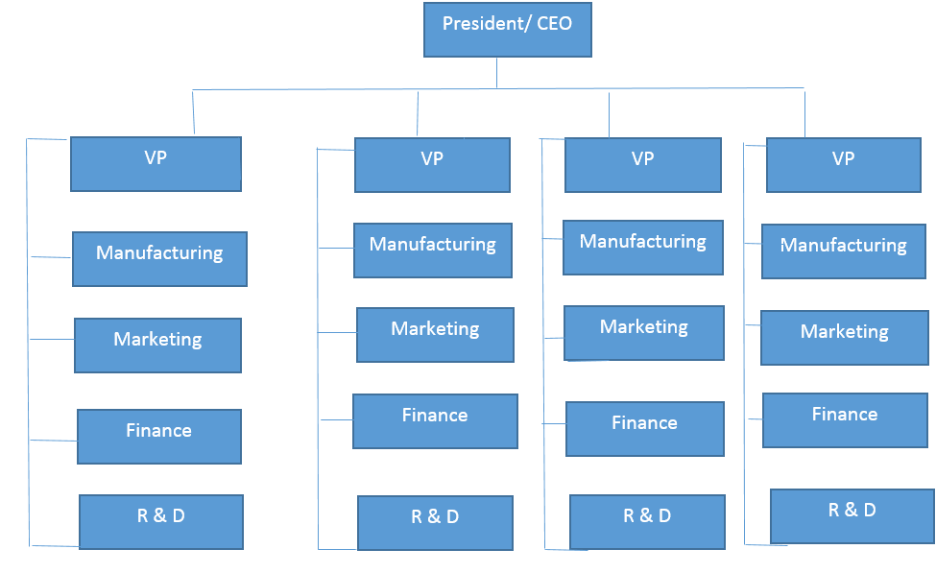
Organization’s Vision, Mission, and Values
Vision: To inspire every individual in the world with high-quality footwear products.
Mission: Creation of innovative and stylish footwear products with the help of global human potential.
Organization’s Values: It is identified that particular organizational values are adopted by the company that eventually appeared in the form of its manufacturing and selling footwear products in both local and international markets. When it comes to exploration of the core values for the company than it is established that high performance, creativity, and sustainability are three major forms of values.
Basic Planning Process for the Organization
It is essential to overview the basic planning process adopted by the company of “The Fast”. This form of consideration further helps to determine the strategic functioning of the company. Planning procedure reflect as the strategic paradigm of the company for both forms of short-term and long-term business operations. Different stages of management adopted by the company to ensure the execution of desired outcomes. The basic planning process reflects the observation of specific organizational goals and develops a suitable action plan to achieve those objectives. Identification of the available resources is established by the company as the first managerial step in the form of proper roadmap to achieve the desired form of business enhancement and product generation. Exploration of the company’s goals helps to set a practical line of action considering the overall perspective of goal-related strategies.
Establishment of the goal-related tasks is another crucial practical phase adopted by the company to develop proper consideration between goals and the practical forms of objective execution. This phase can be a better understanding of the example of the goal of expansion of the global business. The company establishes a realistic and strategic plan of action to achieve this particular objective. Prioritization of different organizational goals and tasks is also one necessary aspect concerning the broad idea of the basic planning process. The company of “The Fast” is focus to make it clear for each stakeholder about the importance of its goals and objectives set by the higher management of the organization. Individuals working at different managerial positions in the company also responsible to set proper timeframe when it comes to the execution of different organizational strategies. Development of proper timeframe makes it easy for all team members to align their personal performance level with the overall approach of the company’s performance management. Development of proper evaluation methods is another critical part of the process planning adopted by the company to ensure the proper execution of all the relevant strategies. The specific strategy of assessment of different operational activities is adopted by the company to enhance its performance level at different stages of the business functioning.
It is important to assess the suitability of the basic planning process adopted by the company considering the domain of three basic levels of management. The overall idea of the planning process of the company greatly influences the approach of three levels of management. Three levels of management typically established in the forms of low-level management, middle-level management, and top-level management. Job positions for all the internal stakeholders are clearly defined concerning the practical implications of the idea of process planning. It is established as a necessary aspect of consideration for the management to develop roles and responsibilities considering the approach of three levels of management. This form of consideration further explains this fact that which individuals are responsible to develop a strategic plan for the company. Job responsibilities are clearly defined in the case of consideration of three main levels of management.

Importance of Quality, Productivity, and Profitability in the Planning Process
Quality, productivity, and profitability are established as important indicators to ensure the successful form of the planning process for the organization. It is important for the manager of the company to focus the strategic goals associated with the aspects of quality, productivity, and profitability because these factors are established as the main indicators of success for the company (Wheelen, Hunger, Hoffman, & Bamford, 2017). Proper planning in this form makes it easy to transmit the actual job roles to all workers and assess their performance level against the parameters set in the form of the desired level of quality, productivity, and profitability.
Relationship between the Human Resource Planning Activities and the Overall Organizational Strategy
The broad idea of organizational strategy is closely linked with the practical measures adopted by the department of human resource management. Strategic planning is established as the step by step planning that ensures proper coordination of different departments working for the company. The company of “The Fast” is committed to developing an effective association between both the perspectives of human resource planning activities and the overall organizational strategy.
The main objective of the approach of strategic planning is to ensure proper development and execution of the long-term objectives of the company. This particular basic aim can never be achieved without the active involvement of the department of the human resource of the company. The domain of human resource planning is characterized as an integral part of the overall form of strategic planning. Partner association between the features of human resource management and strategic planning make it easy for the management to ensure the execution of feasible and successful practical measures.
Philosophy of Management
The particular philosophy of management adopted by the companies reflects their operational position. This specific concept is recognized as the proper representation of certain beliefs of management and culture of the company. The company of “The Fast” is also committed to delivering its basic philosophy of management in the form of its high-quality products to the customers around the globe. This form of consideration eventually helps the management of the company to successfully organize its business referring to the main forms of particular goals.
The mission and vision statements developed by the management of the company ensure that these statements reflect the basic values and beliefs of the company. It defines the idea that what is manufacture and sell by the company under the specific forms of values. On the other hand, it is important to identify how the structure of the organization has the potential to create a positive working environment for its workers. This particular practical measure is essential to enhance motivation and productivity level of its employees. Distribution of authorities at a different level of job roles helps workers to get the required help for the individuals working at different job positions. When all employees have a clear indication that they report to whom then this phenomenon eventually helps them to increase their productivity level and achieve desired organizational tasks (Parnell, 2005). A clear indication of the job roles in case of specific job positions ultimately helps the management of the organization to provide a suitable working environment for its workers. This domain of consideration is also effectively adopted by the management of “The Fast” to ensure alignment of the work performance of all the shareholders.

Control Process for the Organization
The control process is categorized as an important part of the entire form of strategic management adopted by the organization. It is critical for the management of the company to develop different interlinked steps to ensure the suitable form of control process within the set up of the management. the theoretical idea of control process comprised of four major steps to achieve desired outcomes of the accountability. The approach of control process makes it easy for the management to identify how the entire plan is functioning for the company.
At the first step, it is essential for the company to develop standards to ensure the effective form of measurement of the performance. Setting criteria of performance are a critical part that is linked with the feature of measurable objectives. The second step is established in the form of measurement of the performance level of employees. The third phase is established as the practical measure to determine whether performance level is according to the standard or not. The fourth step of the corrective action is also critical that it applies to ensure successful strategic domain in future. Proper consideration of all these aspects ultimately linked to the comprehensive form of operational planning. Assessment of the areas of improvement helps the organization to formulate better strategies for the future.
Conclusion
To conclude the discussion about the strategic concept of operational planning, it is necessary to indicate that this is identified as the important strategic practical measure adopted by companies to ensure the success of the business. Detailed understanding of different functions of the fictional organization of footwear, “The Fast” helps to identify different important strategic forms within an organizational setting. This form of understanding further help to figure out the practical implications of different concepts of management linked with the domain of operational planning.

References
Annarelli, A., & Nonino, F. (2016). Strategic and operational management of organizational resilience: Current state of research and future directions. Omega, 62, 1–18.
O’Neill, J. W., Beauvais, L. L., & Scholl, R. W. (2016). The use of organizational culture and structure to guide strategic behavior: An information processing perspective. Journal of Behavioral and Applied Management, 2(2), 816.
Parnell, J. A. (2005). Strategic philosophy and management level. Management Decision, 43(2), 157–170.
Slack, N., & Brandon-Jones, A. (2018). Operations and process management: principles and practice for strategic impact. Pearson UK.
Wheelen, T. L., Hunger, J. D., Hoffman, A. N., & Bamford, C. E. (2017). Strategic management and business policy. pearson Boston.

