Name
Professor name
Subject
Date
Pair statue of Djehuty-em-hab and lay
Pair statue of Djehuty-em-Hab and Lay is a three-dimensional sculpture, representing the ancient Egyptian art created in 1200-1085 B.C. The statue is currently placed at the Yale University Art Gallery of Ancient Art. The sculpture is made on a red sandstone and black pigment is used for enhancing its visibility. The statue portrays husband and wife, seating together on a double chair. Lay’s right hand is the reflection of the ritual rattle that was known as sistrum. Djehuty-em-hab was the Pharaoh’s army general, seen wearing a full wig and rests his hands on his lap. His wife, chantress of god is holding a ritual rattle in her left arm. She sits close to her husband and her right hand is on his shoulder. The pair statue transmit the themes of royalty and this was common scheme used for gods in the ancient times. This ritual is associated with the worshipping of the goddess of fertility, known as Hathor. Sistirum is used for symbolizing life in Egyptian tradition (Art).
The composition of the sculpture depicts that it is made of red sandstone and pigments. The stones are used for building a 47 centimeters tall statue of the pair. At ancient times Egyptian artists lacked access to materials like plastic and artificial rocks so their primary source was sandstone. Good quality sandstone was used for making statue more robust and making cravings in a way that outlasted for centuries. Stone craving is a common element of art used by the Egyptian artists and it also has religious and cultural importance. Best rocks were selected by the artists that prevented statue from shattering. Red and black pigments are used for enhancing the quality of the sculpture. It has allowed to creator to add more expression.
Balance reflects the elements of line, color, shape, value and texture. The analysis of the statue reveals that the artist has made best use of each of these elements for making a smooth sculpture (Esaak). Colors have significant impact on the visibility of the statue. The artist has used red and black pigments by controlling the grayness. The dress is of brown color while gray color is used for the hair. The statue does not use black color because it is heavier. A smaller and darker shape is utilized for making the image clear. A lighter shape has balanced the dark color. Red color has added more visual weight to the sculpture because it has also allowed to control the saturation. Squares have also helped the artist in giving more visual weight to the statue. Thick lines has also added vividness to the image. Shapes and objects are placed in appropriate manner at the edges and corners for offsetting the visually heavy elements within the composition. The shape of the pair is enhanced by relying on the vertical and horizontal lines. Balance is maintained by managing the smooth versus rough surface.
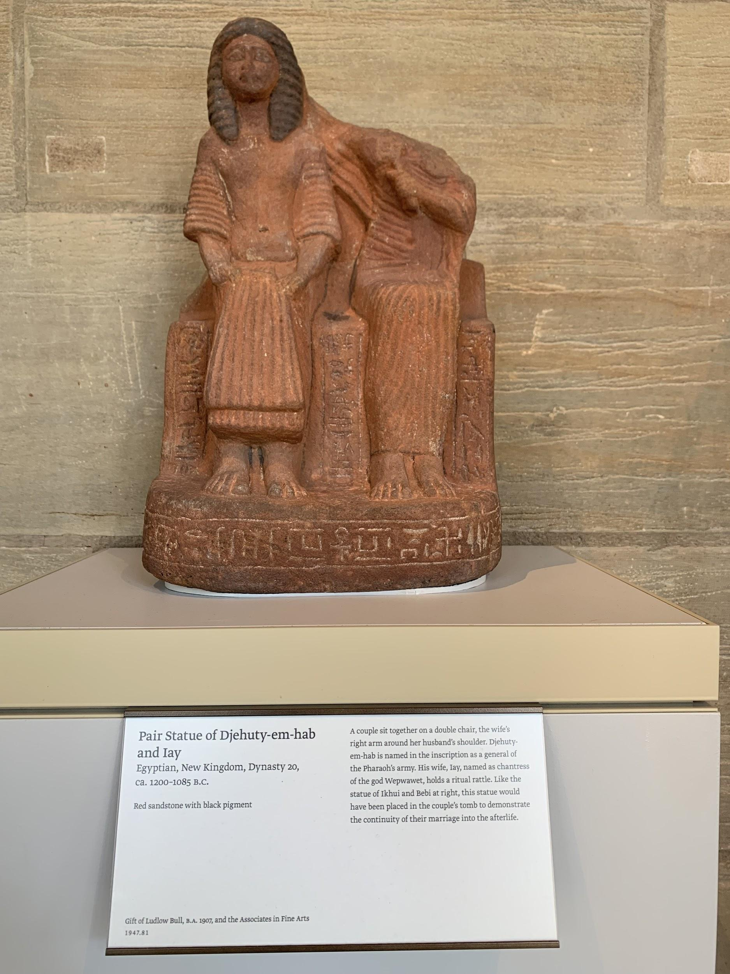
Moods of the pair statue play a dominant role in transmitting the hidden message. The artist has managed to create facial expressions and body gestures that convey the themes of old Egyptian rituals related to the religion and culture. The arm of Lay is on the shoulder of Hab, that reflects the connectivity of the scene with the religious themes. A dynamic composition us used for capturing the calm emotions of the statues. Mood is the atmosphere and feelings apparent in the expression of the pair. The analysis of the sculpture depicts that the face of women is missing while the husband has serious expressions. The eyes of Hab are closed and face is straight that transmits the feelings of calmness and pride. Facial gesture has remained one of the common elements of the Egyptian art for reading emotions. The examination of the mood depicts that he is conveying his power and authority. Visual signs of seriousness is linked to the themes of pride and prestige. The artist has created these expressions with perfection by using lines and squares. Spontaneous inner-state of Hab can be studying by focusing on his eyes and position of the face. Wig is also created for showing the high status of the male figure.
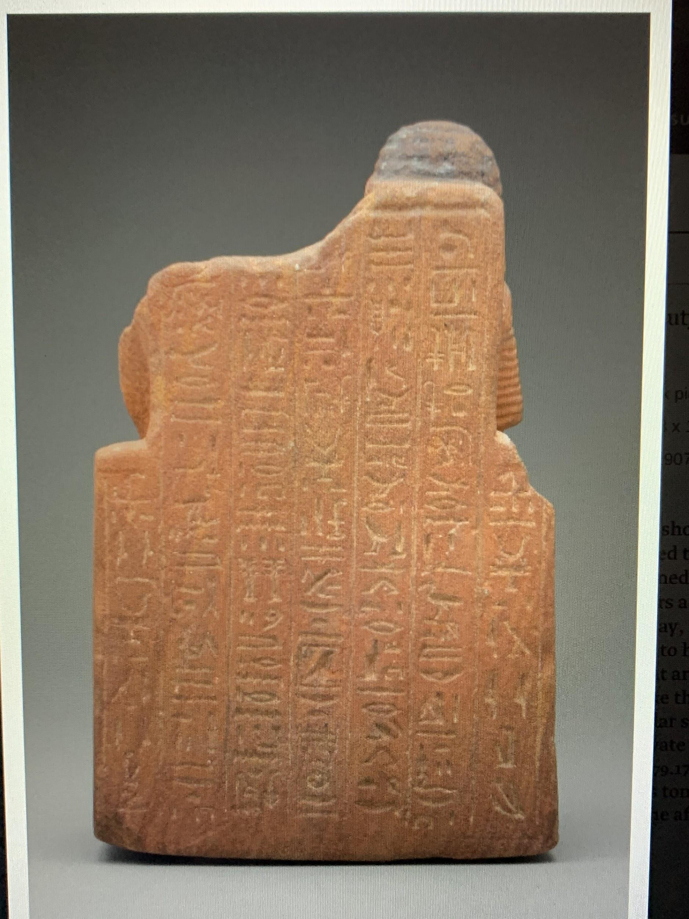
The examination of body gestures of Lay reveals that she is pious and exhibits serenity. She has acquired the power of goddess and expresses her charm. The posture shows that her shoulders are slightly bent, which is due to her connection with the religion. This posture reveals that she is showing respect for her husband. The male figure is sitting in a different pose as the shoulders are straight. Sitting posture of Hab transmits the theme of authority, power and supremacy. He holds more power than his wife. Straight shoulders are used by artist for conveying pride in a recognizable way.
Lightning and shadow are also used for enhancing the beauty of the sculpture. Light on seat is brighter compared to the statues of Hab and Lay. Slight shadows appear on the lap of Lay that has allowed the artist to make proper bent. Craving light and shadow has allowed the artist to focus on certain angles that adds more vividness and clarity to the statue. Shades of gray and red are use for making specific areas distinctive from others. There are engraved patterns on the back and slightly bright light is used.
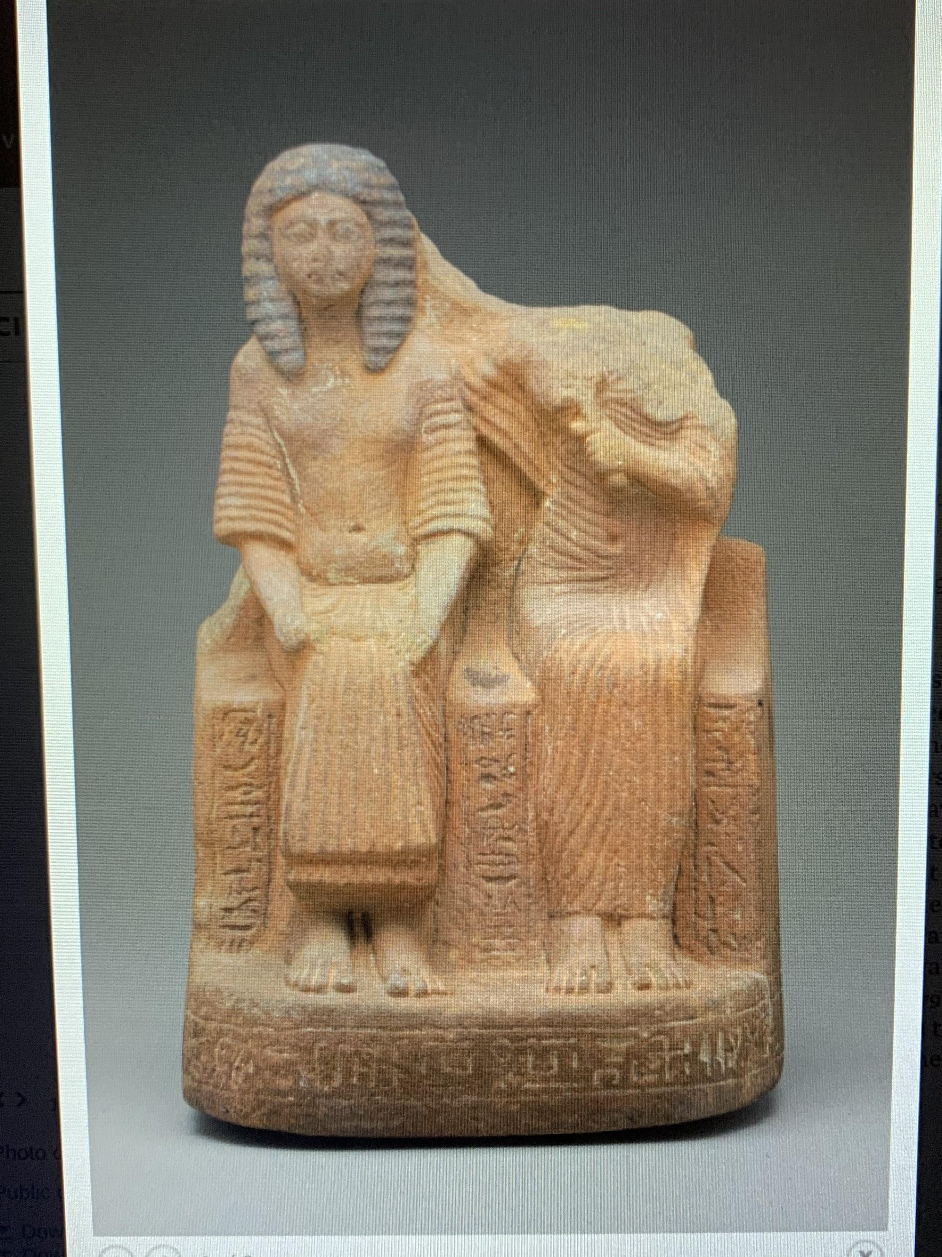

Work Cited
Art. Pair Statue of Djehuty-em-hab and Iay . 2018. 05 11 2019 <https://artgallery.yale.edu/collections/objects/46690>.
Esaak, Shelley. What Is Balance in Art and Why Does It Matter? . 2019. 04 11 2019 <https://www.thoughtco.com/definition-of-balance-in-art-182423>.

