Juvenile Offense Patterns and Trends
[Name of the Writer]
[Name of the Institution]

Juvenile Offense Patterns and Trends
Introduction
The juvenile is the term used for a child, not resembling an adult person, and who reaches a certain age where he is legally answerable for all the illegal activities he commits. An alleged criminal act is when done by a child it is referred to as juvenile crime or delinquency. It is the legal term used for young crime offenders (Dunn, 2017). The past and recent trends and patterns of juvenile delinquencies suggest the increase in some offense and decrease in the others. The comparison of trend and pattern of variables like violent criminal acts and drug abuse among gender, i.e., male and female has been estimated by official data sources, victim and self-report data sources as well. The goal of this essay is to analyze the trends and patterns within the juvenile delinquencies.
Discussion
In America, the determination of young age varies according to respective state, i.e., age criteria differ regarding the commencement of juvenile crime according to the law of each state. The federal law determines a person of age 21 years to be under the category of juvenile delinquency, whereas in some states it is 12 till 18 years. While, in some states like New York and Mississippi the rate is much lower, i.e., 7 or 10 years. The law of Juvenile Delinquency described various acts of crime under juvenile offenses, i.e., violation of any law, drug or substance abuse, violent acts, driving without a license, begging, etc.
The past and recent trends and patterns of juvenile delinquencies suggest the increase in some offense and decrease in the others. These are best measured and recorded through three kinds of information sources or data; official, victim and self-report. The analysis of arresting for the violent criminal acts and drug abuse among juveniles in different states has been estimated over the year 1990 onwards. These two categories are comprehensive and universal in almost every state in the USA.
According to the official data source, the violent acts of crime in juveniles, i.e., murder, rape, robbery, and assaults were increasing from the year 1990-1995, after that, it started declining till lowest-historic point in 2012 (Oudekerk et al., 2018). The trend comparison among gender, i.e., male and female has been slightly varying, as it drastically declined in males than females in recent years.
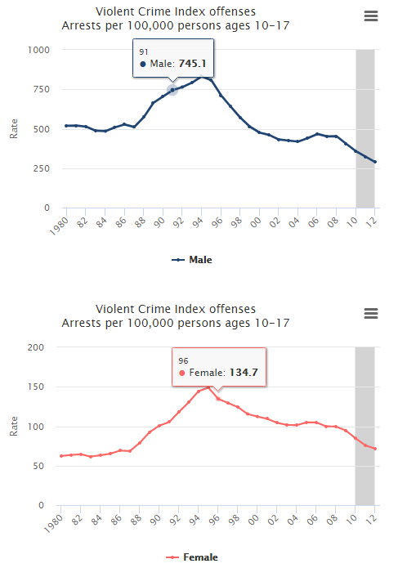
The pattern and trend of juvenile delinquency for drug abuse as generally estimated to be on varying degrees since the 1980s. The violence of drug abuse includes all the aspects of drug and substance-related crimes in juveniles. It started increasing adversely from 1990 to 2000 and then till 2016 it has been declining ever since 2017. The comparison between males and females show no significant difference just that the decreasing rate since 2000 is slower in females than males (Pusch, & Holtfreter, 2018).
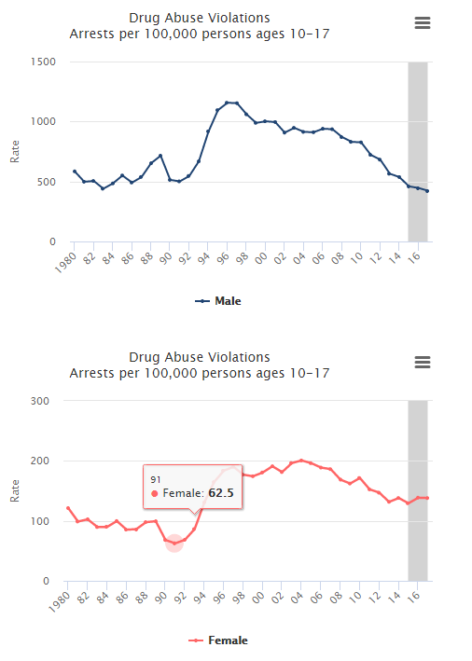

Conclusions
The rates, trends, and patterns estimated by the data gathered from official, victim and self-report measures gives exact and accurate data regarding the increasing or decreasing rate of the particular illegal or criminal act in juveniles. The importance of this aspect in the criminal justice system is that it will provide the estimated crime rate and will further help in controlling the situation and measuring different parameters for the issue in the justice system. Measuring crime rate is essential for describing the type of crime, the reason for its occurrence and the formation and evaluation of programs and strategies. The statistics for criminal delinquencies in juveniles are available for describing the influence of criminal activities on the well-being of the community. The measurement of violence or crime acts are essential for the risk-assessment of different socio-cultural groups, also including the risk-factor of becoming victims or offenders. It is also critical to addressing programs like rehabilitation, deterrence, and incapacitation.

References

Dunn, J. C. (2017). Social Antecedents of Juvenile Delinquency (Doctoral dissertation, The Chicago School of Professional Psychology).
Oudekerk, B. A., Langton, L., Warnken, H., Greathouse, S. M., Lim, N., Taylor, B., ... & Howley, S. (2018). This report was prepared by the Bureau of Justice Statistics (BJS), RAND Corporation, NORC at the University of Chicago, and the National Center for Victims of Crime using federal funding provided by BJS.
Pusch, N., & Holtfreter, K. (2018). Gender and risk assessment in juvenile offenders: a meta-analysis. Criminal justice and behavior, 45(1), 56-81.

