Your Name
Instructor Name
Course Number
Date
Essays I (Chapter 1- 2)
Cahokia
Cahokia was certainly a small city of 20–30K with more people in surrounding areas that seem to have sprung up around 1050, where a ritualised sacrifice was practiced but only 1% of the site has been excavated and research is still being carried out. Describing it as an Empire may be somewhat premature until there is a lot more research, nevertheless fascinating.
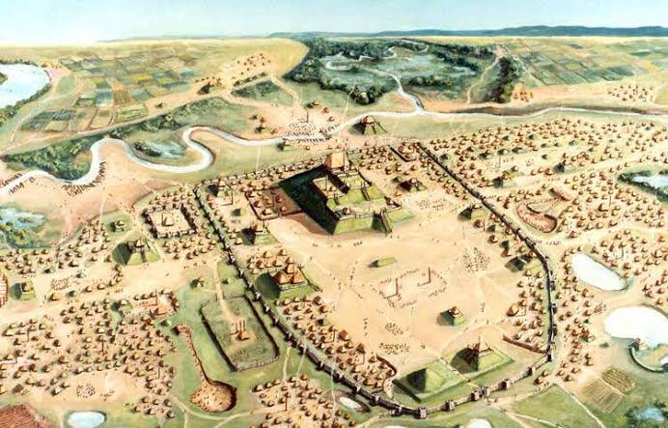
It was a vast city and likely encompassed a large area of influence along the Mississippi River. I don’t know of any civilization that lived peacefully with its neighbors and didn’t war or try to gain wealth/territory or impose the rule. The Aztecs are a prime example of this since they were hated by most of their neighbors who in turn helped the Spanish conquer what’s now Mexico City. The Aztecs’ origins, in fact, may have been from what’s now the USA, possibly the Southwest or even Midwest.
California Peoples
California’s and its people’s importance to the United States cannot be understated. As the most populous state with the largest economy, one that ranks as the world’s fifth-largest, its economic contributions and political influence are both tremendous. It contributes more in tax revenue than it receives in federal benefits, and much of that tax revenue goes to support Red states that enjoy incessantly vilifying it. Its two main metropolitan regions are innovation hubs, generating ideas, inventions, innovations, and technology that induce economic growth; these are what drives economies, not financial incentives.
It is also a bellwether state, the harbinger of social and cultural changes in American society. California is socially progressive, and the social changes that first occur here inevitably percolate throughout the rest of America. The entertainment produced here exerts tremendous influence throughout the world. California is overall very liberal and tolerant, with an eclectic culture that has absorbed numerous demographic groups. The demographic changes that begin here will inevitably sweep the nation.
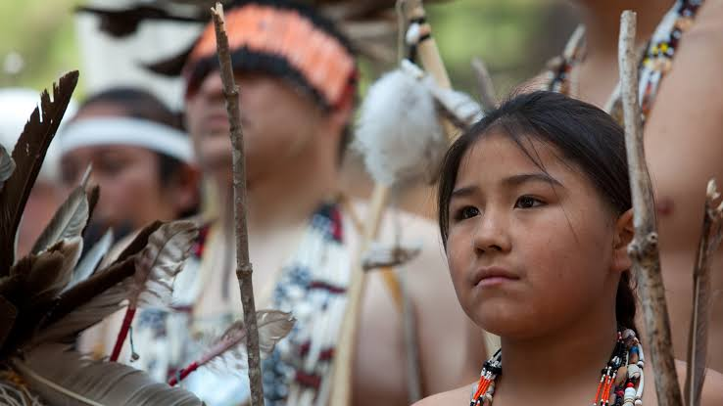
The agricultural sector in California is also the nation’s largest, producing a large percentage, if not a majority, of the fruits and vegetables consumed in the United States. It is the largest producers of many different fruits and vegetables. In summation, California’s importance to America is economic, political, cultural, and agricultural.

2. Europeans
During the era of 1400 – 1500, the political and environmental both climates was changing from the warm medieval period to the little ice age in that century. It was creating a situation of restlessness among the people and all types of bad and unexpected events were taking place. Western Europeans (not all white Europeans) were having it especially bad so they went Viking and started to explore for options desperately.
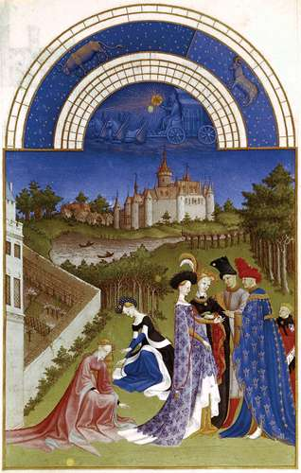
Iberians were the ones, along with the Nordics, with the harshest climate when it came to crops. During the medieval warm period, while all of Europe’s population had been growing, the Iberian population had been dropping steadily 1 million people per century. The climate was murderous at that time, especially for Castile. In 1400 the medieval warm period was giving way to the “little ice age” and the climate was just getting out of hand (the plague, the kazillion droughts all across Europe, all happened in 1400 because of that transition). It was being a particularly hard transition in Iberia. There are even many references and examples present, in the previous transition, during the 800, on the record of people starving to the point of eating each other.
Portugal’s climate dried out considerably and in Castile and Aragon, it became chaotic. Iberians were hungry, in fact starving to death. Portuguese were not used to this kind of weather and Castilians were terrified of a repeat of the droughts they enjoyed during the warm medieval period. To top things up, France was suffering hardship too, even if not so much, and the thing one does when one is in a hard place is war and take land and resources from neighbors, so they were justly terrified. France was the main military power in the west at that time. The Muslim world was also starving, so they were also “getting restless”.
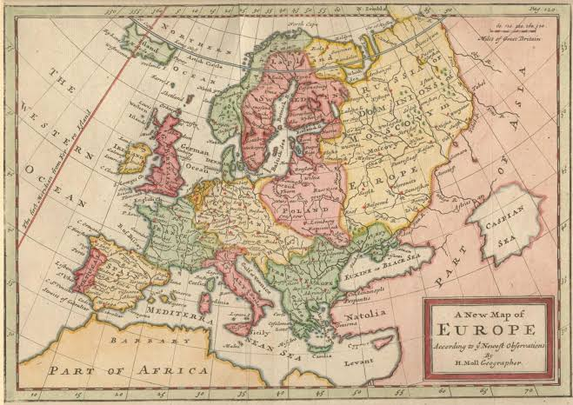
The Ottoman Empire was rising and as soon as they took North Africa, Iberia and Italy were next and they knew it. They needed more population but they were not able to feed it. They needed resources in order to do so but had nowhere to take them from, so they explored around looking for something, anything, options in general. They started developing naval innovations precisely to look around in search of options and actually spent decades on it. It was very similar to what pushed Vikings to explore, commerce, colonize and raid, and the mind frame the Iberians had while exploring was similar. They had all those options in mind and at the same time none of them. As far as they were not planning on colonizing, they were “out for exploration”.
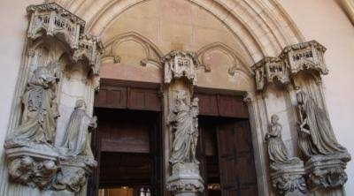
While Aragon found a commercial way to the East, during this exploration and went with commerce, the Portuguese African exploration hit Guinea and found gold, a relatively low population density. Both these nations were weakened both by the Arab Empire’s slave trade and religious wars and by the same climatological instability that was pushing Portuguese out, but too far away to conquer in a traditional sense, so they started a model of exploitation we call colonization now. They took riches without incorporating the land and extended their control only as much as they needed to take what they could (slaves and gold in this case). In the case of the Canary Islands or the Azores islands, they went for regular conquest. So, it can be said that it was very much a Viking situation plus climate changing and bringing all sorts of calamities around that time.

