Thinking and Intelligent
Student’s Name
Institution
Date

Toys for language development
The behavioral toy presented below is meant to help children to learn the language. The behavioral toys have numbers on the bottom part and each part presents a word or letter. A child practices to arrange these parts based on the letters or sound. Each sound matches with the other based on the sequence of the vowel. However, children can arrange on their playground based on the sound any mismatch the block would fall apart. First, it helps children to understand the sequence of the sound and then it colors are matched as well. A child would recognize the color based on the sound and therefore, this would help a child match colors and sound, which is important in learning a language.
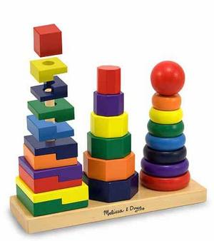
Behavioral toy
Developing language is a critical period in the life cycle of human being. It starts from an early age where a child practices how to pronounce sound and then communicate efficiently. According to Sinauer Associates (2011), the critical period of learning linguistic is the period between 7 months and 15 months. It is the time when a child is practicing how to pronounce a word. And therefore, when a child passes this critical period without communicating, it is likely for a child to become deaf. Most babies begin to produce sound at 7 months and therefore, a baby would fail to produce any speech like if he or she was not provided with any sound like objects or toys (Harrison, 2018).
At this time a child requires toys, and other people to play around together. Studies have also indicated that children who are mostly looked and do not mingle with other children take a long time to speak (Chapelton, 2018). This is because of the lack of things to imitate and learn from. As a result, a child can easily become deaf and it is the reason why some children take more than 24 months before knowing how to speak well while other starts to speak coherently when they are 8 to 10 months. This shows clearly the influence of the environment into a child ability to muster languages.

References
Chapelton, T. (2018). Young children best learn languages. Journal of child development and Support, 2-15.
Harrison, R. (2018). Toys and games help children learn a language. Educational and Language Learning, 2-15.
Sinauer Associates, Inc. (2011). The Development of Language: A Critical Period in Humans: Neuroscience. 2nd edition. New York: Sinauer Associates, Inc.

