Disscussion Post
[Name of the Writer]
[Name of the Institution]

Disscussion Post

The work chosen for this paper is a painting from a surrealist painter named Salvador Dali. Salvador Dali was born in 1904 in Catalonia Spain. Influenced by the ideas and concepts of Sigmund Freud, an Austrian psychologist, Dali meticulously linked abstract art with the subconscious mind. As a result, Dali created numerous masterpieces that, even today, impress and motivate an entire generation.
The name of the painting is "The Persistence of Memory". The masterpiece was created in 1931. The painting has drawn both appreciation and criticism from people from all walks of life over time.
Obviously, “Persistence of Memory” is appreciated by art enthusiasts and critiques. The painting has incorporated all the fundamental elements of art. Some, fundamental elements of art are lines, values, and shapes (Hamblen, 1986). And this painting has got it all what art critiques are after for. An art critique would notice the details of the painting that are highlighted through thicker values rendering three-dimensional perspectives into the painting (Hamblen, 1986). Furthermore, both noticeable and unnoticeable shapes and figures in the painting draw the attention of the critiques. The art enthusiasts and critiques are moved by the aspect of emotionalism incorporated in the painting. Furthermore, the enthusiasts are urged to introspect and think of the precious time they have wasted. Dali wanted to persuade the viewers through persuasion. This persuasion is witnessed by the melting clocks portraying that the time would eventually run out. At that time, surrealism, cubism, and modern art were influencing the painters. That is why surrealism is prevalent in this masterpiece is evident in odd shapes and figures.
The painting fails to draw the attention of the viewers that, unfortunately, goes by the name of millennials. Millennials tend not to focus on the intricacies of the artwork, rather they feel bored from looking at it. It is because they are unaware of the fundamental elements of art, complex concepts of emotionalism, surrealism, persuasion, and cubism that are all witnessed in the piece of art.
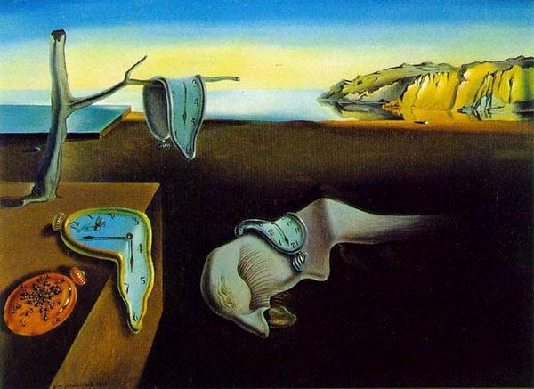
References

Hamblen, K. A. (1986). Three areas of concern for art criticism instruction: Theoretical and research foundations, sociological relationships, and teaching methodologies. Studies in Art Education, 27(4), 163-173.

