Your Name
Instructor Name
Course Number
Date

The Beautiful Body

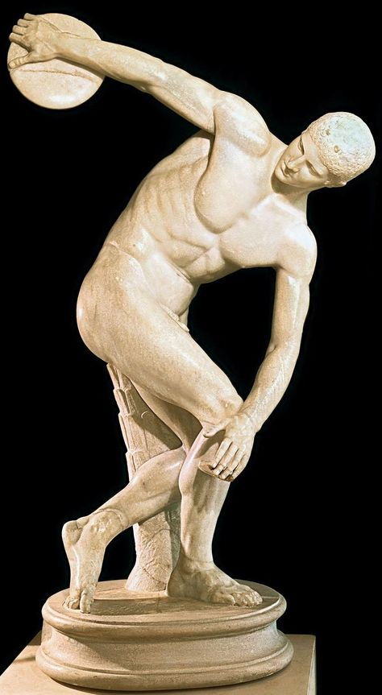
Myron, Discus Thrower (Discobolos), 450 BCE
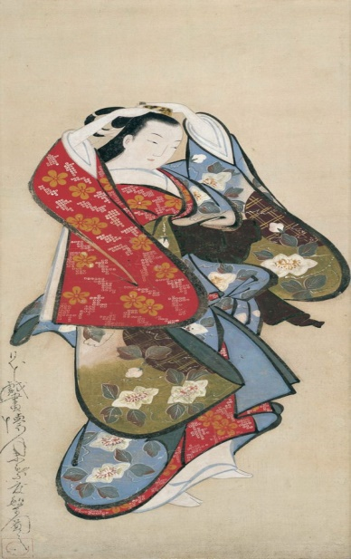
Kaigetsudo Dohan, Beautiful woman, 1715
The two artworks; a discus thrower (Discobolos) and a beautiful woman have some commonalities. The most common thing is the inner beauty and composure. The balance between mind and body is important for survival and that’s what these both artworks represent. The difference between both artworks is that one is more masculine and represents the strength of the body coupled with mental strength. The second artwork represents and delicate nature of woman coupled with inner and strength.
The best depiction of the human body I found is the discus thrower (Discobolos) because it represents the most important attribute of nature i.e. the balance.
I prefer a highly abstract picture of the human body because it definitely would have something hidden in it, which would be perceived by only those who would have gone through or experienced the same. (Panofsky and Drechsel 190) Or by those who would see nature’s profoundness in a more detailed manner.

Works Cited
Panofsky, Erwin, and Benjamin Drechsel. Meaning in the Visual Arts. University of Chicago Press Chicago, 1955.

