Discussion 2
[Name of the Writer]
[Name of the Institution]

Discussion 2
Coca Cola
Coca Cola Advertisement in America
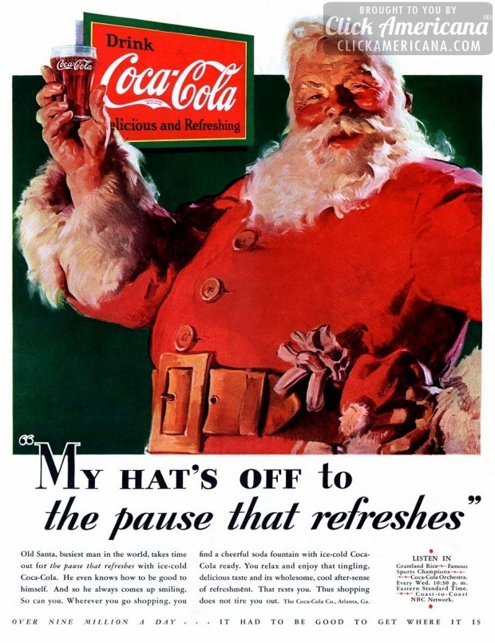
This particular Coca Cola advertisement is from America and the culture of the country is being reflected very well through this magazine advertisement (Arli, 2017). Christmas is a very significant part of the American culture and the way the image of Santa Claus is being used reflects that even he needs a pause to refresh himself amid distributing gifts. The advertisement is also ethically correct as it is not offensive, in fact, it is showcasing the joy and hustle of the holiday season. One can also see that the main essence of the advertisement is to celebrate the richness of the American culture by showcasing the most iconic holiday of the United States.
Coca Cola Advertisement in Pakistan
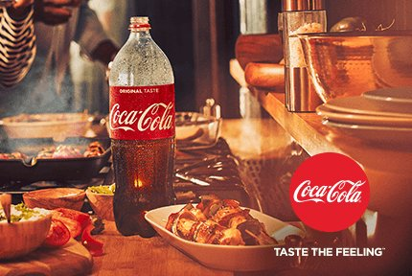
This Coca cola advertisement is gracing many billboards in Pakistan and it showcases the Pakistani culture quite well. In Pakistan the people are very fond of authentic traditional cuisine, which is usually very spicy and people like to pair it with a beverage. Coca Cola has taken that opportunity and projected itself as a drink that is a perfect pair for the Pakistani cuisine. Further, the ad is ethically correct and is doing justice to the Pakistani culture and cuisine while keeping intact the essence of Coca Cola’s mission statement. On the other hand, if Coca Cola will showcase pork meat in the food items that would be ethically offensive. Pakistan is a Muslim country that is why Pakistanis do not consume pork due to religious restrictions (Kadić-Maglajlić et al., 2017).
Coca Cola Advertisement in China
This Coca cola advertisement from a television ad showcases the Chinese culture beautifully. The brand is staying true to its mission while also incorporating the diversity needed to make a mark in a different country with diverse beliefs. In China, family values carry great importance and that is what this ad is capturing; a beautiful Chinese family having a great time with one another while enjoying a refreshing glass of Coca Cola.
Conclusion
It is evident that Coca Cola is a seasoned brand when it comes to marketing and they know how to keep things inclusive in light of the culture and the beliefs of the country they have expanded to. It can be seen in the diversity that is being portrayed by the three advertisements mentioned above (Kadić-Maglajlić et al., 2017). The brand shows that ethics and culture play a great role in advertisement, Americans will less likely consume spicy Pakistani cuisine and Pakistani’s do not eat ham.
References
Arli, D. (2017). Does ethics need religion? Evaluating the importance of religiosity in consumer ethics. Marketing Intelligence & Planning, 35(2), 205-221.
Kadić-Maglajlić, S., Arslanagić-Kalajdžić, M., Micevski, M., Michaelidou, N., & Nemkova, E. (2017). Controversial advert perceptions in SNS advertising: The role of ethical judgement and religious commitment. Journal of Business Ethics, 141(2), 249-265.

