Research Essay

Digital Value Creation Networks and their Peculiarities in the given Context

[Name of the Student]
[Course Name: Course Code]
[Name of the Institution]

[Name of the Supervisor]
[Date of Submission]

Approval Section
Approval
Project Management
Project Management
Background
Conclusion

Document History

Executive Summary
Digital value creation networks have revolutionized business practices to respond to the current trends of business environments. Companies are in dire need of transforming their systems from traditional ways to digital ways to survive and thrive in the present time. The buying behavior of customers has changed dramatically. Their expectations with the companies have increased with the rise of new technologies. Security issues pose serious threats to assets and information of companies. Products come with salient features backed by digital technology. After-sale services provide customers with convenience of maintenance and options for updating or exchanging products. Suppliers, distributors, and advertising agencies – all work in close collaboration with an organization to form a network that creates value for all stakeholders, by incorporating features of digital technology. Companies producing newspapers and information services transform into the digital value creation networks to meet the challenges of current business industries. Newspapers have found new customer segments through new channels of distribution and expedited and improved the processes of value creation with the use of digital technology. Information services provided by different industries have upended the traditional ways reducing efforts, costs, and time.

Table of Contents

Approval Section 2
Document History 3
Executive Summary 4
Table of Contents 5
Listings 6
List of Figures 6
Digital Value Creation Networks and their Peculiarities in the given Context 7
Digital Value Creation Networks 7
In the Context of Newspapers 10
In the Context of Information Services 11
References 13

Listings

List of Figures
Figure 1 Digital technology at the Core of Business Systems
Figure 2 Digital Transformation of a Business

Digital Value Creation Networks and their Peculiarities in the given Context
With the advent of new technologies, digitalization has become the need of every business. It enables a business to respond to the requirements of the modern business environment efficiently and effectively. Every business aims at creating value for the stakeholders – customers, partners, suppliers, employees, shareholders, and the community on the whole. The core procedures and processes involved in the operations of a business are designed and developed to create value. The present-day value creation process differs from the traditional ways. Today, companies engage in developing digital value creation networks to survive and compete in the business world. This paper explores digital value creation networks in the context of newspapers and information services.

Digital Value Creation Networks
A digital value creation network makes connections between processes, operations, customers, data/information, products & services, and places, based on the digital core or platform. In order to create a digital value creation network, manufacturing companies need to redesign their manufacturing processes so as to record, organize, and use the related information digitally (Zott & Amit, 2017). The service organizations need to develop their packages in a way that could be managed for use with digital technology. Alignment of products and services with digital trends needs installing compatible equipment, redesigning processes, and training of staff as per the requirements.
Customers have changed expectations in today’s market such that they are increasingly becoming used to benefit from the facilities provided by digital technology regarding the use of a given product or service. From searching for a typical product or service to buying and using it, customers have become accustomed to the use of digital features available. Networks creating digital value for customers are characterized by managing information on all levels with the use of digital devices and networks. These means of data management include computers, servers, IPs, domains, cloud computing, and many others.
Assets can be divided into tangible and intangible in digital value creation networks. Tangible assets include places, equipment, devices, hardware, and accessories related to networking, computing, etc. Intangible assets include software, Internet domains, IPs, electronic data or information, etc. People involved in these networks have to get formal training for better use of digital devices and technologies.
All the departments in an organization – manufacturing, servicing, marketing, finance, human resource, research and development, public relations, etc. – must use digital technology to retrieve, manage, or produce information relevant to their respective departments (Fjeldstad & Haanæs, 2018).
The following figure can be reviewed for having an idea of how digital technology sits at the core of a business system in today's world.

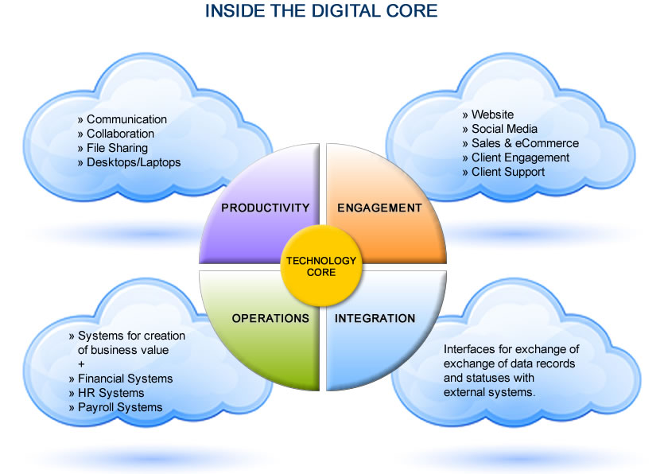
Figure 1.

Digital value creation in an organization encompasses the business system altogether. Data sharing is key to expediting information processing in an organization. Digitalization gives new meaning, scope, and strength to communication, collaboration, and file-sharing. Core processes of the organization, financial systems, human resource management systems, and payroll systems – all undergo digital transformation. In today’s digital world, companies have to engage their customers with the products and services and the digital platform of related services is necessary for this purpose. E-commerce and e-business keep customers informed well of the new products or services and facilitate the buying process for the customers. The website of the company and the sales/support services fulfill the buying and maintenance requirements of customers. For marketing purposes, different ad services are available on the digital platform and companies pursue those services for the development of their businesses. Customers are kept engaged with the company’s offers over time through the use of social media sites. People comment and evaluate products or services, and their feedback provides thoughtful information for the improvement of their offers or solutions to particular needs of customers. Finally, it is essential for businesses to thrive that they interact with the outer world and other companies and markets. These interactions should aim at exchanging useful information with the concerning entities. At the core of every business lies the digital technology that incorporates specific methods and systems into every function of the business.
Digital transformation of a company’s business can be understood through the following figure:

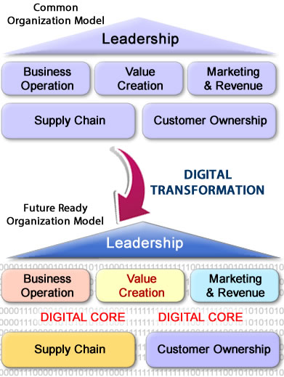
Figure 2.

The figure explains that creating value in a digital network covers all sections of the business. Business operations, value creation processes, marketing activities, supply chain management, and customer relationships – all functions are managed with an underlying digital core (Pagani, 2013).

In the Context of Newspapers
As it is evident that value creation networks have been existing since the emergence of businesses or industrialization, their digitalization only alters the way they create value by incorporating digital services into the systems and networks, to enhance performance and stability. Newspapers have long been traditionally produced in the press and provided only the printed paper copies to the customers. The relevant data and metadata used to be preserved in paper form in the stores, with no backup in another form of storage. With the rise of digital technology, newspapers can be offered in another form, the electronic copies, to the customers. A news company publishes newspapers in paper form and traditionally distributes those copies. Besides, e-newspapers are published online on the company's website from where people can view the newspaper with all the details as given in the paper copies. E-newspapers are a smart way to deliver the product (the newspaper) to the clients or users. A news company has to incorporate several features into an electronic newspaper and have to make use of various techniques and methods to realize this solution.
Digital technology incorporated in the newspapers’ value network can be observed in the company’s business relationships with stakeholders, use of technological advancements, and adaptation with the modern and changing trends of the industry (Rachinger, Rauter, Müller, Vorraber, & Schirgi, 2018). A newspaper company has to revise strategies and methods used in collaborating with the other companies or its stakeholders including the publishing services providers, reporting agencies, authorized institutions, ad agencies, consumers, and other newspaper companies. Relevant alterations to the company’s existing value creation systems are inevitable in collaboration with the services offered by the aforementioned stakeholders of the company.
To effectively manage digital value creation networks, companies need to dedicate a complete department to align the company's value network with the digital requirement of the present age. To run the company’s website and do its optimization on search engines require a team of IT experts or acquisition of an outsourcing company in this regard. The promotion of website and company’s product (the newspaper), marketing executives should be equipped with the digital marketing knowledge and skills. Big data analytics can best be employed to organize, retrieve, and produce information for different business purposes of the company. Mobile usage has reshaped the businesses to a much greater extent than it could be expected before. Users tend to perform most of their leisure as well as productive activities on their mobile devices. This calls for an adaptation of companies’ websites to alter according to the resolutions offered by mobile devices (Lenka, Parida, & Wincent, 2017). A newspaper's website must also adapt to fit the screen dimensions of mobile phone and makes it convenient for the users to navigate through the website. Further, online purchases have to be facilitated for buyers with additional services offered as part of the promotion activities.

In the Context of Information Services
Information Services can be of various types, and companies engaged in providing information services can belong to different industry segments. Digital value creation networks coordinate with these companies to digitally produce, manage, and disseminate information. Most notably, the information services used by a company today to run its business are all digitally managed; examples include legal services, market research, data processing, computer programming, insurance, banking, and many more.
For instance, a news company in the modern world engages with all types of companies related to the information services. To collect information (news), a news company has to work in coordination with information generating agencies, which provide and certify information relate to news. In this regard, mostly the news companies have their independent and dedicated function comprising reporters, informers, and others. The appropriate use of digital devices, the Internet, and services offered by digital networking agencies speed up the process of news collection and authentication (Opinion, Management, Focus, & America, n.d.). For live coverage of events, companies use varied technologies including cameras, Internet, networking, and broadcasting. All these elements prove to be essential parts of a news company’s digital value creation network. The publication services employed by the newspaper companies also make a part of their digital value creation network. The publishing companies receive information from the news companies in digital format through digital network by using digital devices. The news information is processed through different stages with the use of digital applications, equipment, and network.
Data processing is a hallmark of capabilities demonstrated by the digital value creation networks. They enable companies to process big data for numerous useful purposes. Data processed digitally through systems of analytics can be used for getting insight into customer behavior, tracking sales growth over certain period, developing cyber-security for protection of information and assets (tangible and intangible), acquiring new nosiness opportunities, retention of current customers, and bringing innovation to products and services.

References
Fjeldstad, Ø. D., & Haanæs, K. (2018). Chapter 6: Value Creation, Business Models and Organization Design in a Digital World. https://doi.org/10.18261/9788215031583-2018-07
Lenka, S., Parida, V., & Wincent, J. (2017). Digitalization capabilities as enablers of value co‐creation in servitizing firms. Psychology & Marketing, 34(1), 92–100.
Opinion, Management, S., Focus, G., & America, N. (n.d.). Network Revolution: Creating Value Through Platforms, People and Technology. Retrieved December 22, 2019, from Knowledge@Wharton website: https://knowledge.wharton.upenn.edu/article/the-network-revolution-creating-value-through-platforms-people-and-digital-technology/
Pagani, M. (2013). Digital business strategy and value creation: Framing the dynamic cycle of control points. Mis Quarterly, 617–632.
Rachinger, M., Rauter, R., Müller, C., Vorraber, W., & Schirgi, E. (2018). Digitalization and its influence on business model innovation. Journal of Manufacturing Technology Management.
Zott, C., & Amit, R. (2017). Business model innovation: How to create value in a digital world. GfK Marketing Intelligence Review, 9(1), 18–23.

