Unit 8 Discussion (Math)
Student’s Name
Institution

A graph showing Jumia’s Share prices
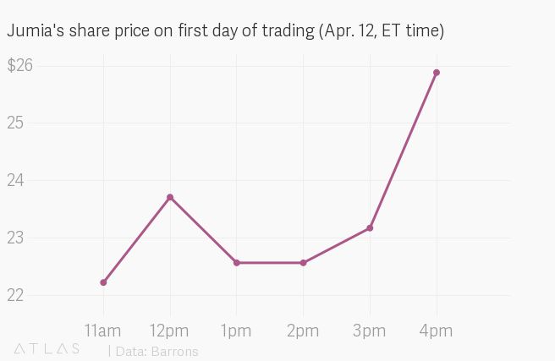
The graph compares share prices at different times on April 12th. Share prices b=avry depending on the information available. However, based on the theory of efficient market hypothesis, it is possible to determine the trend of the shares. The efficient market hypothesis theory provides that the prices of stocks in the market reflect the true prices given all factors maintained. The theory assumes that every investor knows the information available in the market.
The prices are at the lowest as the day begins and increases as the day grows. From the graph the price is at 22.4 when the time is 11 am and $26 when the time is 4 pm. From the fundamental and technical approach, it is possible to predict the prices of shares in the next few days.
The graph considers data for the whole day and produces a line with a predictable pattern. The graph shows that between 11 am and 12 pm, the prices increase up to $23.8 and between 12 pm and 1 pm, the prices drop. The price then remains constant from 1 pm to 2 pm. From 2 pm to 3 pm the prices increase at slower rate. From 2 pm to 4 pm the prices of shares increase at a fast rate implying that it is a perfect time to have a put option. Meaning that it it the perfect time to sell the shares since they are trading at high prices.
The trend of the shares implies that the shares of Jumia have broken a record since they have surpassed the market expectations. According, to the data, Jumia offered 13.5 million shars on this particular day and was able to raise $196 million. Checking on the opening stock, which was $ 18.95 per share and the pricing of the shares at $14.5 dollars, the shares on 12th April, traded from $ 22.4 to the highest of $26.
Questions
- From the graph, what is the perfect time to sell the shares?
- From the graph, what is the perfect time to buy the shares?

Reference
https://qz.com/africa/1594036/jumia-ipo-shares-up-more-than-50/

