Your Name
Instructor Name
Course Number
Date

Assignment 3
SQL is a language to deal with relational databases and is an acronym of Structured Query Language. SQL is a way to give direct instructions to the relational databases to perform certain operations. By using SQL, one can insert, delete, update, drop, create, and search the records of the databases that means all the possible functions a user may apply on a database. SQL has its own syntax like other programming languages and is quite simple and easy to understand. SQL is extensively used in all the popular Database Management systems (DBMS) including Oracle, MySQL, Sybase and Ingress etc.(“What Is a Database?”). Each function has its statements and syntax to follow in order to execute the instructions. For example, a SELECT statement is used to select any entry to retrieve data and then INSERT, DELETE, UPDATE, CREATE, DROP statements are used according to the requirement.
There are various fields in the market where SQL programmers are in demand in order to handle databases and to perform other functions. An SQL programmer writes queries, designs tables and makes sure that the queries are performed and operated at optimal speed. Jobs that require SQL skills include office administration, maintaining records of college students, SQL developer, Database Administrator, Database Analyst or Oracle developer. The job description of an SQL expert includes: coding and designing databases for data storage, modeling data to develop database structure, improving the performance of the database by creating table indexes, and creating optimized queries while working with web and application developers. For large and complex databases, an expert level SQL developer must be selected because it involves expertise and experience to be able to run and execute SQL queries in a reduced time of a few seconds to milliseconds. Before making the decision of selection of a SQL expert/developer, it is important to specify the services which are required from the person so that selection is done according to the required level.

- Run the SQL command and discuss what it does?

SELECT *FROM Countries;

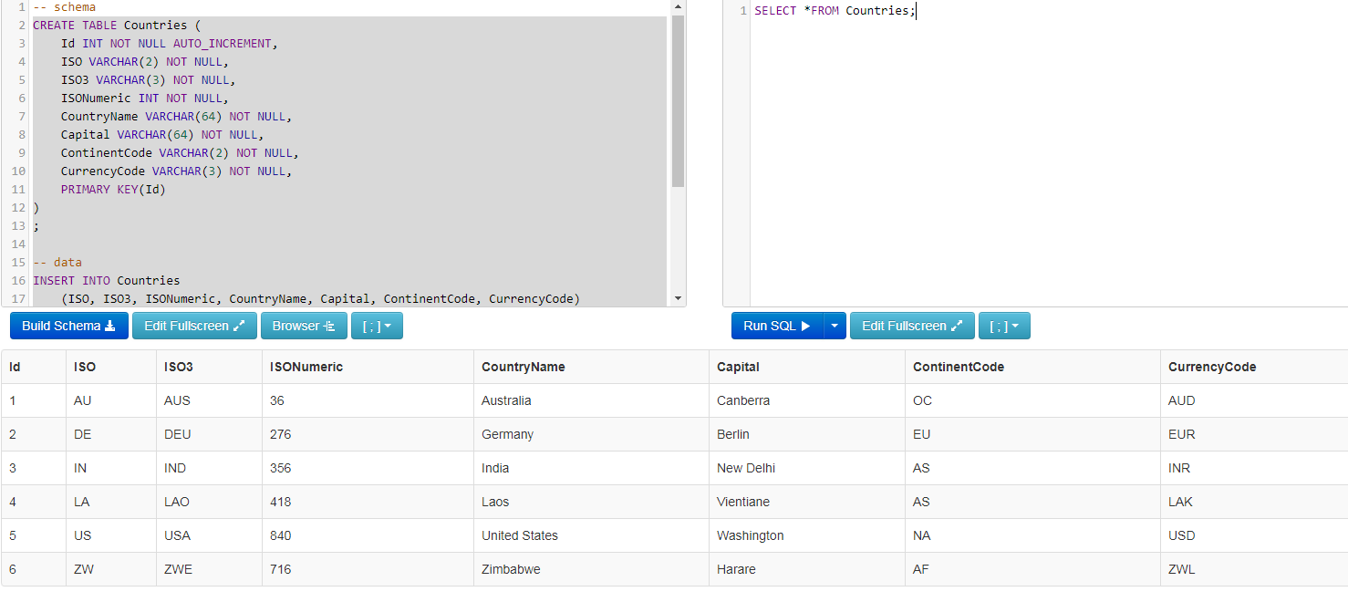

In SQL, the SELECT statement is used in order to select data from a particular database. In a database, data is stored in the form of tables that are organized in the form of rows and columns(Projects, “SQL Fiddle | A Tool for Easy Online Testing and Sharing of Database Problems and Their Solutions.”). By using SELECT statement, one can select any table from the database. In this example, we have a Table of “Countries” and by using the SELECT statement, the whole table is selected and displayed as shown above.

(B)
Replace and Run the SQL command below and discuss what it does?

SELECT*
FROM Countries
WHERE (ContinentCode = ‘AS’)

In these lines of code, we have used the WHERE clause, which is used to further specify and filter the research. In Countries Table, there is a column of CountryCode which has codes of all the countries included in the table. ‘AS’ is the code of India and Laos so, the SQL command displays all the table entries/information of India and Laos as shown below.

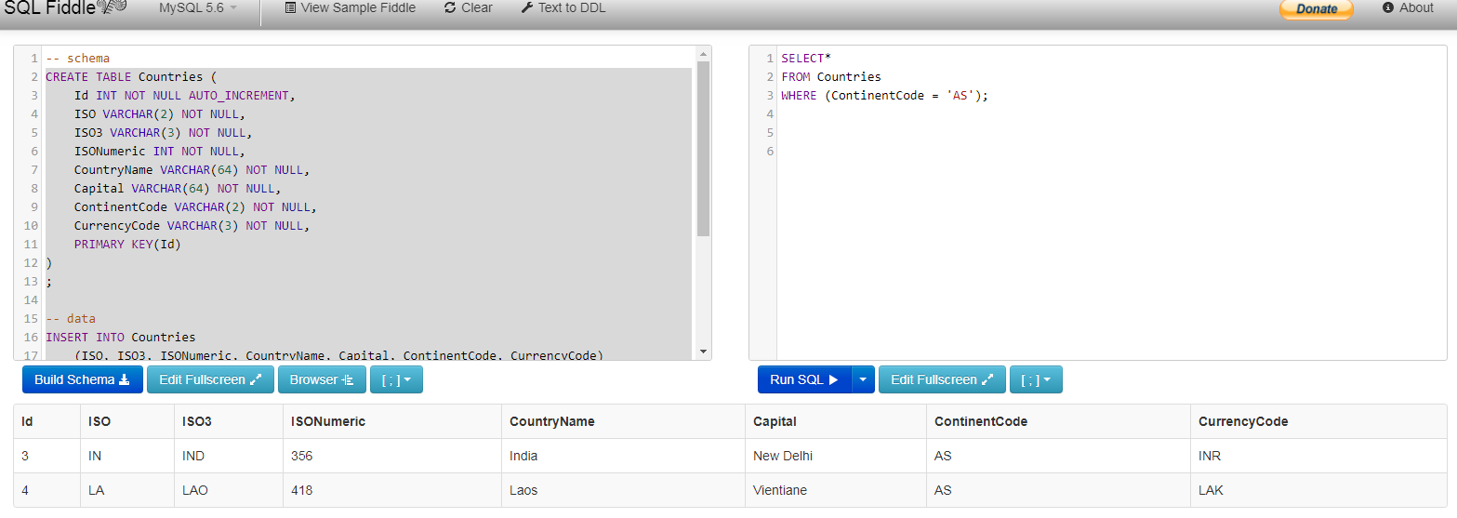

(C). Write your own SQL code which searches the continent, ‘North America’.

In order to search the continent of North America, we specify the column of Country name by using the WHERE clause in the table Countries. The code for this query is
SELECT*
FROM Countries
WHERE (CountryName = 'United States');

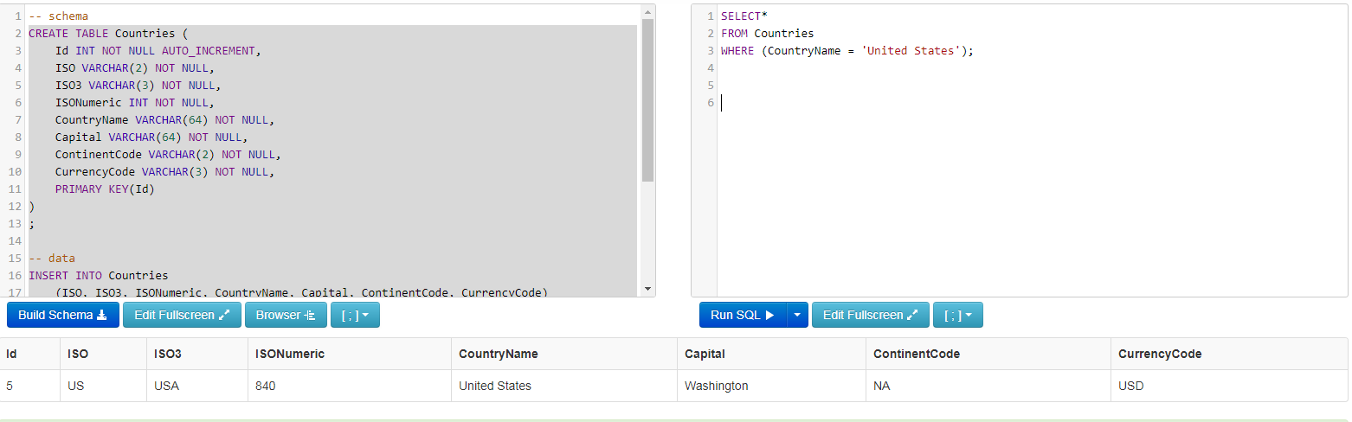

The database displays the entries of the database with information of continent North America with continent code ‘NA’ along with other information including its Capital, currency code, ISO Numeric, ISO, Id and country name details(Projects, “SQL Fiddle | A Tool for Easy Online Testing and Sharing of Database Problems and Their Solutions.”).

Works Cited:
“What Is a Database? - Definition from WhatIs.Com.” SearchSQLServer, https://searchsqlserver.techtarget.com/definition/database. Accessed 22 Jan. 2020.
Projects, Z. Z. Z. “SQL Fiddle | A Tool for Easy Online Testing and Sharing of Database Problems and Their Solutions.” SQL Fiddle, http://sqlfiddle.com/. Accessed 22 Jan. 2020.
---. “SQL Fiddle | A Tool for Easy Online Testing and Sharing of Database Problems and Their Solutions.” SQL Fiddle, http://sqlfiddle.com/. Accessed 22 Jan. 2020.
“What Is a Database? - Definition from WhatIs.Com.” SearchSQLServer, https://searchsqlserver.techtarget.com/definition/database. Accessed 22 Jan. 2020.

