Work Breakdown Structure

[Name of the Writer]
[Name of the institution]
[Date]

Project Scope Statement
Project Name
Building Renovation Project
Project Timeline
The project is starting from 03/1/2019 and will finish on 6/30/2019 if no delay comes.
Budget for Project
List of Expected Project Cost
Main Constituents of Renovation | Expected Budget
- Hiring of Project team | $50,000
- Assurance of structural stability | $5000
- Demolishment | $8000
- Major work of building | $9000
- Flooring | $5000
- Plumbing and Electric Services | $12,000
- Passage for Elevators | $20,000
- External Work | $4000
- Interior Finish | $5000
Total | $118,000

Project Objective
The purpose of this renovation project is to remodel and reshape the 2nd and 3rd floors of the existing building so that the capacity for the company’s newly established departments can be increased. The idea is to bring more efficiency in the workplace by modifying the physical space available to the company.
General Objective
The aim is to enhance the productivity of all the employees and build a comfortable and peaceful environment for the company’s staff to work.
Specific Objective
- Reorganize and repair the two floors of the building according to the potential capacity.
- To design the two departments in such a way that it facilitates the newly hired human resource.
Project Deliverables
The deliverables that will be received during every phase and at the end of the project. They are as follows:
- Renovated 2nd floor with 40 new cabins
- Renovated 3rd floor with partition of 5 rooms
- 2 additional restrooms
- 2 elevators
- Extra space for new employees
- Waiting area
- Separate meeting room
- I.T room
- Redesigned windows on each floor
- Doors for the floors
- Small room for utility services control
- Kitchen for each floor
Project Milestones
- Approval of Government Authority for renovation
- Acceptance of Planning Commission
- Framing in given time
- Partitioning
- First Fix
- Interior Finish
- External work
Technical Requirements
- Experience of Project Manager
- Earth Work in both the floors
- Fire Protection
- Weather tight structure
- Plumbing Specialties
- Insulation expertise
- Windows suitable location
- Spacing of Cabins with electronic equipment
- Proper allocation of wiring

Limits and Exclusions
Project scope document must keep in consideration which aspects are included in the project scope and which are out of project scope. Below are the functions mentioned which limits the project scope. They are:
In Scope Inclusions of Project
- Renovation of 2nd floor and the walls
- Renovation of 3rd floor and the walls
- Rebuild the roof
- Redesign the structure
- Wiring
- More space for cabins
Project Exclusions
- Not more than 40 cabins which makes other cabins congested
- Heating and ventilating
- Air conditioning system
- No material will be used which has a validity of only 5 years
- Electronic setup
- Use of Glass in windows

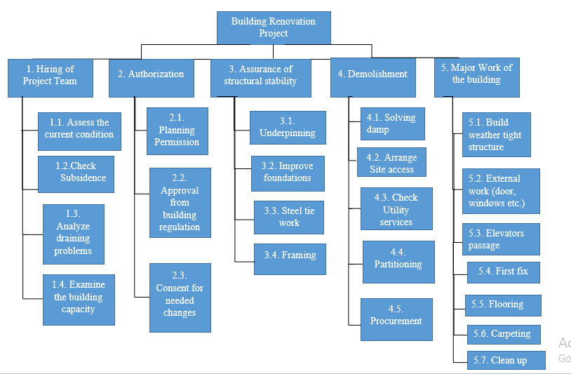
Work Breakdown Structure (WBS)

References
Lock, D. (2017). The essentials of project management. Routledge.
Lock, D. (2016). Project management in construction. Routledge.
Siami-Irdemoosa, E., Dindarloo, S. R., & Sharifzadeh, M. (2015). Work breakdown structure (WBS) development for underground construction. Automation in Construction, 58, 85-94.
Burtonshaw-Gunn, S. A. (2017). Risk and financial management in construction. Routledge.

