Strategic Communications and Media Plan
[Author Name(s), First M. Last, Omit Titles and Degrees]
[Institutional Affiliation(s)]

Author Note
[Include any grant/funding information and a complete correspondence address.]

Strategic Communications and Media Plan

Introduction
Since the advent of the industrial revolution, collective efforts have been put in action at an individual and societal level to improve living standards and increase those amenities in life which do not require much physical work. Economic growth and development have been the primary target of the governments and various consortiums of several countries. In the pursuit of extracting huge returns from investments and initial financial capitals, multi-national companies and corporations compromised the safety of future generations and did not realize how their lucrative actions are damaging the ecosystem. Within the shortest time possible, sustainable development was replaced by unsustainable development and has since imposed great suffering on the human race.
Unsustainable development meets the temporary needs of top-notch conglomerations and billionaires of the world who only constitute roughly 1% of the global population but their collective wealth is 44% of the world’s total wealth. Although a small segment of the world’s population are benefitting greatly from these multi-billion dollar corporations and the huge amounts of profit earned, at the same time the ability of future generations to have a secure environment, which is conducive for their survival, is being compromised.
According to a recently published report, which targeted a lot of subjects and various ecosystems in their findings, the human race is living far beyond what it can afford in terms of ecological and environmental resources and means. Massive exploitation of natural resources, irregular planning and establishment of infrastructure, and the resulting environmental degradation and various types of pollution are some of the dangers which pose a constant threat to the precariousness of future descendants of the current generation. A lot of adverse global conditions are indicative of the increased human demand and the alarmingly low levels of nature's supply of supportive capacities. Some of these adversities which the planet earth is constantly facing are climate change, global warming, deforestation and soil erosion, unavailability of potable water, diminishing productivity of land and soil, and extinction of wildlife species which is the biggest threat towards the survival of humans.

Dominant Narrative
The dominant narrative is based on close analogies between unsustainable development and a fraudulent investment strategy, which is essentially a market failure. Increased unsustainable investment is only possible because economic activities by different lucrative economic organizations are intentionally distanced from their actions’ outcomes (Madhavan, 2011). The perspectives by the business owners who shirk from their corporate social responsibilities present their definitions and concepts about the scopes of sustainability regarding relentless economic development (Steurer, 2005). Technological advancements and recently emerging concepts of equity with changing times and needs are accredited to when concerns are raised regarding environmental degradation. The initial investors of this deceiving strategy are the winners, but everyone who is following their steps is a victim. Even though the majority of the population is greatly benefiting from the fruits of developmental activities, people can never begin to cover the costs incurred as environmental damage. In this context, almost the entire human race is a victim of its own doing (Kopnina, 2016). The dominant narrative denies the burden of responsibility; no one wants to stand culpable for the depletion of resources and massive environmental degradation, but everyone is certain that economic growth has the means and ends for its decline. For simplicity, it can be stated that when no one will be around as an adverse effect of unsustainable development, who will enjoy the fruits of economic activity?
Literature has established two different definitions of sustainability; weak and strong, owing to its intensity and the degree of threat posed by either one of them (Shang, 2019). These descriptions are also ill-defined in their inherent nature because sustainability is largely based on the extent of substitution between the natural sources meant for the human race and man-made capital.
One of the key factors which pave way for the currently prevailing narrative of unsustainable development is a wide scope of deception which is directed by those who benefit from economic development and are only slightly affected by its adversities. The current living standards are represented inaccurately and the levels of investment to meet the global demands are also wrongly propagated and interpreted.

New Narrative
Stories based on reality are needed for guidance and correct understanding of how severe the issue of unsustainable development is. Currently, extant heroic narratives which indicate towards magical realism and courageous actions solving some of the biggest problems in the fraction of a second are no longer helpful and a new narrative which is fully based on real facts and figures should be spread (Darby, 2019). Finding new and pragmatic solutions for unsustainable development is extremely necessary if we want to ensure the continuity and survival of our future generations and ultimately of the human race.
Our organization, “Environmental Defense Fund”, will help build the new narrative through a series of actions and tactics so that individuals, different associations and policymakers give this issue bigger part of their time and a major effort is allocated towards its resolution.
The manifestations of unsustainable development (e.g. depletion of the earth's assimilative capacity, a growing legacy of environmental degradation which is being transferred from one generation to the next and the decline in quality of living standards) are evident in the contemporary world and the new narrative will revolve around the gravity of this problem. The potential theme to build the new narrative would be to make people realize that all these economic activities at the cost of environmental degradation which are being regarded as steps towards utopia, are a catastrophe and no one will be exempted from its harmful effects. Everyone is equally responsible, and everyone is equally a victim.

Slogans, Hashtags or Memes

Slogans
Environmental Defense Fund will use the following slogans for spreading awareness:
- Earth Day- Each day, Earthy day
- Resist Plastic---- (& patriarchy)
- Think Sustainable- Live Responsible-
- Keep calm and cut carbon!
- I object- to NOT developing sustainably!
- Who owes ecology an apology? You, me and modern technology
- What will your children drink?
- What will your children breathe? What do you breathe?
- Where is the Environment?

Hashtags
#SustainableDevelopment #sdgs #mdgsHaveDefaulted #TimeToWakeUp #NoFoodForTheFuture #Pollution #LetsNotFoolOurselves #UnsustainableDevelopment #GlobalGoals #CarbonFootprint #LessIsMore #Recycling #WasteDisposal #CorporateSocialResponsibilty #CorporateSustainability #Environment #ClimateAction
#ecofriendly #LivingInIgnorance #corruption #accountability #ponzischeme #fraudulentinvestment #temporarybenefits #dyinggenerations #nofuelforfuture #nowaterforfuture #nowater #nolife #growingeconomies #cleanenergy #reduceconsumption #humanplanetinitiative #conservationoflife #cutcarbon #thanksbutnothanks #noplastic #globalchoices #teachsdgs

Memes
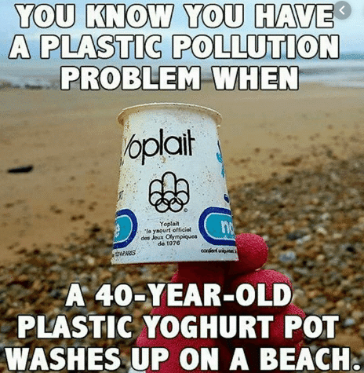
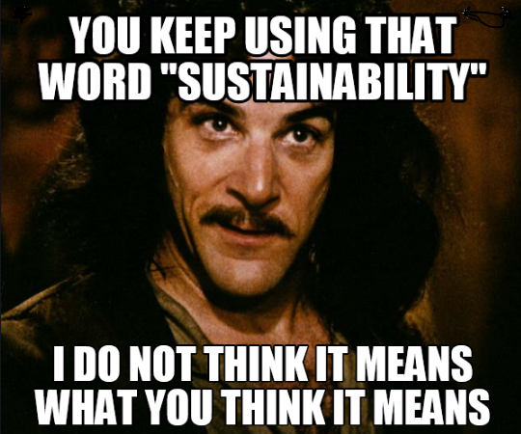
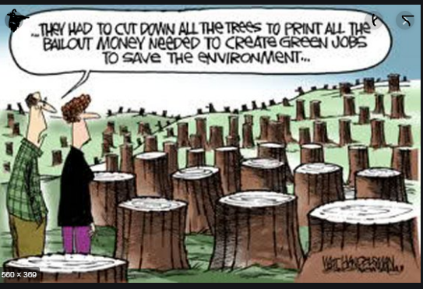
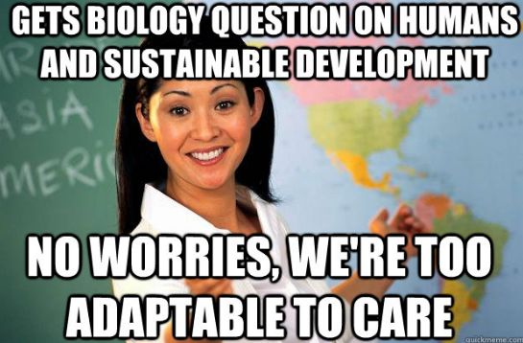

Goals
The long-term objectives of our campaign are:
- Addressing a wide range of social needs of the local community involving food security, potable water, sanitation facilities, job opportunities
- Tackling climate change locally
- Preventing the environment in a small capacity
- Safe removal and management of solid waste
- Bringing a decline to air pollution by launching another ‘no smoking’ campaign
Intermediate goals:
- Raising awareness
- Promotion of an active dialogue among the general public and the stakeholders of the multi-billion dollar companies
- Establishment of live web lectures and informational videos about the dangers of unsustainable development
- Talking to people (word-of-mouth)
- Addressing the children in schools and parks and teaching them the grave consequences of unsustainable development through skits and dramas.
The campaign will win concrete improvement in peoples’ lives by educating them and the children in the local community. It will be a two-process where all the agents of socialization will actively learn from each other and adapt practices on securing the future for coming generations. The people of the local community will have a complete sense of autonomy on the amenities they use and on the proper ways of waste disposal which they were previously unaware of.
Some short-term or partial victories that can be won while moving towards the long-term goals are proper practices of waste disposal being implemented in the local community, and awareness developed among the children who have impressionable brains and thus will become functional citizens of the society in the future.

Organizational Considerations

Resources
The staff of the organization including local policy specialists, event managers and digital strategists will put in their services for this campaign.

Budget
Following is the budget breakdown for this campaign:
- Office
- Office rent and utilities
- Phones
- Phone cards
- Printers
- Computers
- Toner
- Internet access (it was present but need to update the speed)
- Tea/coffee
- Postage charges
- Volunteer charges
- Printing/Photocopying
- Flyers/leaflets
- Invitations
- Photocopies
- Other paraphernalia (stickers, signs, banners, slogans)
- Fundraising
- Events
- Meetings
- Gatherings
- Staff appraisals
- School visits
- Park visits
- Contacts
- Community meetings
- Door-to-door canvassing
- Meetings with stakeholders and their acquaintances

- Media and Communication
- Radio ads
- Newspaper ads
- Website updates
- Press releases
- Billboards
Specific Ways in Which the Organization Will Be Strengthened by This Campaign
The Environmental Defense Fund will be strengthened by the promotion of an enabling environment, the involvement of all the stakeholders in dialogues regarding future policy and monitoring and evaluation of all development activities.
Internal Problems to Be Considered
The internal problems of the organization do not add much to form a barrier in the way of this campaign because this organization is a non-profit, allocating all its resources and collective effort to save the planet from the harmful effects of unsustainable development. Apart from running short of expenses and some discrepancies in the budget, there are no internal problems of the organization to be considered.

Constituents, Allies and Opponents
All participants of the campaign who are affected by the problem will be the constituents. Some influential members of the local community such as political leaders, clergy will also be involved. The discussion will be done with them in advance and they will be apprised of the different events of the campaign.
Chief executive officers of the local civic organizations working for the welfare of the local community are the allies of our organization and will also support the cause of our campaign.
The owners of the plastic utensils businesses are the opponents of this campaign and they may pose barriers in the smooth working of our campaign.

Tactics

Meeting with the state minister

Vigil

Demonstrations

Report on the economic impacts on the environment

Newspaper advertising

Actions for information and public hearing
All the above-mentioned tactics are directed at specific targets and are flexible and creative which will engage the interest of a large number of people from the public community.

Timeline
This campaign will take 2 weeks and then on the evening of the last day, a fundraiser will be conducted for donations and charity works for the unprivileged section of the community.

References
Darby, S. &. (2019). Between and beyond social entrepreneur and activist: Transformative personas for social change. ACME: An International e-Journal for Critical Geographies, 724-750.
Kopnina, H. (2016). The victims of unsustainability: a challenge to sustainable development goals. International Journal of Sustainable Development & World Ecology, 113-121.
Madhavan, S. &. (2011). Unsustainable Development: Could it be a Ponzi Scheme? SAPI EN. S. Surveys and Perspectives Integrating Environment and Society.
Shang, C. W. (2019). Weak sustainability is not sustainable: Socioeconomic and environmental assessment of Inner Mongolia for the past three decades. Resources, Conservation and Recycling, 243-252.
Steurer, R. L. (2005). Corporations, stakeholders and sustainable development I: a theoretical exploration of business–society relations. Journal of business ethics, 263-281.

