Name of the student
Course
Name of the instructor
Date
Political Cartoon
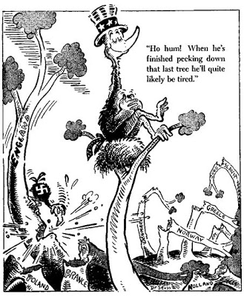
- What is the main message of the cartoon?
America thinks that it is invincible, untouchable and complacent that Germany would be wearied out before it begins to attack it. Dr. Seuss mocked this attitude of isolationism and tried to deliver the message that America needs to step up and save its fellow European countries.
- What event, issue or person does the cartoon refer to or target?
The cartoon refers to the event of World War I. The bird pecking on the trees has a Nazi symbol on it representing Germany and the other bird sitting on top of the tree is wearing Uncle Sam's hat representing the United States of America.
- Is the cartoon trying to persuade or inform? Is so, what and how?
The cartoon is trying to persuade the American people that they should come out of their zone of contentment and isolation and consider the possibilities of a combined attack of Axis on the United States. It is also a call for America to gather its resources and take a definite stand against the vicious turmoil that had been smashing Europe apart.
- What reaction or impact is Geisel looking for?
Geisel is looking for a change in the attitude of American people towards the mayhem of World War and how it can bring chaos in Europe and eventually in the United States.
- What devises are used to get this message across?
The devices used in this cartoon are symbols, irony and captioning and labels.
- Choose one of these devises and discuss it in detail.
The captioning and label devise used in this cartoon is a prominent feature as it clarifies the meaning by putting the Nazi party symbol on the bird and writing names of the countries that had been attacked by Germany on the pecked trees. There is also a caption that further elucidates the objective of this cartoon.

- How has Geisel drawn the people/animals? Are they distorted or exaggerated? How does this affect the impact of the cartoon?
The woodpecker that represents Germany in this picture is a small weak animal, while America is represented by a big bird with its eyes closed, sitting on top of a tree and wearing Uncle Sam’s hat. The pecked trees represent the European countries that have been attacked by Germany.
- Is the cartoon effective? Why or why not?
This cartoon is quite effective as it highlights the irony that how the United States is oblivious to its surrounding nations. The big bird with closed eyes on top of the tree depicts America's hegemony and isolationism. The ironic and satirical tone makes it very effective.
- What would make this cartoon more effective?
This cartoon could be made more effective by adding some caricatures for the American and German leaders to embellish the comic effect.
- Do you think cartoons are a good way of communicating a social or political message? Why or why not?
Yes, cartoons are a good way of communicating a social or political message as graphics help in persuading and understanding any issue with critical analysis. It also delivers the cartoonist's point of view and shapes readers' views without even having them realize.

