Name of student
Name of institution
Name of instructor

Business platform
Summary
Marijuana is one of the products that is illegal in many countries though there are measures in many parts if the world to make it legal. Many people who use the product always have to face many hassles before they can get the best quality that they need. We saw this as a business opportunity. It can be easy to bring the dealers with their clients closer to each other so that we can reduce the time duration that the clients always take before they can access the best quality of the product from the market. One problem that people have also had in the past is that they fail to find other users who can be willing to discuss with them a lot of things about Marijuana. On the normal social media platforms, it is not easy to start such discussions as a result of stigmatization and the kind of laws that control the usage of the product. Bud-ee is a social media platform that will be used to bring together all the users so that they can find where to interact without the fear of interfering with community rules. The major idea behind the app is that many people have always created offline groups where they can discuss the issues they have concerning consumption of the product. People who use the product find it hard to interact with each other on platforms like Instagram and Facebook. Such content is regulated and it might be easy for marijuana enthusiasts to find room for discussion of the things that affect them. In case such people fail to find people who can understand them they always feel that they are not understood in the society. Most of them end up being lonely as a result of being judged by the rest of society. We shall look at why this is a viable business opportunity that should be supported.

Moving to an online platform
Currently, there are many people who wish to find other people they can talk to about Marijuana but they end up not getting any because of the rules. Some of the people have come up with offline groups where they meet and discuss on the value of the product as well as the things that can be done to improve it. Mostly, such people always find it quite hard to involve other people who are far away but are so interested in the discussion. Bud-ee will help the people to also get an online platform where they can interact with other like-minded people. The use of the internet is something that has enabled many people to interact with other people across the world. Marijuana enthusiasts would also love to interact with other similar people across the world. It is through such interactions that they can learn of the improvements that have been made in other parts of the world. The online platform will also reduce the problems that users always go through as they try to get the best quality of the product. Just like the market for any other product, it is infiltrated with low quality products and this poses a challenge for the clients. The app will together sellers and buyers. Clients will share information on where they can get the best quality products for their personal use.
Business sustainability
Both the business of the dealer and that of the app will depend on the number of people who are using the app. Clients will mainly depend on the apps so that they can know the dealers who sell the best quality and are closer to them. The sellers will also find it easy to market their products because they will have access to the clients. As a result of the stigmatization and laws that control the consumption of the product, it is not always possible to market it and this has a negative effect on the growth of their businesses. With the help of such a product, they will have access to people who are only mainly interested in the product. They will also learn from the clients about the improvements that they need on the product so that they can serve them to the best. There are a lot of discussions about the consumption of the products. Many countries are legalizing the usage and this will mean that more people will be willing to use the app so that they can interact with their fellow users of the product.
Supply chain code of conduct
Since there are many people who sell low quality products in the market, the app will eliminate them from them from the market. If every user of the product they will learn how to avoid the cons who sell low quality products in the market. Before a seller is allowed to get into the platform, he or she will have to undergo serious scrutiny so that they prove they are selling the best quality. By ensuring that only those suppliers who are licensed to sell the product are on the platform. This will be done after ensuring that they have good history in the business. In fact, this is a factor that will drive many users to join the platform because they can be sure to get the best quality marijuana at the best rates in the market.
Mitigation of the risks involved in marijuana consumption
The major risk that people have always had in the past is the fact that they do not always know which quality they should go for. It is a problem that has led to many users buying low quality marijuana that has been mixed with other products. Any person would be greatly concerned with the products that they consume. Some people make use of the product for medicinal purpose. In case they are exposed to such risks, it ends up bringing more problems to their health. The use of this app will remove such fears because only those trusted dealers will be on the platform and clients will not be worried about buying products that can cause health problems.
Social interactions
Apart from using the platform to purchase and sell marijuana products, it will be a platform where people who the product can interact. For a long time, this group of people has failed to find a place where they can talk about interfering with the peace of others. The other social media platforms are for everyone and it would not be appropriate to bring up such a topic. They also need a platform that can give them the freedom they need so that they can interact with one another. Bud-ee will help them to share information about the things that they should be discussing about the product. Clients always need to learn about new specifications that have been added to the product and the manner in which they can also improve their consumption. Sellers will also see the improvements that other sellers are making on their products so that they have the best products for their clients. It will not only be a market place for the marijuana products but will also provide a space where the people can talk freely without the fear of being judged. There are people who cannot talk about the product as a result of the fear of being judged by other people. Illegalization has made other people who do not use the product to pass stigmatization on the users and it is not good for the users. The app will help them to meet other users so that they stop being lonely.

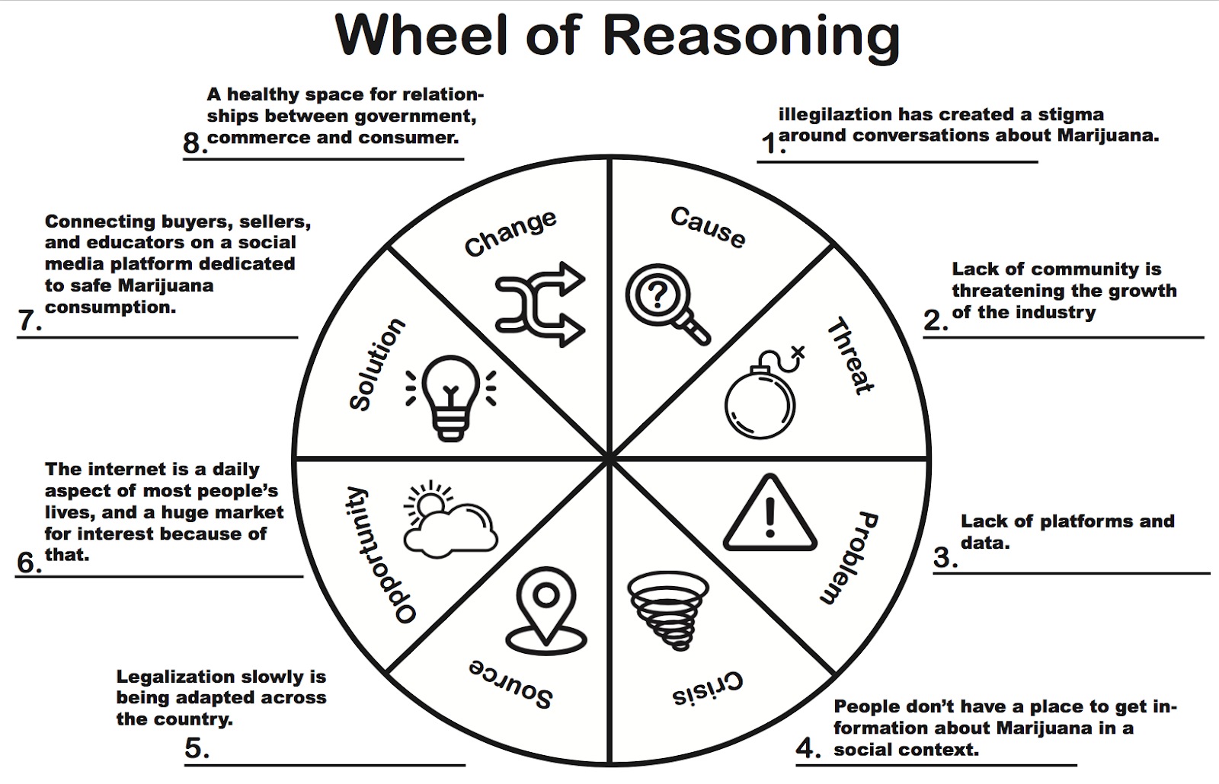
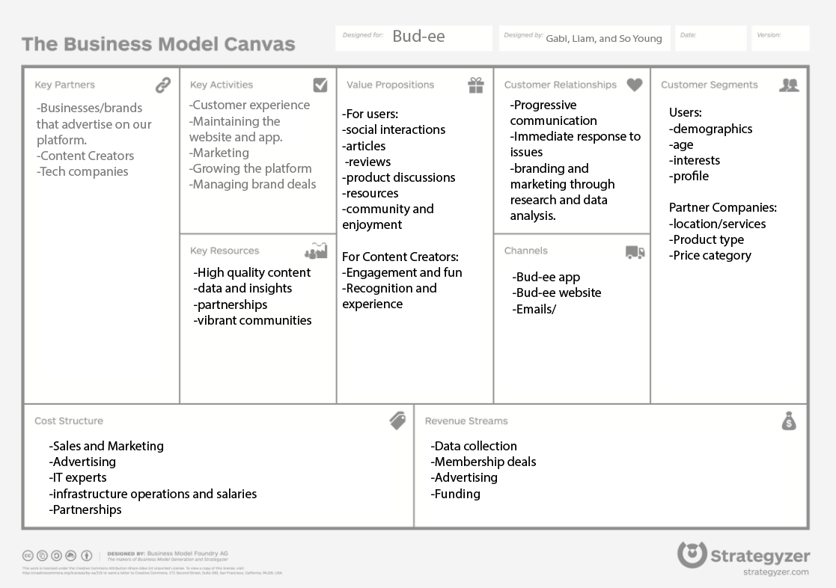

System map
