Supply and Demand Outline
Your Name (First M. Last)
School or Institution Name (University at Place or Town, State)
Apple iPhone 6 plus
The iPhone 6 plus is one of the famous product of Apple company. It got popular due to its battery life, advertisement, high functionality, and easy to use. Sale of iPhone 6, 6s, and 6s plus in America is about seventy-four million, seventy-seven million, and twenty million respectively. Approximately 170 million iPhone 6, 6s, and 6s plus is sold. In the first three days ten million iPhone 6 and 6 plus is sold. In U.S cost of iPhone 6 plus vary according to its version. Cost of 16GB, 64GB, 128GB, would be 299, 399, and 499 dollars respectively. Off-contract cost of iPhone 6 plus started from 749 dollars for 16GB to 849 dollars for 64GB, and 949 dollars for 128GB version (“Apple Announces iPhone 6 & iPhone 6 Plus—The Biggest Advancements in iPhone History,” n.d.).
The stock of iPhone was going down whereas androids were rising in the stock market. After the launch of iPhone 6 plus, Apple stocks start rising. Demand for iPhone 6 plus exceeded than expectation. Apple increased its supply chain to raise its production. Shipment of Three to four million units falls to manage the new production lines. Due to the increase in demand iPhone 6 plus remain out of stock in starting consistently. Supply readjustment took time which means there would be the time lag between retail availability and supply management.
Two main factors that are the increase in price substitute and fall in the price of complement can lead to the shift in demand curve from left to right. If the demand increases for the competitor's products due to advanced features, excellent advertisement strategy can shift the demand curve of iPhone 6 plus to the left.
The demand for iPhone 6 plus was recorded more than expected due to which supply curve shifts to the right from left. The main factors that moved the supply curve from right to left include the popularity of product with high profile advertisement and advanced features of the product. To meet the demand, supply needs to increase, and factors like the technique of production and the increase in resource price lead the supply curve shift from left to right.
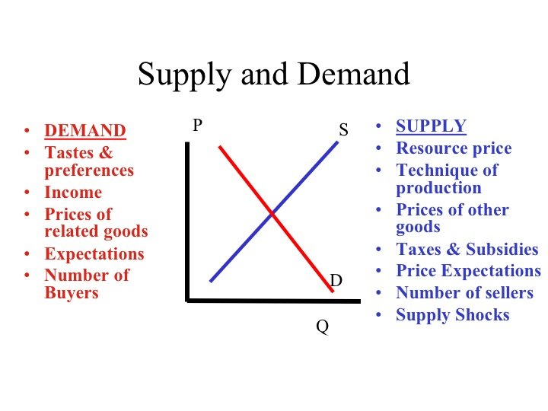
The above graph shows the factors which affect the demand curve. It includes taste and preferences, expectations, the income of the consumers, total buyers, and expectations. Supply of iPhone 6 plus also depend on different factors some are resource price, the price of other goods and expectations, supply shocks, taxes, subsidies, and technique of production (Mayo, 2014).
Price floor or price ceiling in the iPhone 6 plus would benefit consumers because Apple Company is in control of iPhone 6 plus pricing. It is like government regulation of the price floor. Where Apple make sure that the price doesn't rise from a certain level even when the demand is too high than the supply chain. This means the only option for the company is to change the supply chain rather than increasing the price of the phone to decrease the demand. The ten million iPhone 6 plus sell out in just three days of launch results in profit for not only producers and distributors but also for the consumers (Straub, 2015).
iPhone 6 plus leads the Apple stock high in starting but later on it results in market failure due to many issues. Issues of touch screen and bending screen results in decreasing the demand of the phone. Also, issue rises due to the warranty that is whether the consumer can get repaired set or not. Another issue that came into notice was the camera of the iPhone 6 plus. Many complain received about the blur images even when the consumer keeps the iPhone still. iPhone 6 plus is not the complete market failure, but issues decrease the overall demand of it (“Apple’s iPhone 6, 6 Plus are failing early thanks to ‘touch disease,’ bending problems - ExtremeTech,” n.d.)

.

References
Apple Announces iPhone 6 & iPhone 6 Plus—The Biggest Advancements in iPhone History. (n.d.). Retrieved January 12, 2019, from https://www.apple.com/newsroom/2014/09/09Apple-Announces-iPhone-6-iPhone-6-Plus-The-Biggest-Advancements-in-iPhone-History/
Apple's iPhone 6, 6 Plus is failing early thanks to "touch disease," bending problems - ExtremeTech. (n.d.). Retrieved January 12, 2019, from https://www.extremetech.com/mobile/234552-apples-iphone-6-6-plus-are-failing-early-thanks-to-touch-disease-bending-problems
Mayo, B. (2014, October 7). With stronger than expected demand for iPhone 6 Plus, Apple reportedly shifting some production away from iPhone 6. Retrieved January 12, 2019, from https://9to5mac.com/2014/10/07/with-stronger-than-expected-demand-for-iphone-6-plus-apple-reportedly-shifting-some-production-away-from-iphone-6/
Straub, M. (2015, September 22). Pewaukee Economics : The iPhone 6s Is Going To Be Big! Retrieved January 12, 2019, from http://pewaukeeeconomics.blogspot.com/2015/09/the-iphone-6s-is-going-to-be-big.html

