Bahamain Artist/Painter
[Name of the Writer]
[Name of the Institution]

The artist I chose to write about is Christophe Roberts
Christophe Roberts is an American- Bahamian artist who was born in 1980. He has learnt many art disciplines including painting, graphic design, sculpture and direction. He uses everyday objects like building materials and shoe boxes. A famous saying of him goes as “A true artist can use all the tools in his box. His style transcends through multiple platforms, from digital, to organic, to textile.”
Roberts’ aunt, Gloria Ward, was a fashion and production designer and has worked for many artists and films. She was an early influencer for Roberts. Roberts was into art from an early age. He saw Anacron as a role model in his young age. Anacron was a dancer, rapper, producer and a graffiti artist. The art piece that attracted Roberts to multidisciplinary art was the KRS-One concert.
Roberts earned his bachelors in arts degree from Cornish College of Art based in Seattle. He studied film, web design, music and illustration. Robert also went for an independent study at Brooks university. Seeing the paintings of Pablo Picasso inspired Roberts towards painting. He started to sell modern cubist paintings and also recorded hundred songs in Seattle. He came back to Chicago in 2006 and continued selling his paintings. He took part in many group shows and created associations with many art spaces. And in 2010 in New York, the Lyons Weir Gallery exhibited his paintings. He mainly painted animals and also working as a graphic designer. Then Robert focused on innovating his sculptures that he made using the Nike shoeboxes and for this reason he is also featured on the brand’s website.
Roberts cites the animal figures as the “metaphor for his ambitions”. Later he shifted to Harlem and started designing T-shirts for brands. Then Oliver “Power” Grant of Wu-Tang Clan asked for his collaboration for a show for Wallplay Gallery. That same year, Roberts installed at the Complex Magazine office. Robert now lives in Brooklyn and his focus is sculpture, designing and painting. his work has been exhibited in many times since early 2000s. he had his work exhibited in wallplay gallery in 2013, initiative gallery New York in 2014 and Nike air max con in 2016. People have seen his work at the NEXT Fair, as part of Artropolis. He mixes in his work all the disciplines of art he has learnt. His paintings and sculptures are powerful and complex and convey strong meanings.
Christophe Roberts work is fun and creative. Wherever his work is displayed, it is the front and center of the show. His sculptures made of shoe boxes gain the attraction of everyone. His work is more innovative than many artists (Scaldaferri, n.d.). His style is unique and he inspires many young artists through his work and style. His sculptures are not only cool to see but also carry different perspectives and messages. He expresses masculinity, bravery, emotion and ambition. Like the bird sculptures he makes from the Nike shoes boxes are a symbol of the friction between the longing of consumers for the brand’s products and the satisfaction they get from buying them. Nike produces quality products and the sculptures add to the level of loyalty of the brand’s customers. The formation of the bird sculpture hints at qualities like aggression, determination and strength that are very important qualities for an athlete.
Roberts not only asserts on just making art. He contracts vast perspectives and strong emotions into his artwork. For example, the eagle sculpture made from the shoe boxes depict strength, positivity and value. These are the most essential qualities for a person and anyone who wants to live his/ her life on their own terms. His work creates a perspective for the onlookers and it has been pretty much appreciated. It also influences the youth as in how they se themselves and the legends who lived before them (Newsinger, n.d.).
Roberts has been featured by Nike and he is the only artist featured by Nike on its website. The pigeon sculpture that he made from the shoe boxes of Jordon and air force. This sculpture was created for the legendary Jeff Staple. The pigeon symbolizes the ability to thrive and positivity.
Christophe Roberts has always used shapes as an element o his work. These shapes possess symbolic value to him and he uses what he needs to use to express an emotion. He has been incorporating this thoughtful process into his work since a very young age and this practice has enabled him to create the big abstract artwork and he knows well how to metaphorically present his sculptures as messengers of ambition and emotion. He has used both digital mixes and carving that further make his work commendable and authentic.
His artwork seems to be a mix of the characteristics of a hustle and bustle of a space and also what he or another person perceives and questions about it. Many things have influenced the artist to follow this path i.e. art but mainly it was the hip hop culture. And he went on to produce music (Newsinger, n.d.). In his artwork, one can see the impacts from other artists work like McFarlane and Jacob Lawrence.
The accuracy, precision and technical aspects of his art can be attributed to his education in art at the Cornish College of the Arts in Seattle, Washington. He has said that the education and training at his college made him to aspire for more and not confine himself to one type of art. He is of the opinion that creating only one type or art is like limiting one’s creativity. So he left Chicago to travel to learn and explore many cultures that made him the artist he is today.
The other forms of his artwork like his paintings and music are also well appreciated but it is the sculptures that gain the most traction. And he has been able to sell many pieces of his sculptures (Ginsburgh, 1996).
In addition to art, Christophe has adequate knowledge of technology and this enables him to create a balance between his freestyle and the art of executing in a scientifically careful manner.
Roberts residence at the New York city and his association with Nike has helped him a lot as an artist. Nike has appreciated Roberts’ work even if it seems to oppose and protest the practice of capitalism that the brand operates along. Christophe’s ability to create a work that resonates with him and his experiences so well have enabled him to bring together his creativity and personal perception. And he has proved himself to be an artist of value. The huge eagle sculpture he has created is related to the legendary JFK and he wishes it to influence the younger generations as how they see their legends.
Christophe Roberts is an artist who has made his way up the ladder through hard work and dedication. He is an inspiration to the next generation of artists. He is the personification if the concept of hard work and determination. I chose to study him because I believe that the artists of this era can be better inspired by the living legends. Although the older generation of artists has had many great artists like Amos Ferguson and Francis but their time was different from today. The artists need to look up to someone who has had relatively similar situations and opportunities like them and ho they have defied the gravity and made it to the top. Classic artists are admirable and are respected but todays artists need to work according to the current trends and circumstances. Roberts is a living example for the aspiring artists out there and is influencing many of them. He has proved that one can succeed on his own. Even without having unfair advantages over others or availability of resources and favorable circumstances, one can achieve what he/ she wants to. His art brings out the energy and the power from those sculptured animals and transfers it into the onlookers. His way of taking the ordinary and transforming it into something beautiful is exceptionally amazing. To succeed in life, we need to search and follow real life examples. One can create his work following his own will and defy the norms and can excel. It is of course very important to have adequate knowledge and skills about the work, but creating new and unique artwork can also be loved if it has value and meaning. In the world there are many artists and creative thinkers who have immense talent but just not the right direction or opportunity/ platform. Christophe Roberts is a guiding light to them. He is the manifestation of creating one’s opportunities for oneself. He is kind if an artist who has presented what art really is. Art is being yourself and making your own. Art is not what stereotypes but it is the thing that breaks the stereotypes. Art is something that makes life easier and pleasant.
Attached below are the images of art pieces discussed above.
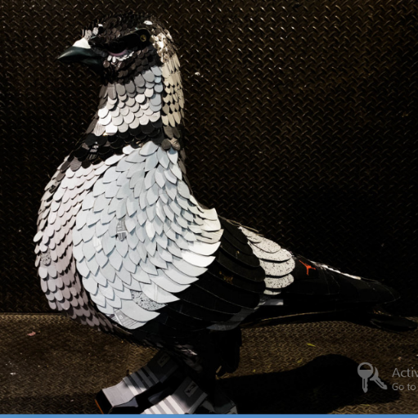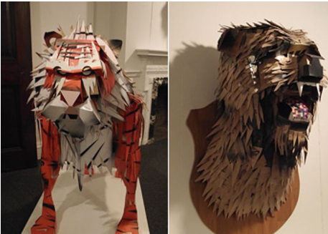

References
Ginsburgh, V. (1996). What is wrong with droit de suite: The economic arguments1.
Newsinger, J. (n.d.). Lobster.
Scaldaferri, G. (n.d.). Art in the Bahamas | Top 10 Contemporary Art Galleries. Retrieved March 30, 2019, from Culture Trip website: https://theculturetrip.com/caribbean/the-bahamas/articles/art-in-the-bahamas-top-10-contemporary-art-galleries/

