Name of student
Instructor Name
Art 101
10 October 2019

Internal Assessment
The article is written by William G. Gale in which he expressed his concerns about U.S. budget office release regarding an unusual combination of lower interest rates and high federal debt. The author states that the current situation will lead the economy towards financial cries. Even after the low-interest rates, and the country is operating at almost full employment the fiscal outlook of U.S economy is traumatic (Perspectives)

Reasons
During the recession, the fiscal deficit of the U.S economy was on a hike. Up till now, the economy has grown and is operating at full employment level; still, the fiscal deficit is continuously rising. According to Gale, the reasons behind this critical situation are lower interest rates and high federal debt. The diagram given below will help explain how lower interest rates give rise to the fiscal deficit.
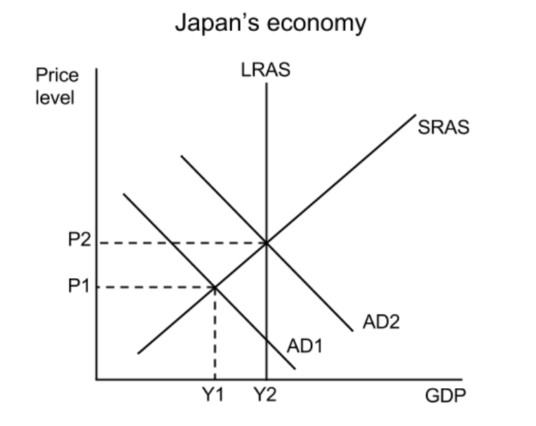
P → Price Level
Y → Aggregate Supply
AD → Aggregate Demand

Channel
Lower interest rates make the borrowings cheaper, intended towards more spending and investment. The increase in spending and investment, leading to higher aggregate demand (AD2) and economic growth. The rise in AD may cause inflationary pressures (P1 to P2). The shift in aggregate supply from Y1 to Y2 is because of an increase in Government spending (Investment) due to a lower interest rate.
Theoretically, a lower interest rate reduces the incentive to save, encourage borrowings at cheaper rates, lowers the mortgage interest payments, and give rise to asset prices. It is terrible to think about how expensive would it be for the U.S government to pay such a huge amount of debt if the interest rate jumped high again shortly.

Explanation
The U.S government is making a lot more payments for Medicare, Medicaid, Social Security, and interest on the debt, giving a hike to government spending, which further adds to federal debt of the country. The lower interest rate, on the one hand, helps the U.S. government to borrow more spend more and consume more. But on the other hand, the pre-funding policy for social security and Medicare necessitates higher taxes (for pre-funding) or reduced spending (cut down the need for pre-funding), making the program defenseless in recessions.
The figure below shows a shocking situation of Debt/GDP ratio of U.S economy.
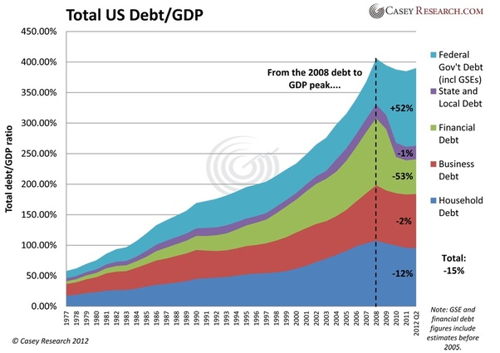
Increase in fiscal debt is continuously followed by financial, business, and household debt just because the borrowings are cheap. People keep on borrowing and consuming more with fewer savings. But once the interest rate rises, there will be a heavy debt burden on the whole economy.
Low interest on federal debt is not a blessing for U.S government, but it is more expletive, because it makes borrowing and spending easy; logically, federal interest payments should be even higher than they are today. For this, policy-makers should opt for more investment followed by deficit financing, in human capital, research and development, and infrastructure despite lower interest rates, for sustainable growth in the long run.

Conclusion
From the above discussion, it is concluded that as long as low-interest rates and high debt to GDP ratio continue together, there is nothing to worry about. The problem will arise when high debt leads to higher interest rates. There will be extreme pressure on all the macroeconomic indicators, including consumption, investments, government spending, and balance of trade. Government of America should be worried about the rising fiscal debt and Artificially lowered interest rates because the situation is leading to malinvestment, which will lead the economy towards massive capital accumulation, deflation, and ultimately depression.
While writing his perspective on the current US situation, the author ignores the role of public behaviors in response to the changes in tax policy. The author suggested a long-term solution to the aforementioned problems that policy-makers should opt for policies like phased-in consumption taxes (progressive consumption taxes) and a carbon tax to incentivize people and industrialists to increase the spending and production. But he ignores the fact that substituting the tax systems would penalize the existing wealth holders when they try to spend their accrued savings, which have already been taxed (income tax). However, investment boost in social security and rising increasing competition in health insurance markets will reduce medical expenses and will reduce the need for pre-funding.
The long-term solutions suggested by the author will work, but there is no policy recommendation to avoid the exogenous shock in fiscal debt if in case the interest rate goes up due to any reason.
Above all, the long-term deficit financing will surely provide insurance against the threat of rising interest rates soon. Gradual debt reduction policies will allow the investor to cope up with his business plans, and ensure certainty about future initiatives.

Works Cited
Perspectives, William G. Gale for CNN Business. "Opinion: Don't Be Fooled by Low-Interest Rates. America's Ballooning Deficits Are More than Our Economy Can Handle." CNN, https://www.cnn.com/2019/08/28/perspectives/us-deficit-debt-economy-interest-rates/index.html. Accessed 12 Oct. 2019.

