ASSESSMENT 2: Proposal

Assessment Question | How do gender inequality and stereotypes shape female offending patterns?

Type your responses in the boxes below:

Contention | Gender inequality and stereotypes are the most relatable source to understand criminal behaviour. Due to patriarchal society, they get more chances to commit a crime while females are categorized as physically weak and dependent, therefore the crime rate of women for heinous crime is lesser than the men.

Paragraph one
Introduction | History indicates that men commit crime more than the women (“Limitations to equality,” 2014). Gender inequality and stereotype are the crucial factors that shape female offending patterns. Many people think that due to gender inequality women hold more aggression and hate which result in violence and other crime while the reality is that women, due to lack, of hold over resources and oppression do not get involved in criminal activities.  Gender inequality is a problem where men get privilege and women have to face discrimination on the basis of gender. Every government and people through various movements tried to get women equality (Cauffman, n.d.). Still, gender inequality and stereotypes are the constant aspects of society. However, different evidence indicates that because of pervasive gender inequality and stereotypes, the involvement of women in crime is minimum while men with so much privilege and dominant position are more violent and involve in criminal activities (Liddell and Martinovic, n.d.).

Paragraph two
Background | 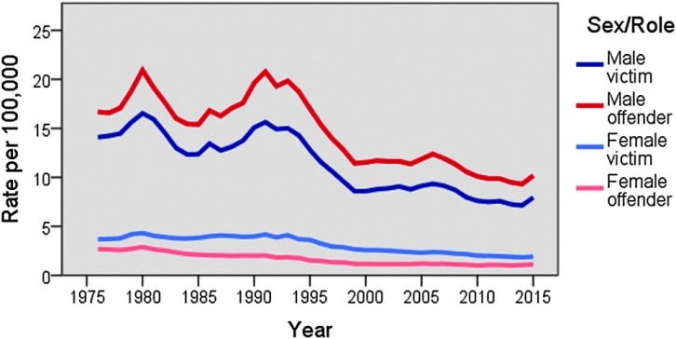  The trend indicates that women offender percentage is far lesser than the men offenders. The reason behind this sharp gap is gender inequality and stereotypes (Hu, n.d.).

Paragraph three
Argument one | In our society women are associated with family, traditions and norms where their basic role is to keep their family together, on the other hand, men are responsible for the financial condition of the family. Even when women follow her goal or do a job, the family remains their priority. Therefore, women carry more emotional feelings while men are more practical (Beckmann, n.d.). In this situation, men face more aggression and violent nature than women. Hence, women due to gender inequality and stereotypes remain less violent and aggressive.

Paragraph four
Argument two | In contemporary time, women are more active toward the feminism. Different movements and marches for the equality of the women are observed within a few years. In addition, a sharp increase in the involvement of women in criminal activities and violence has been observed. The governments are focusing on decreasing the gender gap at workplace and privilege is being given to women through priority to the women employee (Bloom et al., n.d.). In addition, the wage gap because of gender is also decreasing. With so much positivity where women are getting their rights, violent nature and crime should be decreased. However, the opposite trend had been recorded. With the increase in women power, their involvement in crime and violence is increasing.

Paragraph five
Argument three | Another aspect which indicates the positive relationship between gender inequality and stereotypes with the female offending pattern is the access to opportunities. As women face inequality in jobs and stereotype like weakness and danger related to night jobs, it make difficult to join different types of job. Jobs like a truck driver, guards, and other night shift duties are considered bad for women and men get these opportunities due to the mindset that men are strong and safer. These stereotypes provide men with more opportunities to get involved in criminal activities (“ASARaceCrime.pdf,” n.d.). They try to get more profit with short cuts while women find fewer opportunities and willingness to do any violent and criminal act. This is how gender inequality somehow plays a positive role in women offending pattern.

Paragraph six: optional
Argument four | All the above stereotypes and social norms make women closer to moral values than men. Women set happiness, family, and positivity as their priority. Opportunities like higher education and good job become the reason for progress rather than the money which minimize their willingness to do any criminal activity. On the other hand, men learn to get a good education for a good job and a good job for a good amount of money in their account (“90409_Section_1_Women_and_Crime_An_Introduction.pdf,” n.d.). The struggle for money makes them more willing to get involved in criminal activities as a shortcut. Therefore, women offending pattern become less effective due to gender inequality and stereotypes.

Paragraph seven
Conclusion | Therefore it can be concluded that on one side society is working hard to minimize the gender gap and to eliminate the typical stereotypes from society. On the other hand, this gender inequality and stereotype are resulting in low involvement of women in criminal activities. The offending pattern of women gets controlled by the inequality in society.

Key resources | 1. 90409_Section_1_Women_and_Crime_An_Introduction.pdf, n.d.  2. ASARaceCrime.pdf, n.d.  3. Beckmann, A., n.d.Female offending and the question of gender specificity 266.  4. Bloom, B., Owen, B., Covington, S., n.d. A Theoretical Basis for Gender-Responsive Strategies in Criminal Justice 25.  5. Cauffman, E., n.d. Understanding the Female Offender 24.  6. Hu, A., n.d. Gender and criminality: common stereotypes.  7. Liddell, M., Martinovic, M., n.d. Women’s Offending: Trends, Issues and Theoretical Explanations 16.  8. Limitations to equality: Gender stereotypes and social change [WWW Document], 2014. . IPPR. URL https://www.ippr.org/juncture-item/limitations-to-equality-gender-stereotypes-and-social-change (accessed 4.22.19).

