Welcoming Children and Families: A Family Resource Guide
[Guendi]
[Name of the Institution]

Welcoming Children and Families: A Family Resource Guide

Personal Introduction
I am Guendi from Herndon, Virginia (USA). I am a soul who loves to be in good company everywhere, and all the time. I believe that this world is full of happiness and joy for those who strive to find it everywhere. For this reason, I like be surrounded by good souls, and it is where my love for children comes in. I think and I strongly feel that children are the purest version of their selves and perhaps it is the reason that I like their company the most. This was my vocation, but now I have chosen to become an early childhood professional. Children are the most beautiful creation of the Almighty lord. So, to preserve and adequately develop this beautiful creation of lord, one must be duly in love with them. I am irrevocably in love with children, and I find this career as early childhood professional quite stimulating where I would get a chance to do what I love the most. Children have several developmental stages depending upon their age brackets. It is infants, toddlers and early childhood. What I think early childhood is the age when children have somehow developed the minimum level of their faculties, and they have begun to understand this world. They quickly adopt new patterns of life. This entire course of Child Development, and the diverse observation and experimentation has added to my professionalism. I have spent enough time in noticing and observing various children and really grasped all the important ingredients of this early child growth. I am quite fit for this responsibility now. Thus, I am really keen on training such early childhood pupils that are about ready to join the world as independent creatures.

Importance of Early Learning
The high-quality care is immensely important for the child’s overall growth and development. Children are the young souls and the need to be dealt affectionately and appropriately. High quality care has the potential to make or break a child’s future as a young adult. If any component of growth and development is missed out, then the child suffer throughout his life. It is also related to the socialization principle as championed by several sociologists. They opined that it is a process when a person becomes a good member of the society through several methods and strategies (Mooney & Edwards, 2001). So, to achieve the objective of socialization, there are several agencies involved to make a child more conforming and good member of the society. Education is the main agent of socialization after the institution of family. Consequently, when early children get admitted to learning institutes, they encounter the first most formal institution in their lives. They must be welcomed happily in this new formal structure of the world, so they continue to enjoy the learning process as well. Child development is the complex and intricate phenomenon and it has been systematic in its approach and its design.
There are some theories about child development as well. This was an attempt by the psychologists to understand the human development process (May 09 & 2019, n.d.). The various categories of psychologist are: cognitive psychologists, behavioral psychologists, developmental and others. Among the various important theories of child development are Piaget's Cognitive Developmental Theory and the Behavioral Child Development theory.
The piaget’s cognitive theory is related with the person’s thought processes. It is the process where person’s th interacts with the world (Kamii & DeVries, 1980). He opined that children have different thought processes than the adults. He identifies several steps and stages in the child development. He mentioned sensorimotor stage, the preoperational stage, the concrete operational Stage, the formal operational stage. He listed ages along with these stages where each stage had its own characteristics. His Preoperational Stage, and the Concrete Operational Stage, was about the early development of a child. He states that in age 2-6 a child begins to use language in order to understand the world (Egan, 2012). Then, between 7-11 he develops the rational side to his personality and he becomes the practical person in his approach. Hence, this theory resonates that in early childhood children begin to understand the world and their cognitive side gets developed which is the same point of view as mine which is necessary to implement in classrooms.
Another theory is Vygotsky's Sociocultural Theory which focuses on the social processes around the children. Here, he illuminated the role of practical education for the development of child (“Vygotsky’s Methodological Contribution to Sociocultural Theory - Holbrook Mahn, 1999,” n.d.). Like Piagets, he also opines that children learn actively and through hands-on experiences. They need active engagements with different members whether parents, teachers or the peers continuously. In this way, culture plays an important role in the development of personalities. So, Vygotsky places heavy influence on it and I also believe that culture is duly important in early childhood developmental phase.
Cultures do have influence on typical and atypical development and it is the air which the people in the society continuously breath. Atypical can be modeled in a better way as they are the special children with special needs. For typical development, it is good to strive a harmonious balance between the culture and innovative strategies.

Environment
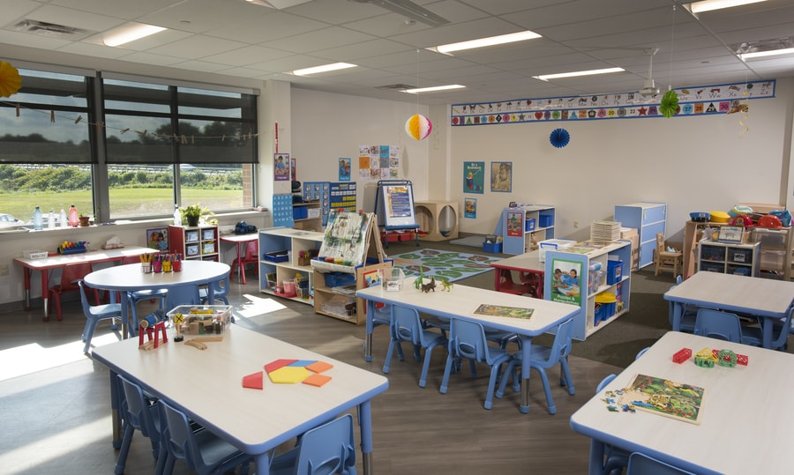
This is the model classroom for the early children. This shows the room which is airy and bright. It is quite colorful which shows the point that children learn better when they are surrounded with bright, vivid colors. Proper sitting place with peers is another added feature of this exemplary classroom. This works best for the young pupils as they are just beginning to understand the formal structures such as classrooms in this world. This colorful room will make the learning process more accurate and interactive. There has been an adequate display of the charts, symbols on the walls to make children adopt things quickly and easily.
This environment is good for the children. They can learn and play at the same time. this learning space allows them to use different kinds of playful activities in this classroom. They can take a walk, run or jump to perform their physical playing activities. This is equally well for the symbolic play activities where different shapes are put in front of them. Here, children can have different role-playing strategies as a part of their psychological play.
Play is so pivotal in classrooms. This is the place where instructors and pupil can engage in healthy discourse with one another. I believe, play is much important to the cognitive development of children. Different mind games and puzzles can serve the purpose in the classrooms. Their cognitive development gets better when they engage in a thinking process. It is this cognitive development which is the backbone of all other developments. Hence, I find these problem-solving techniques quite effective in classrooms where children exercise their thought process.
For children to be good individuals in their coming years, it is very important to grow their social and communication skills. It is widely believed that an individual develops his self in a group life. Thus, for the effective growth and development of the children, it is very important to pay attention to their group life. Children should be able to spend time with their peers and fellows, and they must be guided in leaning new languages. It will be so helpful in their later years of life as they would have no difficulty in communication with others.
For physical activities, some appropriate time must be fixed for their physical activities a as playing hide and seek, running or doing some exercise in classrooms or grounds. Also, for their social and emotional skills, children must begiven practical situations to ponder upon and then give response. This practice develops the moral intelligence in early age children. However, if a child behaves negatively, it is important to deal him with kindness and love, rather than strictness.

Families
Family plays a very important role in the development of children. It is the first place where a child opens his eyes. According to several social thinkers and sociologists, it is the first learning place of a child. An individual is socialized in his family first, so no one can deny its contribution in the life of children. In this way, the institution of family is much important even in classrooms because when a child sees his parents in this formal structure, he takes more interest in the learning process. He becomes pro-active in learning as he wants to make his loved ones see what he is capable of.
When I had discussions with families, I found that there are some families that are really supportive of their child all the time. They are very conscientious of their child, and pay great attention to his details. However, the other ones are not that much keen on noticing every activity of their child. This has a negative impact on the early growth and development of a child. So, to make families more responsive to their child, it is mandatory that they must be kept abreast of all their activities on daily basis. I usually write it on the daily journals and try to keep regular an amount of correspondence with parents.
I believe this regular correspondence with families and parents of children is very important for the early childhood development. It becomes a two-way communication process between two groups where they ultimately share the goal of healthy development for a child. If there is no communication between parents and instructors, it is ultimately the child who suffers. Thus, it is a great initiative and all stakeholders must put it into practice.

Resource Page
Name | Contact | Website
Christine M Cosgrave  Psychologist, Psy.D. | (571) 200-3498 | https://www.psychologytoday.com/us/therapists/internal-family-systems-ifs/va/herndon
Martha Fischer | (703) 382-1535 | https://www.psychologytoday.com/us/therapists/internal-family-systems-ifs/va/herndon/313413?sid=5cf213fe8ef67&ref=4&tr=ResultsName
Russell (Russ) Carlton | (703) 594-4043 | https://www.psychologytoday.com/us/therapists/internal-family-systems-ifs/va/herndon/146379?sid=5cf213fe8ef67&ref=6&tr=ResultsName
Kate Tedeschi | (209) 600-4617 | https://www.psychologytoday.com/us/therapists/internal-family-systems-ifs/va/herndon/397347?sid=5cf213fe8ef67&ref=9&tr=ResultsName
Juvenile and Domestic Relations District Cour | 703-246-3367 | https://www.fairfaxcounty.gov/juveniledomesticrelations/family-counseling

And for some non-natives are:
Name | Contact | Website
NAMI | 800-950-6264 | https://www.nami.org/find-support/diverse-communities/african-americans
Ellis Psychological Services,LLC | (703) 596-1895 | https://www.psychologytoday.com/us/therapists/african-american/va/mclean/98236?sid=5cf2160fea510&ref=1&tr=ResultsName
Monica Robb | (703) 468-4496 | https://www.psychologytoday.com/us/therapists/african-american/va/fairfax/182875?sid=5cf216023be71&ref=6&tr=ResultsName

There are some resources that can help the families to understand their child better. It is a great step that offer much better prospects for the child. Moreover,it is important for parents to duly understand their children. For this purpose, the support of the external sources comes. Even internet offers several websites that offer good help to the struggling parents.
Firstly, it is this (“Parents,” n.d.) that is quite helpful in dealing with issue of parenting. Her parents can find help in diverse resources and focus on the effective well-being of their child. Another resource where they can find help is (“Child Development Advice And Parenting Help For Parents,” n.d.) which is quite helpful in dealing with children of different age groups. It is a good source that can be used to understand a child growth and development. Furthermore, this (“Winners -- The Webby Awards,” n.d.) is also helpful for those parents who are really struggling to understand the healthy development of their child and they want to do better in terms of being parents. Such websites resources are no doubt a great source of help for the parents in this complex age. Hence, these sources must be utilized enough to deal with different dynamics of early child development.
Conclusion
To summarize, as a child development professional it is good to understand the dynamics of early childhood first. Since I am a person who loves to be in the company of children, so I find it quite easy to connect with children. However, early child developmental phase is not that easy as it seems. Several theories have to be kept in mind to fully and effectively focus on the childhood development phase. Moreover, their classrooms need to be fully adequate for the different types of leaning and playing activities. For this purpose, parents and teachers can take help from various sources available either online of offline. Raising children is an art and it must be done systematically and affectionately.

References
Child Development Advice And Parenting Help For Parents. (n.d.). Retrieved June 1, 2019, from https://childdevelopmentinfo.com/
Egan, K. (2012). Primary Understanding : Education in Early Childhood. https://doi.org/10.4324/9780203813577
Kamii, C., & DeVries, R. (1980). Group Games in Early Education: Implications of Piaget’s Theory. National Association for the Education of Young Children, 1834 Connecticut Avenue, N.
May 09, a board-certified physician | U., & 2019. (n.d.). Influential Theories About How Children Grow and Develop. Retrieved May 31, 2019, from Verywell Mind website: https://www.verywellmind.com/child-development-theories-2795068
Mooney, L. A., & Edwards, B. (2001). Experiential Learning in Sociology: Service Learning and Other Community-Based Initiatives. Teaching Sociology, 29(2), 181–194.
Parents. (n.d.). Retrieved June 1, 2019, from Resources for Early Learning website: http://resourcesforearlylearning.org/parents/
Vygotsky’s Methodological Contribution to Sociocultural Theory - Holbrook Mahn, 1999. (n.d.). Retrieved May 31, 2019, from https://journals.sagepub.com/doi/abs/10.1177/074193259902000607
Winners -- The Webby Awards. (n.d.). Retrieved June 1, 2019, from https://www.webbyawards.com/winners/

