Assignment
[Name of the Writer]
[Name of the Institution]

Assignment
Hershey’s Company
One of the most demanded desserts or sweet snack all across the globe is chocolate. From children to adults to old age people no one can stop themselves from eating chocolate. It is one of the most addictive things in the entire world. There are various companies which annually produces tons of chocolates, but one of the pioneer company is of Hershey's. They are producing chocolate since 1894 and have enhanced their quality from time to time, and they are the pioneers in chocolate production (Thorlakson, 2018). The only way to find out their success is through SWOT analysis and their leading and low-quality products through BCG matrix.
SWOT Analysis
The SWOT analysis of any of the company gives a detailed overview of the company through which they are going through to enhance the performance of their company.
Strength  Strong portfolio as a brand.  Dealing strongly with the community. | Weakness  Need for inculcating new technologies.  Not useful in merging various cultures in the working environment.
Opportunity  New customers are plunging in through online sources.  Introducing new policies for the change in the working environment. | Threat  Increasing competition with various brands.  Facing different issues in law in various countries.
BCG Matrix
The BCG matrix is considered as a detailed analysis of the products offered by the company. This matrix discusses the strategic position of the business and the products that are provided in the portfolio.
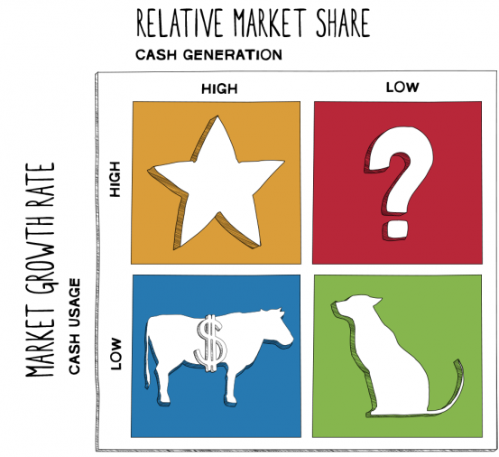

The Star product of Hershey’s is always the Hershey’s Kisses which are still high in the market as they are still in demand and the public gets highly attracted to it. Then comes the Cash Cows which are the market generator of the company and these are the milk chocolates. This was the remaining chocolate which gave an identity to the company. Then comes the questionable product of Cookies' n Cream which is not much available n market and their existence become a question mark (Kurie, 2018). The last but not the least is the presence of the Dog products like White chocolate which so not being utilized in the market effectively and do not give any benefit in the market generation and profit generation of the company. By keeping a precise detail in the views of the products, the market value can be increased tremendously.

References
Kurie, P. (2018). In Chocolate We Trust: The Hershey Company Town Unwrapped. University of Pennsylvania Press.
Thorlakson, T. (2018). A move beyond sustainability certification: The evolution of the chocolate industry's sustainable sourcing practices. Business Strategy and the Environment, 27(8), 1653-1665.

