Affordable Care Act Policy Analysis and Evaluation
[Name of the Writer]
[Name of the Institution]

Contents
Introduction 3
Client History 4
Program Objective 5
Timeframe for the Pilot Program 6
Evaluation Flexibility\ 6
Flexibility in Program Implementation 7
Program Evaluation Personnel 8
Chief Investigator 8
Main Research Coordinator 9
Economic Consultant 9
Research Assistant 9
Volunteers 9
Program Budget Projection 10
Data Collection 10
Analysis of the Data 13
Evaluation Presentation and Communication 14
Program Evaluation and Limitations 15
References 16

Affordable Care Act Policy Analysis and Evaluation

Introduction
Affordable Care Act is one of the most important laws when it comes to the general healthcare and provision of the people. Also known as the Obamacare, it a law that allows the comprehensive healthcare reformation of the people and the core idea of the act is to ensure that sustainable healthcare provision has to be there for the citizens of the United States. At the same time, the other major goal of the act is to make sure that the affordable healthcare is available to the people and more and more people are integrated into the healthcare system. Furthermore, the law is providing people with the subsidies along with the premium tax credits that are available at the lower cost. This option is available for the people whose income is ranged between 100 % to 400 % of the poverty level. In order to make sure that the policy is able to take its effect on the general populace, there is a need to make sure that the effort is carried out with regards to making sure that how the right sort of balance is needed to be achieved in terms of the balance that seems to exist in terms of the budget constraint as well as making sure that high quality healthcare services are provided to people at the particular point of time. With better healthcare provision, it can be made sure that the balance is going to be achieved in The program also intends to make sure that the innovative medical care is being provided to the people as well as making sure that the medical delivery methods are being designed with the intent to ensuring that the lower costs are achieved when it comes to the provision of the healthcare at the given point of time. The problem with the program is that it is quite an ambitious thing to ensure that quality healthcare is being provided to the whole population due to the fact that by its nature, it is cost intensive project, and no matter how much effort is going to be made during the course of the whole activity, there are going to be severe budget constraints. The main issue for all the stakeholders is to make sure that how the right sense of balance is going to be achieved when it comes to making sure that the budget cuts should be in line with the provision of the quality healthcare.

Client History
Before one goes into the detail of how the Affordable Care Act is going to be made more fiscally viable, it is important to understand the history and motivation behind the bill. The Affordable Care Act was presented in 2010 by then President Obama and the idea behind the Act was to make sure that the people are being provided with the stable and affordable health insurance. Looking at the history of the United States, people have a hard time gaining access to the insurance and the private insurance providers are the ones that have been found out to be quite vulnerable when it comes to making sure that the insurance abuses that are witnessed across the industry are avoided at the particular point of time. The major underling goal of the President that point of time was to make sure that the strategy was being devised that is going to ensure that better healthcare access is being provided to the people and the concerns of the people are being addressed in terms of how equitable healthcare provisions are going to be taken care off. Looking at the core objective of the Affordable Care Act, the first thing that it is attempting to do is to make sure that the access to the healthcare coverage is being improved for the people of the United States. In order for that to happen, the idea must be to make sure that the relevant healthcare benefits must be provided to the people who have low income and the ones that are living with the disabilities. The legislation has always been considered as one of the most important passages of law that is going to allow better prevention and cure rationale for the people who are suffering from HIV and AIDS. For instance, one of the major provisions of the law is that how the insurers are not going to be denying access to the children who are living of the HIV and AIDS. Not only that, the effort is also needed to be made to make sure that the better sense should be prevailing when it comes to making sure that the healthcare insurance and the provision of the medical insurance is done in the manner that should make sure that how quality healthcare is going to be provided to people at the particular point of time. The other major objective of the Affordable Care Act was to make sure that the quality coverage and access to the healthcare is being provided to the wider demographic so that the major population of the United States could be provided with the healthcare insurance options and allowing more equitable distribution of the resources in terms of how provision of healthcare is supposed to be carried out.

Program Objective
Despite the fact that the Affordable Care Act is something that sounds well and has a good intention behind it, there are many underlying complications behind the program. One of the major concerns when it comes to the implementation of the plan is that how it is going to be made sure that the budgetary constraints of the government that comes with such an ambitious plan are going to be worked out. It has to be noted that the United States is battling with the biggest budget deficit of its century and to ensure that the better sense should prevailed in terms of how the management of the resources is supposed to be carried out, it is imperative that some sort of balance has to be there in terms of how allocation of the resources is supposed to be carried out. As per different policy makers, the approach that has been adopted in terms of the way Affordable Care Act is being implemented is that there are many underlying pilot projects that are currently working with the program and one of the reasons that the program has not been doing well and causing lot of problems is that how the spending patterns are going to be determined. As the choice was being made towards ensuring greater coverage expansion rather than provision of quality, there are lot of problems in terms of how it the systematic and verifiable cost control mechanism is going to be implemented in terms of the way quality improvement program is going to be working out. So the core objective of this plan is to make sure that the sense of balance is achieved with regards to making sure that not only the broad base coverage is being provided to the specific population groups, but it should also be made sure that the efficiency constraint has to be taken care off in terms of the way implementation of this program is going to be done at the particular point of time.

Timeframe for the Pilot Program
Now, looking at the time frame for the implementation of the cost control mechanism, it has to be noted that keeping in mind the vast range and reach of the program, it should take at least 24 months so that the particulars of the program are being implemented. The idea is to make sure that there is flexibility in terms of how evaluation is carried out.

Evaluation Flexibility\
The first thing that is going to be done when it comes to the program is that it would be made sure that the data collection protocol is needed to be developed. The major rationale for this protocol is to make sure that the data collection mechanism is needed to be developed that is going to ensure that the cost control rationale is developed. This data is then going to be representing each of the demographic group and the sub population that is going to be affected by the cost control exercise. Furthermore, there would 2 months more time period that is going to be needed to make sure that the dissemination process in terms of the data collection is being done in an appropriate manner.

Flexibility in Program Implementation
One has to be quite accurate when it comes to making sure that the pre-test and post-test time frames are going to be implemented in an appropriate manner. The idea is to make sure that the agenda has to be there in terms of how VHS is going to be used so that the identification of the cost control protocols is going to be done along with making sure that if there is any change in the initial rationales and parameters, then it has to be accounted for considerably. Furthermore, the effort is going to be made to make sure that the time frame that is being discussed for the implementation of the program is already optimistic, so effort is going to be made to make sure that* this time frame does not exceed and the cost control procedures are implemented appropriately at the given point of time. In the hindsight, it can be said that the idea is to make sure that the sufficient healthcare provision has to be there for the people as well as making sure that the appropriate cost control measures are also there.

Program Evaluation Personnel
In order to make sure that the implementation of the program is carried out well, there are many key personnel who have to make sure that they evaluate each and every aspect of the program. The idea behind the whole thing is to make sure that the research programs are setup in an appropriate manner and policies are setup with the greater scope of the impact. Not only that, there is longitudinal analysis that was carried out at the multiple sites that also affected the efficiency of the program, so one has to be quite careful when it comes to making sure that the right personnel are deputed for the program. Keeping in mind these considerations, following are some of the people who must be on board for program to run successfully.

Chief Investigator
They would be the one that will look after the implementation of the program and determine what direction program is taking. Not only that, they would be charged with making sure that the coordinated effort is carried out in terms of how the communication of the information is done and how the pilot program is needed to be there in terms of the way evaluation process is going to work.

Main Research Coordinator
They would look after the technical aspects of the research as well as making sure that the program evaluation and research protocols are setup in an appropriate manner.

Economic Consultant
The economic consultant is the one that would look after the oversight and direction of the research as well as making sure that the methodological firmness and applicability of the research has to be there in terms of the overall design. They would also assist in the development of the economic framework that would allow further insight about the program.

Research Assistant
During the course of the research, there is going to be needed to make sure that the data collection protocols are being setup in an appropriate manner. In order for that to happen, there is a need to make sure that the proper evaluation of the research methodology has to be done

Volunteers
These are the people that would actually go in the field and aid with the collection of the data. They would also make sure that the right protocol is setup as far as the way collection of the data is supposed to be carried out and thus allowing better insight.
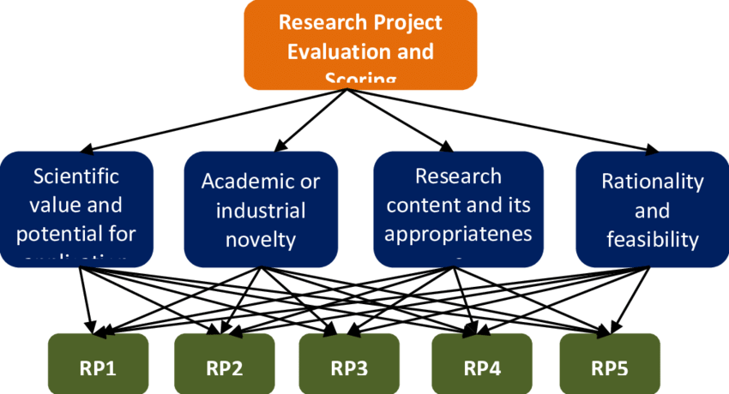

Program Budget Projection
When one talks about the evaluation of the program and the VHS and the mandatory rationale when it comes to the cost control. Now, the key thing that has to be kept in mind is that the program scope is such that it is going to be going on for 24 months, and during the whole process, it is imperative that there are going to be instances that the likelihood of going overboard with the budget is always going to be there. In order to make sure that these things are taken care off in an appropriate manner. The other thing that has to be done is that the duration of the project is also quite accommodating, so effort is needed to be made that the during the course of the project, the timelines should not be exceeding as it would directly have an impact on the cost consideration of the project at the given point of time. So, all these considerations are always needed to be kept in mind when the budgeting aspect of such a project is needed to be done. There are going to be expenses in terms of the travel and the data collection as well as the documentation that are needed to be kept in mind to make sure that the reimbursement process is going to be carried out with the help of the small utility that would always show the overdraft, the comparison against the budget and other such particulars about the project so the insight is always going to be there in terms of how the project’s cost consideration are kept in mind. Many more problems loom just over the horizon. The infamous “doc fix” for the sustainable growth rate (SGR) formula under Medicare threatens large cuts to physicians fees every year. Congress passed the latest SGR patch in December and deferred cuts for 2011, without offering any permanent resolution. Ultimately the SGR has to be addressed, but the fiscal cost is staggering: estimated at $276 billion over 10 years. The CBO also estimates that costs for the new insurance subsidies and Medicaid expansion under the Affordable Care Act will grow by about 8% annually beginning in 2019.
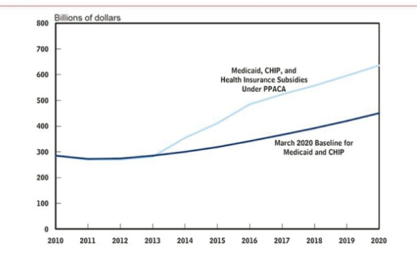

Data Collection
The collection of the data is going to be one of the most complex things that is going to be done during the course of the project. Now, the data collection protocol for the program is going to be done during the primary periods, the pre-test implementation and the post-test implementation of the program. At the same time, whenever there is a case of the economic study, there is a need to make sure that the effort is carried out with regards to how the study is going to be done in terms of the higher level of accuracy as well as the one that being generalized quite easily at the moment. There is lot of dichotomy in terms of how this study is going to be carried out. Not only that, there is also a need to make sure that the randomized controlled trials are going to be developed to make sure that the higher internal validity is going to be made possible along with the observational model being implemented.
The other thing that is going to be kept in mind is that how the comparisons of the different studies are going to be carried out that are prospective in nature and when that happens, there is a strong likelihood that the data that is going to be collected would be misleading to say the least. When that happens, there is a need to make sure that the insight about all the relevant factors are going to be obtained to make sure that the shift and the improvement in the validity of the research is being done in terms of the way combination of the different collection methods are going to be used during the research. The other thing that is needed to be kept in mind as far as the way collection of the data is being done is that how the validity constraints are kept in mind. Most of the times, the validity concerns are implemented in the manner that the external constraints play an important role in terms of how the whole situation is going to be worked out. The idea is to make sure that the usage of the proxies has to be done so that the collection of the resource utilization is being done along with the estimates. There has to be reliance on the patient self-reported data as well that is needed. What it tends to do is that it makes sure that all the underlying methods that are being used when it comes to the collection of the data would assist as far as the validity of the study results are needed to be obtained. At the same time, there are national guidelines are well that must be implemented when it comes to the way rationale is needed to be developed for the collection of the data and the way economic evaluation is being done. Not only that, the corresponding agents and devices should also be working in the manner that the issue of the more in-depth perspective can be developed in terms of the way economic analysis is being done.
It has to be noted that the core objective of the research must be kept in mind, specially the way comparison of the costs is going to be done in terms of the ECMO and how it compares to the conventional treatment with the passage of time. Not only that, there is a need to ensure that the measurement of the cost effectiveness and the cost utility must be done. It is an important determinant looking at the success prospects of the research and without a concrete idea regarding how the cost and benefit analysis would be done, the research would lose its merit. As far as the healthcare implications of the data is concerned, it is going to be recorded from the intensive care resources so that the parallelism is supposed to be there in terms of the way research is needed to be carried out. The other major question is that how the sensitivity analysis is going to be carried out and how some of the other cost intensiveness rationales are developed. The cost utility analysis is going to be based on the quality of life adjusted years and how they are gained from the Europol EQ-5D for the first six months. Then other factor that has to be taken into account is the way sensitivity analysis is being carried out. The idea is that how the probabilities that are related to the different patients would vary and what would be the lack of the healthcare provision that is going to be witnessed if that one element is removed from the narrative. The other thing that is going to be done is that how the probabilities that are related to the cost effectiveness would be varying based on how the different funding thresholds are going to be worked out. The other important consideration is the way recording is going to be done. The chunk of the data that is going to be dealt with during the course of this research is so vast that at times it is going to be quite hard to ensure that the consistent pacing is being allowed at the given point of time in terms of the way trial record is going to be done. It has to be noted that some of the details and the aspect of the healthcare that are going to be talked about in this research are not normally found elsewhere. Well-funded and well-designed high risk pools could provide a solution for the chronically ill who cannot currently afford insurance at market rates, without distorting the entire market through community rating and guaranteed issue regulations. Finally, the states should be encouraged to experiment with additional innovations. Reforms in Utah, Massachusetts, and elsewhere should be allowed to flower or fail before the entire nation is committed to one state’s work in progress. Tax reform should be the first order of business. Policymakers must replace the current open-ended employer deduction with a fixed individual deduction or a flat tax credit for the purchase of at least catastrophic health insurance. Low income uninsured and Americans with serious pre-existing conditions should receive more help. Policymakers should also focus on fundamental Medicare and Medicaid reforms.

Analysis of the Data
Looking closely at the particulars of the program, one thing tends to stand out the most is that how the budget deficit has become a lingering problem with the passage of time, and how it has become impossible to make sure that the arrangement of the new subsidies is going to be made possible to ensure that the upper income portion of the population that does not have life insurance can take into account their overall healthcare. One of the thing that can be done is to make sure that how the possibilities are going to be explored in a sense that how the score of the Affordable Care Act is going to work out base on the premises that how the planning for the education is going to be done. The policy making in this regard is needed to be done in the manner that at least about half a trillion dollars can be saved if the dollars are shifted out of the private economy and that cost saving has to be directed towards health care programs and obligations. That would hinder the job growth in the private sector. The other thing that stands out in terms of the way this whole act must have been implemented was to make sure that the tax reforms were needed to be brought. It has to be noted that the tax reforms are an important consideration in terms of the way overall planning is being done whenever there is any major fiscal announcement, and in terms of the continuity, without bringing about major tax reforms, it is quite implausible that the Affordable Care Act is going to be sustained for a very long time. The health insurance markets were also witnessed to be quite monopolistic in nature which in turn is increase the competition. The idea is to ensure that the quality of the healthcare and the overall cost that goes into it must be lowered. Specially in the long run, the objective is to ensure that the Medicare payments must be lowered so that the current populace is able to have access to the healthcare. The higher cost of insurance is one thing that is pulling it back and effort is needed to be made to make sure that the greater degree of control is exercised in this regard. Finally, we should face the reality that there is no administrative “silver bullet” for fixing health care. Every wealthy country is faced by the triple challenge of aging populations, rapidly advancing health care technology, and a shrinking workforce to pay for it. Individuals will need to assume more responsibility for their own health and plan for long-term health care expenses that will accrue with a substantially lengthened lifespan. As a society, our assumptions about health and work will have to adapt to these new realities. Longevity is a blessing, but we can no longer assume that programs created in 1965 will meet the new health care realities of the 21st century. Our current health care arrangements have many flaws, but we should not lose sight of the many blessings that come from the life saving and life lengthening technologies generated by the U.S. health care system. Reforming the reforms is our next task, one that I hope we will approach with more sobriety and less partisanship than has been our recent experience.

Evaluation Presentation and Communication
Looking closely at the way program worked, the first thing that tends to stand out the most is that what were some of the choices that were made by the administration during the course of the whole process. The nature of the program was such that the expansion became the key objective during the program. There was little thought and consideration put towards making sure that method can be devised that would make sure that the challenge of the bending curve could be implemented in an appropriate manner. It was one of the prime reasons that even the decade after the program was implemented, it had done little to make sure that the quality improvement was visible at the broader level. What it has done is that due to the nature of the program, the cost of the healthcare has increased at an alarming rate. The healthcare spending has also increased in the given time period and thus there is lot of work that is still needed to be done so that the program become much more appropriate at the level at which it is operating at the given point of time. The sense of perspective is also needed to be there in term of the broader planning.

Program Evaluation and Limitations
When the program of such magnitude and scale is being carried out, there is all the likelihood that there are going to be some limitations. One of the major limitations that has been discussed above is that no matter how much time and resources are being dedicated to the research of this scale, there are always going to be instances when the sample size and the data collection would leave something to be desired. Furthermore, the other major problem is that the correlation between and the way high quality healthcare is supposed to be defined is something that is highly subjective in nature, and due to that, it is imperative that some sort of context has to be added behind the numbers at the particular point of time. The other underlying limitation that is going to act as a major setback for the research is that how the lack of implementation mechanism is going to make it hard to ensure that this whole framework can be applied at an appropriate level. Due to that, the desired results of the framework would not be seen and thus there is going to be lack of empirical evidence for the research.
Health insurance markets should also receive a powerful dose of competition: either through pure interstate insurance sales or through an optional federal charter for health insurance.9 One study commissioned in 2008 by the Department of Health and Human Services found that the number of uninsured Americans could be reduced by eight million simply through effective interstate insurance sales. Well-funded and well-designed high risk pools could provide a solution for the chronically ill who cannot currently afford insurance at market rates, without distorting the entire market through community rating and guaranteed issue regulations. Finally, the states should be encouraged to experiment with additional innovations. Reforms in Utah, Massachusetts, and elsewhere should be allowed to flower or fail before the entire nation is committed to one state’s work in progress.

References

Albright, H. W., Moreno, M., Feeley, T. W., Walters, R., Samuels, M., Pereira, A., & Burke, T. W. (2011). The implications of the 2010 Patient Protection and Affordable Care Act and the Health Care and Education Reconciliation Act on cancer care delivery. Cancer, 117(8), 1564-1574.
Breathett, K., Allen, L. A., Helmkamp, L., Colborn, K., Daugherty, S. L., Khazanie, P., ... & Peterson, P. N. (2017). The Affordable Care Act Medicaid expansion correlated with increased heart transplant listings in African-Americans but not Hispanics or Caucasians. JACC: Heart Failure, 5(2), 136-147.
Dresden, S. M., Powell, E. S., Kang, R., McHugh, M., Cooper, A. J., & Feinglass, J. (2017). Increased emergency department use in Illinois after implementation of the Patient Protection and Affordable Care Act. Annals of emergency medicine, 69(2), 172-180.
Hall, M. A. (2013). Evaluating the Affordable Care Act: The eye of the beholder. Hous. L. Rev., 51, 1029.
Kim, C. Y., Wiznia, D. H., Wang, Y., Save, A. V., Anandasivam, N. S., Swigart, C. R., & Pelker, R. R. (2016). The effect of insurance type on patient access to carpal tunnel release under the Affordable Care Act. The Journal of hand surgery, 41(4), 503-509.
Sommers, B. D., Buchmueller, T., Decker, S. L., Carey, C., & Kronick, R. (2012). The Affordable Care Act has led to significant gains in health insurance and access to care for young adults. Health affairs, 32(1), 165-174.
Sommers, B. D., Gunja, M. Z., Finegold, K., & Musco, T. (2015). Changes in self-reported insurance coverage, access to care, and health under the Affordable Care Act. Jama, 314(4), 366-374.
Sommers, B. D., Kenney, G. M., & Epstein, A. M. (2014). New evidence on the Affordable Care Act: coverage impacts of early Medicaid expansions. Health affairs, 33(1), 78-87.
Uberoi, N., Finegold, K., & Gee, E. (2016). Health insurance coverage and the Affordable Care Act, 2010-2016. Washington (DC): Department of Health and Human Services, Office of the Assistant Secretary for Planning and Evaluation.
Wherry, L. R., & Miller, S. (2016). Early coverage, access, utilization, and health effects of the affordable care act medicaid expansions: A quasi-experimental study. Annals of internal medicine, 164(12), 795.

Appendices
Appendix 1
Data Collection Form

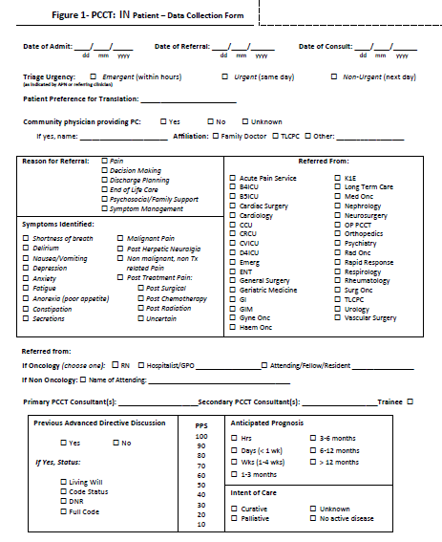

Appendix 2
Organizational Hierarchy
