The Kilauea Volcano in Hawaii
Your Name (First M. Last)
School or Institution Name (University at Place or Town, State)
Introduction:
Kilauea is one of the several dome volcanoes that is making Big Island of Hawaii, and there is eruption of hot lava and ash since decades. According to the record, the explosion of lava at Hawaii is taking place since January 1983; one of the reasons for this activity is that most of the Kilauea is below the sea level. There are numbers of natural phenomenon and one of the most familiar and destructive is the earthquake. Earthquakes are mainly caused by volcanic eruption, and this fact cannot be denied that there are hazardous damages caused by earthshaking such as economic and physical damages. Volcano usually damages buildings, takes life of living creature and damages the overall system of a country; though damage to the buildings could be fixed but humans, who are hurt, cannot be compelled to their normal life sometimes. Though Kilauea is the youngest Hawaiian shield volcano but it the most active of all as well. Many changes have occurred in its shape, and Kilauea Volcano in Hawaii has mainly resulted in the ground displacements, landslides, liquefaction, seiches, Tsunamis, and fires.
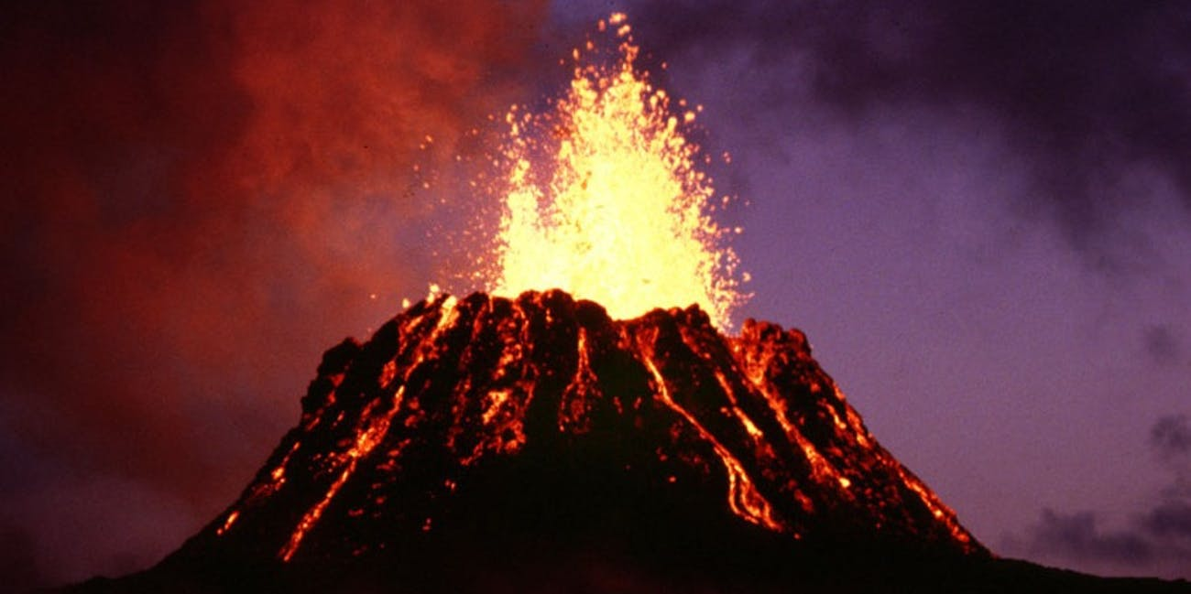

Discussion:
For knowing more about Kilauea, it is essential to know a little about its background. It is among the most active volcanoes of the world. Eruption of lava started since 1983, and the same phenomenon is there till date, it has been seen doing the same even with greater impact. Eruption is not at all a good thing and has been causing destruction at great level, and in Hawaii, it has caused damages to the Big Island. If looked back in the past, it could be found that in 2018 Hawaii's Big Island was rumbled for a few months after the lava has surged from the fissures on its slopes. According to the geologists, still, there are booms caused because of that explosion. Booms have been reported in history since researchers explored the earthshaking activity, and these booms are taking place in the US most of the time at this particular area. These booms create various physical impacts on people, such as cultural noise is caused by this explosion.
Nothing happens without a cause in the world. Likewise, there could be numbers of causes of eruption. Mostly geologists claimed that molten rocks that flows under the ground, is one of the primary causes of the volcanic eruption. Eruption is not at all a healthy activity; instead, it casts adverse effects on life, and physical world, such as it destroys the homes, hospitals, institutes, etc. Change in the direction of lava, caused by eruption is even sever matter that destroys things at large scale. Continuous eruption may lead to the mixing of water and lava that would cause an explosion. One of the most threatening damages caused by eruption is the raising temperature that is ultimately contributing in global warming. A volcanic eruption not only damages animals and humans but also casts drastic effects on the overall nature since ages.
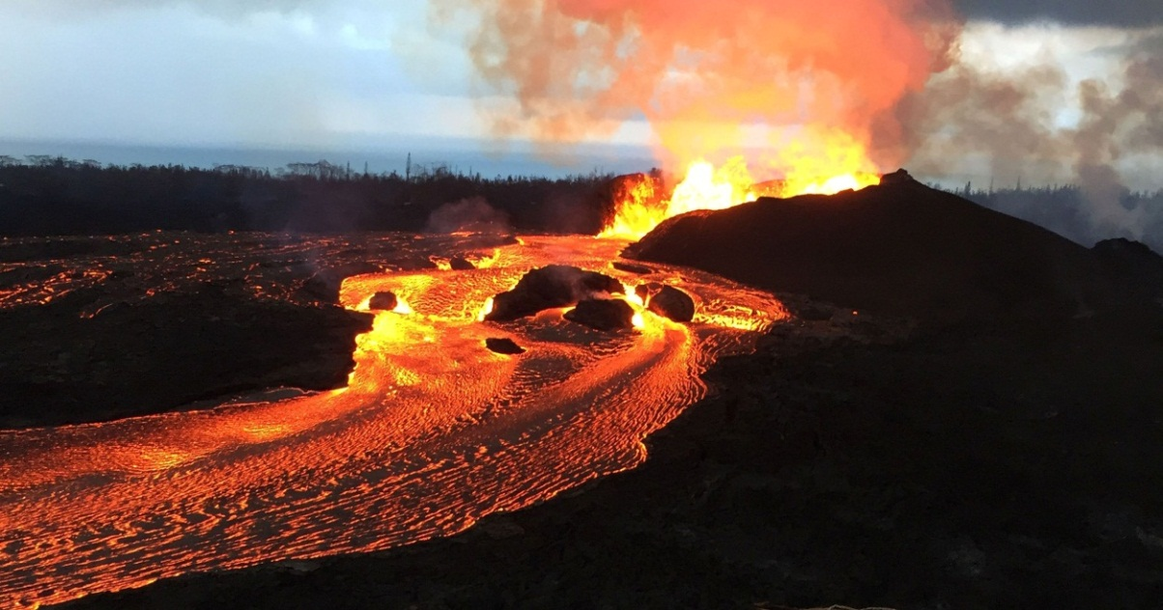
Damages that it was causing in the past are still having same or even stronger impacts on the world, and geologists have predicted that its impacts in the future are going to be drastic. According to a geological survey, the score of the future threat to this area is 263 and lives are at the risk in this area. If talking about this particular area, it would not be wrong to say that not only lives are at great risk, but this eruption threatens the infrastructure as well.
Hawaii has become one of the favorite spots of tourists as there would be no greater adventure than watching the live volcanic eruption. Just for watching this eruption, every year thousands of tourists visit this area (Hawaii’s latest volcano problem,2018). Naturally, eruption is not a safe thing, but here the scenario is a little different because the government is making a lot of money from this natural eruption that’s the only advantage of eruption. This area has become a favorite place for the geologist, photographers, and adventure lovers. Being adventurous is quite okay but being smart would be like a cherry on the cake, so tourists should be careful about their safety first.
Having an adventurous life is good, but at the same time, necessary measures should be taken for keeping the population away from this area. Government should be ready for facing an emergency as it is a sensitive area. One of the main things on which the government should be focused is that, infrastructural investment should be discouraged near this area where eruption is unpredictable, as it could cause significant loss to the investors. Not only investors are going to lose their money but also many people could be at the risk of losing their lives any time in such an area.
Conclusion:
Earthquake is a natural phenomenon that causes great disaster, and as per the records, since 1820s, Kilauea volcano is making eruptions. Explosion is causing greater danger to all types of life, and it's responsible for threatening the infrastructure as well. Firing and tsunami in this area are mainly because of this eruption. Tourism is being promoted in this area, but at the same time, this fact should be kept in mind that eruption is an unpredictable process that can cause damage to the tourists. So, as a whole it could be concluded that tourists should learn safety measures for keeping them safe. Security agencies should be given proper training for dealing with any unpredictable situation. Government should take care of tourist’s safety first that are coming for having an adventurous experience.

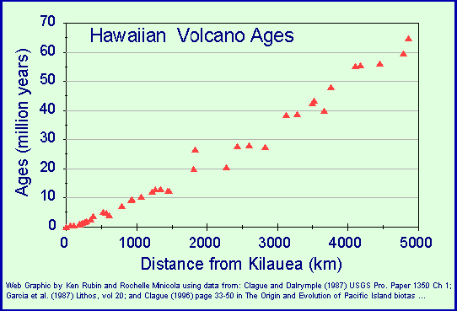
References
(reddit, 2018)
(“Hawaii’s Kilauea eruption could last for years, geologists warn | US news | The Guardian,” n.d.)
(“The USGS Hawaiian Volcano Observatory Is A Trusted Source For The Kilauea Eruption,” n.d.)
(“Hawaii’s latest volcano problem,” 2018)
Hawaii's Kilauea eruption could last for years, and geologists warn | US news | The Guardian. (n.d.). Retrieved February 2, 2019, from https://www.theguardian.com/us-news/2018/jul/24/hawaiis-kilauea-volcano-eruption-could-last-for-years-geologists-warn
Hawaii’s latest volcano problem: What to name the new Kilauea lava cone. (2018, December 10). Retrieved from https://www.nzherald.co.nz/travel/news/article.cfm?c_id=7&objectid=12174191
Reddit, A. S. via email S. on F. S. on T. S. more B. this article S. on F. facebook S. on T. twitter S. via email S. on L. linkedin S. on G. P. google-plus S. on W. whatsapp S. on P. pinterest S. on R. (2018, December 10). Hawaii's latest volcano problem: What to name the new Kilauea lava cone. Retrieved from https://www.nzherald.co.nz/travel/news/article.cfm?c_id=7&objectid=12174191
The USGS Hawaiian Volcano Observatory Is A Trusted Source For The Kilauea Eruption. (n.d.). Retrieved February 2, 2019, from https://www.forbes.com/sites/startswithabang/2018/05/24/the-usgs-hawaiian-volcano-observatory-is-a-trusted-source-for-the-kilauea-eruption/#1e18ab25e975

