Folio task Report
[Author Name(s), First M. Last, Omit Titles and Degrees]
[Institutional Affiliation(s)]

Author Note

Folio task Report
Introduction
In this task, we are required to analyze a bridge and its parameters. Different cables are used in the construction of this bridge on the road. We need to calculate different parameters of these cables, along with the parabolic equation of the bridge. For determining the equation of bridge, we have to use two methods i.e. ‘trial and error method’ and the simple ‘algebraic method’. In addition, we have to do some simple reasoning regarding the different signs of the parameters. All the details are explained below under their specified headings.

Mathematical Investigation and Analysis (1)
The general equation of a parabola is, ‘y = a$x^{2}$ + b$x$ + c’. Now, in this formula, if ‘a’ is positive, then it means that parabola opens in an upward direction, and if it’s negative, then parabola opens in a downward direction. In this case, the shape of the bridge can be represented by the parabolic equation: ‘y = a$x^{2}$ + b$x$ + c’ Now, as for the bridge, the face of the parabola is downwards i.e. it opens in the downward direction. Hence, its ‘a’ value is negative. Also, the value of ‘c’ is ‘0’ because the bridge intersects with the y-axis at the origin. If ‘c’ had any value other than zero, then the bridge would have moved upwards or downwards, making it unable to stand. The value of ‘a’ is less than ‘1’ because if it’s greater than ‘1’, then the curve would open in the upward direction and the desired structure of the bridge could not be achieved. If its value is equal to zero, then the curve would become flat and its shape would be distorted. Hence, its value will always be less than ‘1’, in fact in this case, as the curve is downwards, its value will be less than ‘0’ i.e. negative. Once, we know the equation of the parabola, we can find its roots simply by using the quadratic equation. i.e. ‘x = -$b± \frac{\sqrt{b^{2}-4ac} }{2a}$’. For finding the vertex, we will first take the derivative of the equation of the parabola and then put it equal to zero to solve it for the value of ‘x’. We will then put this value of ‘x’ in the original equation of parabola to get the corresponding value of ‘y’. These two values of ‘x’ and ‘y’ will be our required vertex. i.e. (x, y). The value of ‘x’ calculated for finding the vertex will decide the axis of symmetry for the given parabola.

Mathematical Investigation and Analysis (2)
To find the equation of the parabola using the ‘trial and error method’, we first have to calculate at least 5 points of the parabola. This can be done by using quadratic interpolation. After doing the interpolation, we will find the common differences between the ‘y-values’. And then, by equating those differences to the general form of quadratic equation, we can determine the values of ‘a’ and ‘b’. By doing the analysis, as stated above, the values of a & b, we got are,
a = -0.0099 and b = 2.7000111.
Substituting these values in the general form of quadratic equation, our final quadratic equation looks like,
y = -0.0099$x^{2}$ + 2.7000111$x$ + 0 (‘c’ is replaced by ‘0’)
For the verification of our equation, we plotted it on Desmos. The result we got on Desmos is attached below,
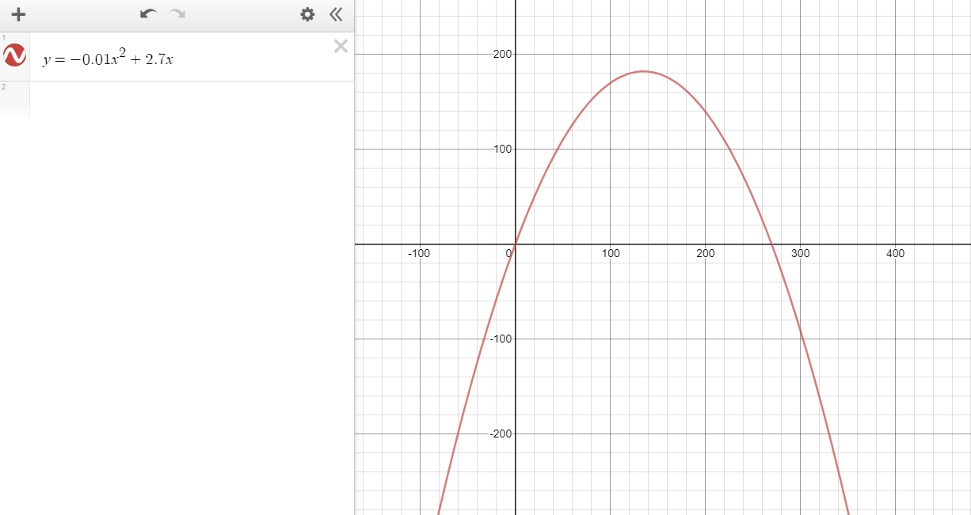

Mathematical Investigation and Analysis (3)

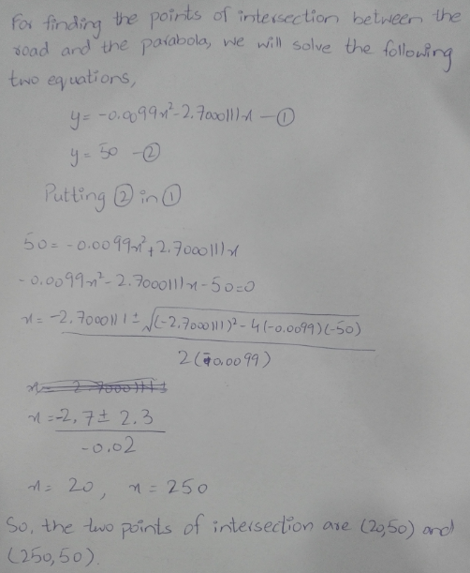
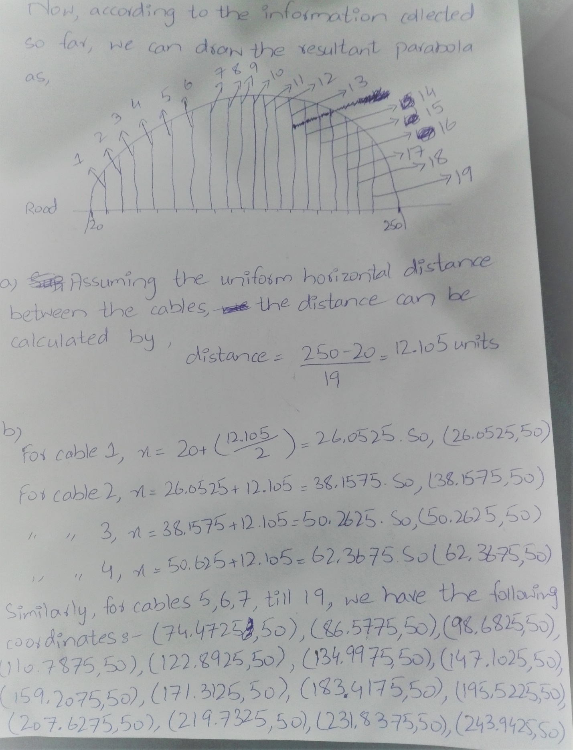
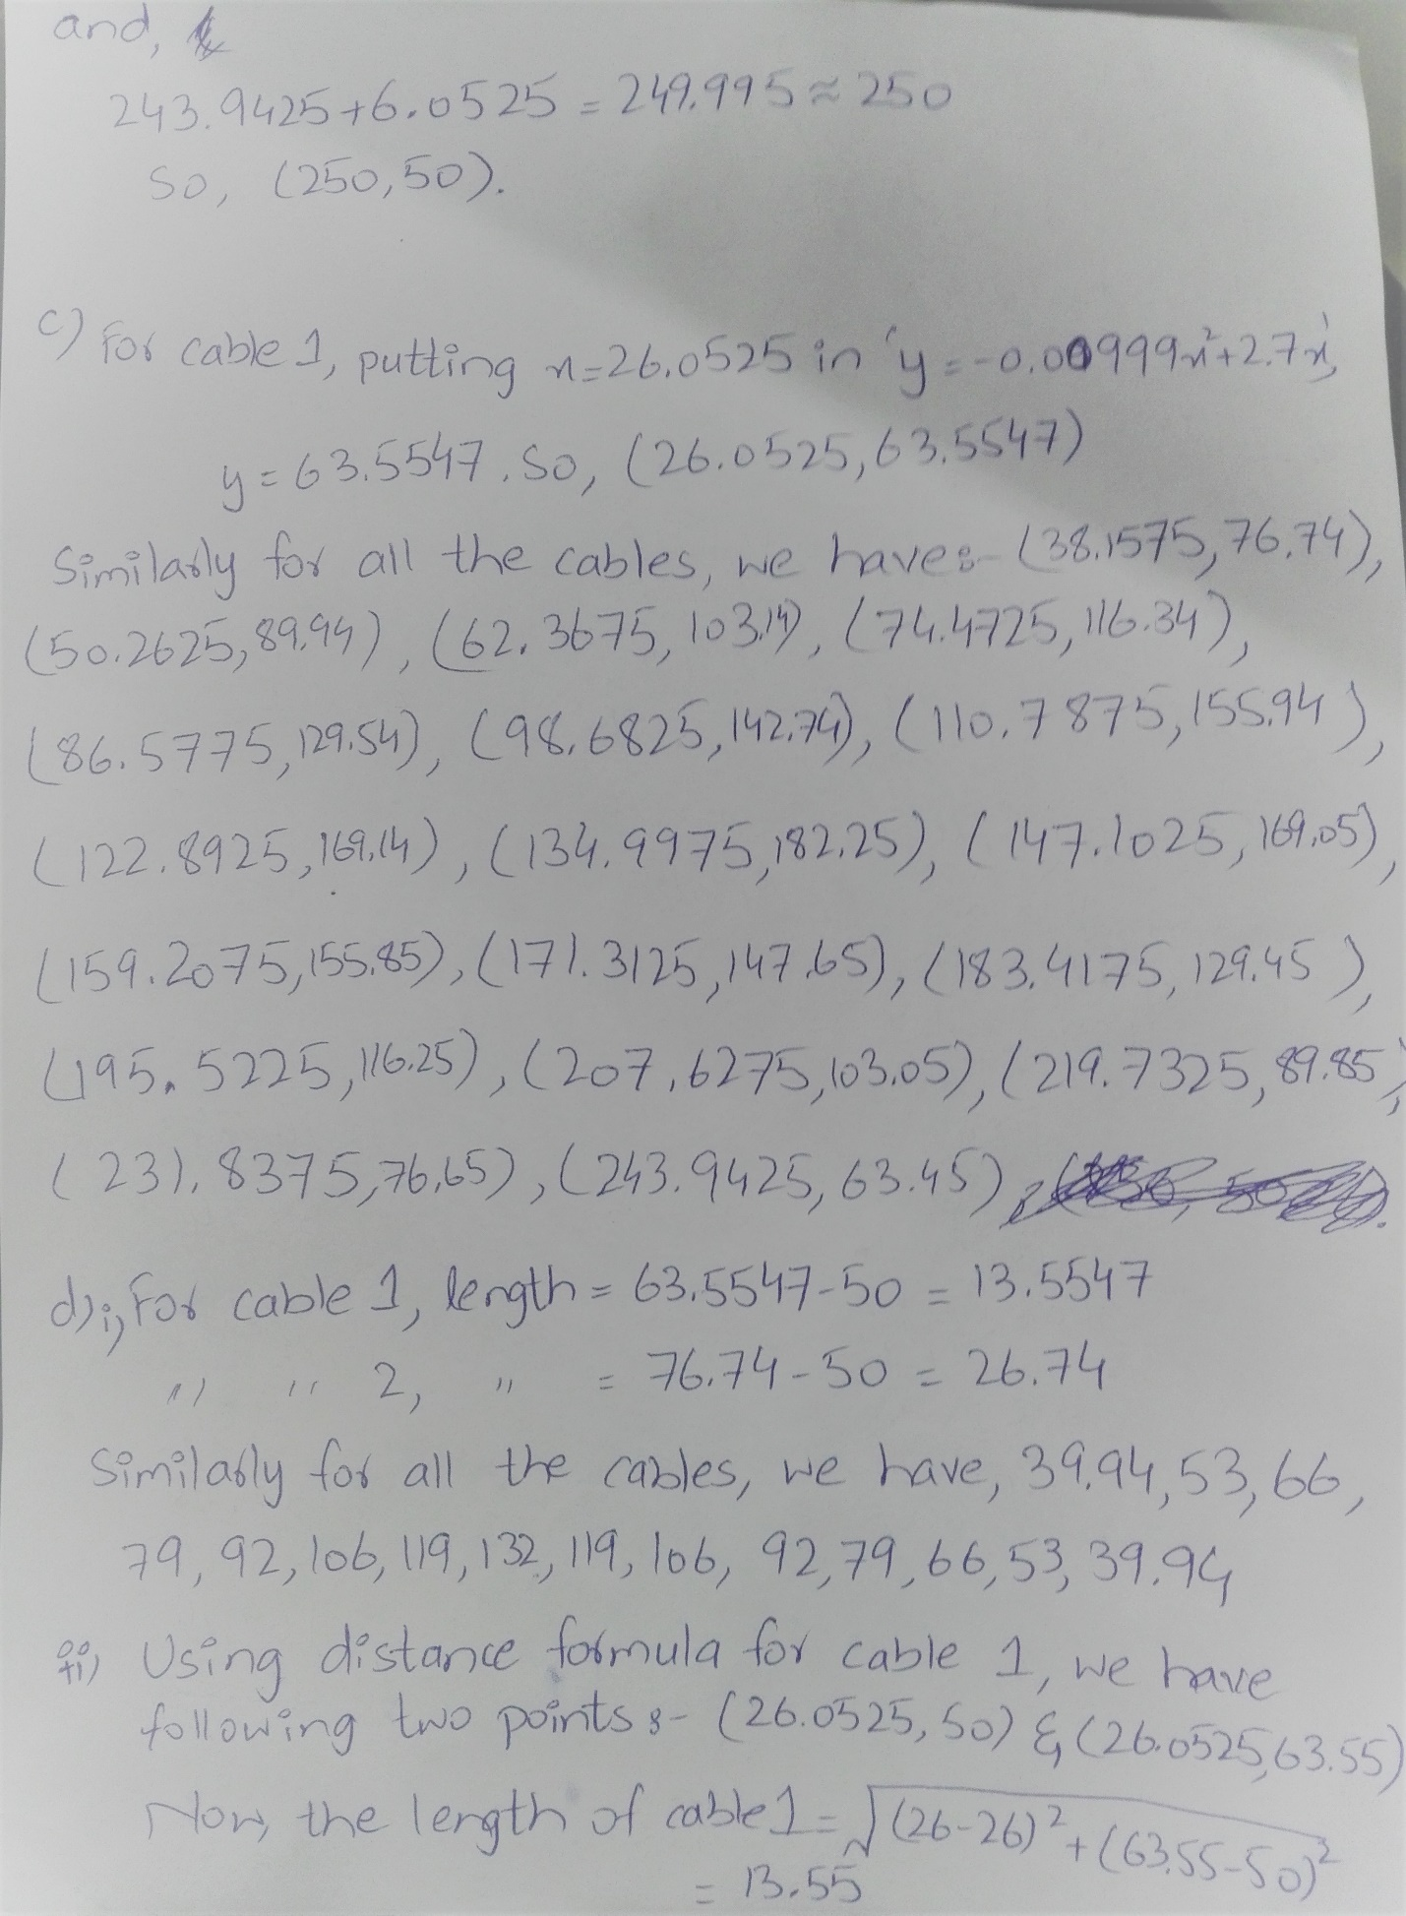
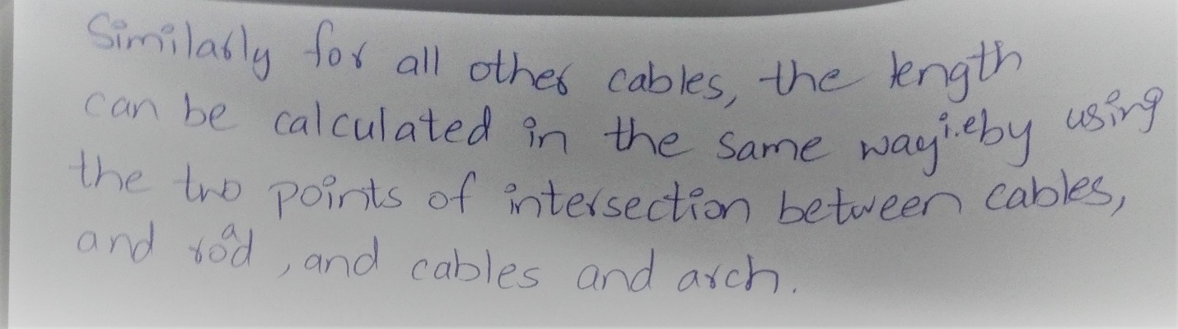

Mathematical Investigation and Analysis (4)
The ‘trial and error method’ is not suitable here, as it is very lengthy because we have to find multiple points on the parabola first. On the other hand, by using the vertex and a point on the parabola, we can determine the equation of parabola quite easily. The derivation of the formula is shown below:
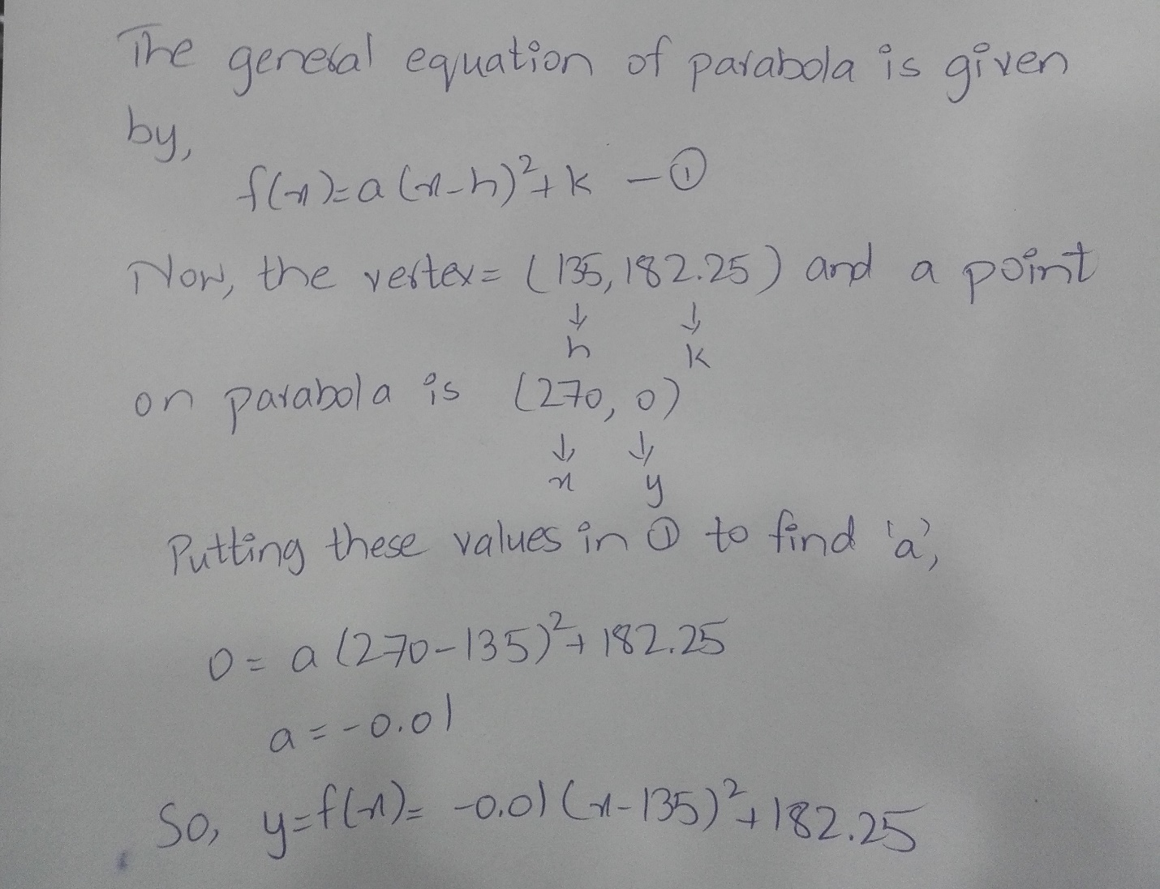

Conclusion
After the verification of our formula by both the methods and by Desmos, we come to this conclusion that our analysis is true. All the parameters of cables and bridges, calculated above support our result.

