Health History Assignment Part 2
[Name of the Writer]
[Name of the Institution]

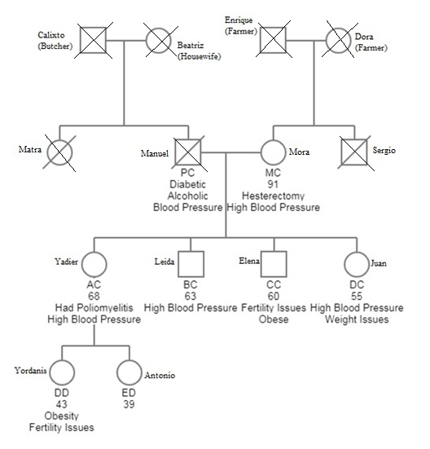
Family History
Calixto lived in Varadero, Cuba. He was a butcher by profession. He was married to Beatriz, who usually took care of the household. He died a natural death at the age of 79, while his wife Beatriz died at the age of 84. It is notable to mention that both Calixto and his wife were not diagnosed with any serious illness or disease. Enrique and Dora, on the other hand, were farmers. Enrique got married at the age of 17. At that time, Dora was only 15 years old. They also died a natural death. Dora died at the age of 61, while Enrique was only 54 at the time of his death. Manuel and Matra are the children of Claixto and Beatriz, while Sergio and Mora are the children of Enrique and Dora. It is notable to mention that only Sergio is living among these four, as others died. Manuel and Mora died a sudden death, while Matra died due to diabetes and high blood pressure issues. Sergio is still alive, but she had gone through hysterectomy after giving birth to the fourth child. Mora is 91 years old with high blood pressure issue. Matra and Sergio’s had four offspring including Yadier (68 years old), Ledia (63 years old), Elena (60 years old), and Juan (55 years old). Matra and Sergio kept an adequate gap in the birth of each child to avoid any complications. However, every child is suffering from high blood pressure, which is definitely a derivative from their parents. Yadier had poliomyelitis due to which he is unable to move the majority of his body parts. Juan is suffering from weight issues, while Elena is facing fertility issues. The children of Yadier are Yordans and Antonio. Yordanis is 43 years old, while Antonio is 39 years old. Antonio does not have any specific health issues, while Yordanis is obese and suffering from fertility issues. It is important to mention that Yadier has recently moved to the United States with her family in search of a better job and lifestyle.
Culture and Genetics
Yadier moved to the United States with her children in search of a better lifestyle. Yadier worked as an employee in the cotton factory in Santa Clara for more than 4 years. However, she was unable to get sufficient wage there, that’s why she decided at the age of 60 to move to the United States. It is important to mention that they are living in the US for more than 8 years. At the start, they had to face several difficulties in the US due to a major difference in the culture of Cuba and the US. Yadier and her entire family belong to Catholicism. Upon their arrival in Texas, they found that the majority of people are Christians. It was hard for them to settle in the changing environment, but they somehow managed it. Yadier’s family believe that their acceptance by God is totally dependent on their deeds in this world, while Americans believe that if they have trust on Jesus, then they will be accepted by Jesus in the life hereafter. It is notable to mention that the Cuban literacy rate is 99.75 percent. In Yadier’s homeland, routine vaccinations include polio, influenza, Tdap (tentaus, diphtheria, pertussis), and MMR (Measles, Mumps, Rubella). Yadier and her family members were recommended to take some necessary vaccinations for the United States in order to avoid catching any disease. Cubans are very sensitive and protective regarding their healthcare and wellbeing. Therefore, Yadier’s family took necessary vaccinations for the US including Hepatitis A, Hepatitis B, and Rabies. In Cuba, equal and free access to health services and education of society become the main concerns in health after the revolution. They had to face difficulties in accessing medications due to economic distress in Cuba. With the passage of time, access to health care became free of charge due to international cooperation and importance on education. When Yadier’s family visited the US, they were considering a free of charge health care services in the country. However, they were disappointed to see that healthcare is not free in the US. Cubans were given nutrition support according to their policies, however, in the US, this scenario was different. Therefore, it was difficult for them to settle in a different environment, which had completely different healthcare preferences as compared to Cuba. As they have a Cuban background, so they believe that food combination of milk with fish is dangerous. They are very suspicious about their food intake, so they often avoid food combination that can give rise to allergies.

