Most of the early adults live with their families in Australia.
[Name]
[Institution]
Words count= 2126

Most of the early adults live with their families in Australia.

Introduction
Over the last couple of centuries, there have been great changes in the living at home transition of young people in most of the developed countries like Australia. Studies show that young adult in Canada and in Britain substantially live away from the home of their parents and they leave either as a lodger or as a boarder (Zhao, Rajulton, & Ravanera, 1995). After the late nineteenth century this pattern of leaving changed in many developed worlds including Australia. However, marriage is a proxy that is used to define the home leaving time for individuals. After the 1960s another pattern immersed in Australia and that was the trend that unmarried start living away from home (Schneider, 2000).
Evidence showed that a new trend was emerging among adults. In the case of Australian adult leaving home after the marriage has decreased and instead young and single people are living away from home to enjoy the freedom more than people who are married. The Housing Income and Labor Dynamics (HILDA survey 1981-82 shows that his new transition is due to some social changes like most of the youth leave home for study and they have to move out for jobs. The middle-level average leave home for the sake of getting independence and the Australian institute of family studies have shown that these changes are going to affect young women more than man (Young, 1996).
However, other studies show that most of the adults in Australia prefer to stay with their parents. In 2016, 43 percent of the young people with an age group of 20-24 years live with parents and this percentage has increased from the year 1981 when 36 percent of the people of this age used to live with their parents (“Young people living with their parents,” n.d.).
The main focus of this research paper is to identify the fact that whether the young people in Australia leave home early or late?
Research hypothesis.
Most of the early adults live with their families in Australia.
Focusing questions:
Are young people in Australia staying at home or have different living arrangements?
Which gender is leaving or staying at home more and why?
What are the factors that contribute to the trend of young adults living with or without their families?
Action plan:
The main focus of the research paper is investigate that whether the research hypothesis is true or false. For more in-depth study of the topic, the focus questions are analyzed. The research paper will take help from secondary sources to answer the focus question and thus will investigate the said hypothesis.
Investigation of the Topic Findings
Living arrangements of young adults in Australia:
Young people in Australia who are transitioning for the care of home are considered as a vulnerable group that has not received support from their family members (Chamberlain & MacKenzie, 1992). The latest Household, Income and Labor Dynamics in Australia have identified that renting ratio has dropped to 48 percent in 2016 from 55 percent in 2011 among the age group 25-34-year-old. This data shows that children tend to live more in the houses of their parents rather than living on their own. Further investigation has shown that these young people are coming back to live with their families after moving out (Jennings-Edquist, 2018).
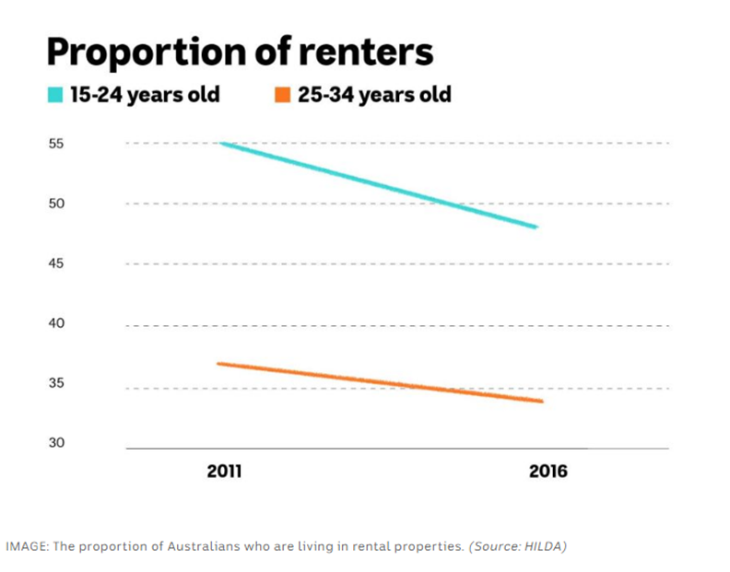

However, the Young adult makes a smaller proportion of the Australian population. There were almost 5.3 million Australian in 2011 who have an age limit of 18-34. Due to the aging of the Australian population young member of the society are less in number. However, the living arrangements of these people have been changed from years. In 1976 approximately 65 % of the young adult were living with their partners and 74 percent of them were having proper families. In 2011 the percent of living with partners have changed at dropped to 42 percent (Kilmartin, 2000).
After the 1960s it has been found in many cities of Australia that young people before the age of marriage prefer to live alone without their families these young people are attracted by broader education facilities, and job market (Flatau, James, Watson, Wood, & Hendershott, 2007).
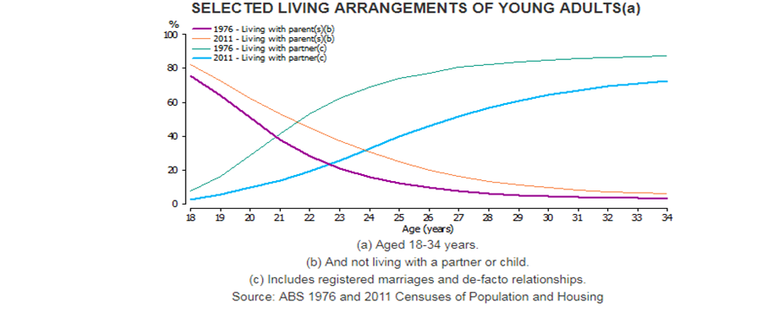

The above graph shows that 29 percent of the young adult in 2011 used to live with their patterns and this percentage used to be 21 percent in the year 1967 (Kilmartin, 2000).
However, the decision to live with parents or live independently is the first housing career choice for young people. Majority of the views show that young adult lives their homes early but close investigation shows that it is not true (Mallett, Rosenthal, & Keys, 2005). From the year 1979 to 1995 the rate of living at home of a young group of people with age limit of 15-19 have declined but the rate has increased in people of 20-14 years of age. However, the number of young people above the age of 20 are living more with their parents in Australia than any other developed countries (aifs.gov.au, n.d).
Moreover, young people are more likely to be living with their parents now than they used to live in the past. In 1986, 19 percent of the young adult wise to live with their parents in 2016 this percentage has increased to 23 percent. This happened due to the changes in the living arrangements of the young adult in Australia (De Vaus, 2004). In 2006 it is not common for a young to be a partner and live in a couple of families but it was the trend in 1986. With the time being living arrangements like group houses also became trendy and young adult prefer to live in group housing with their parents (Statistics, 2009).

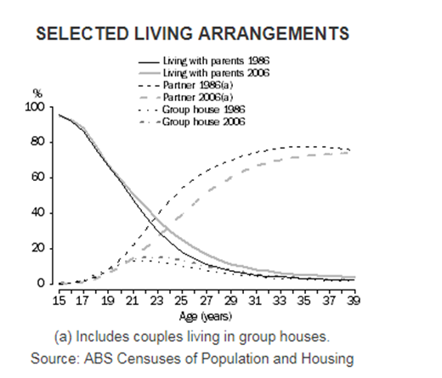
The graph shows that the trend of living with parents is increasing among young adult than living with partners in Australia (Statistics, 2009). Moreover, young people who are leaving their parents are coming back to live with them and this trend is also increasing among young adults. The probability of the youth to return back is 46 percent in Australia and the majority of the young women who left home come back to live with their parents (Chamberlain & MacKenzie, 1992).

The factors that contribute to the trend of young adults living with or without their families:
There has been a shift in the reason why people left home in Australia. Leaving home to marry and moving in with partner have become very less. Moving out to live alone due to conflict with parents is increasing in the current time in Australia (Flatau et al., 2007a).
The main cause of this increasing percentage of young people living with their parents is housing stress. Because most of young adults group people study at universities and the do not have time to have a job that can help them pay their rent. (Johnson & Chamberlain, 2014). However, another major factor the contributes to the increasing rate of young people staying at home is the nuclear family system of Australia (Kiernan, 1992). Since 1970 the women in Australia are giving birth to no more than two babies and a smaller number of members in the houses are making the consequences of moving out of children less. Young adult considers staying home an economically wise decision in Australia and this though adds much to the increasing rate of young living with families (Chamberlain & MacKenzie, 1992).
However, data collected by the Australian institute of family studies show that nearly 46 percent of the young who are receiving former care live with their families after the care ends and the really more on their parents’ support for residence. The social relationship of young adults with their parents is also increasing and 74 percent of the youth are satisfied with their relationship with their biologic parents and prefer to live with them (Purtell, Muir, & Carroll, n.d.).
The cultural background of the youth also impacts the likelihood of living with their parents. 83.3 percent of the young adult life with their parents in Australia and people from New Zealand have the lowest percentage in this regard and 47.7 percent if the people with an age group of 25-29 live with their parents who are residents of Australia (aifs.gov.au, n.d).

Which gender is leaving or staying at home more and why?
The latest Housing Income and Labor Dynamics (HILDA) survey shows that most of the young people live with their families in Australia. The survey concluded that the number is increasing more for woman than man.50 percent of the youth prefer to live with their parents and the majority of them are females (Chamberlain & MacKenzie, 1998).
In 2017, 56 percent of the males with an age group of 18-29 lived with one or both the parents and this percentage was 47 in 2001. The percentage of women living with their parents has increased from 36 percent in 2001 to 54 percent in the year 2017 (Marks & Fleming, 1999).
The ratio has been increased in women of early ages till their twenties. The gap between a young man and young women is shrinking and compare to more women are living at homes (Marks & Fleming, 1999). As women in younger ages get married and have children so they tend to be more attached with family than males (Kirkpatrick Johnson, Elder Jr, & Stern, 2005). Most of the rural areas in Australia have women who prefer to live with their parents or partner as compared to women in urban areas. Cities have a lower rate of living with parents of both the genders (McMichael, Gifford, & Correa-Velez, 2011).
As marriage makes women more bound than men thus their rate to stay at home is high than man. But other factors like housing coast and work pattern make both the gender live with their parents. Challenges to have a good job has increased for both man and women in Australia so the preferer to move in with their parents so that they would not have to worry about paying bills (Hartley, 1993).

Analysis of Information

The latest Household, Income, and Labor Dynamics survey in Australia has identified that nearly 50 percent of young adults prefer to stay at home with their parents. The same survey has found out that renting ration in Australia has dropped from 55 percent in 2011 to 48 percent in 2016 (Jennings-Edquist, 2018). It means that young adult is not living in rented houses but have moved in with their parents.
However, data collected by the Australian institute of family studies show that 46 percent of the young adults live with their parents after the end of their residential care programs. According to AIF the relationship of parents with their young children is also increasing and it is therefore 74 percent of the young adult is satisfied with the relationship with their parents so they are living with them.
AIFS survey 1981-82 shows that young people used to move out in search of jobs, for study or marriage but now they experience huge residential cost and tdo not a get-well definite job so young adults tend to live with their parents (Young, 1996). The percentage of a young adult living with their parents has increased to 43 percent in the year 2016 from 36 percent in the year 1981 (Jennings-Edquist, 2018).
The data given above shows that due to some transformational changes in the social and economic make up of Australia Young adult prefer to live with their parents and the majority of them are staying at home.
Conclusion
The hypothesis of this study is about the phenomenon that most of the early adults live with their families in Australia. The collected seconderay data from AIFS survey and the latest Household, Income and Labor Dynamics survey says that the percentage of the young adult staying at home has increased in the current period. The reasons behind this increase in percentage are that the Australian families have shrined to became nuclear families and children feel comfortable at home then moving out. Secondly, the increasing rate of rents and lack of market attractions also let them stay at home. Majority of the got married and stay at home.
Other factors that contribute to the staying of young adults at home are that various ethnic group live in Australia and gave the cultural norms to live with their families. Thus, the overall number of young adults staying with their families in Australia has increased. Majority of the youth in rural areas move out in search of education or job but the housing stress in Australia has minimized the inflow of youth from rural to urban areas.
Thus, they prefer to stay with their parents and find it the best economic decision ever. Staying with partners have also decreased and young adults no more stay with their partners due to the huge economic stress and thus stay with their parents.

References
Chamberlain, C., & MacKenzie, D. (1992). Understanding contemporary homelessness: Issues of definition and meaning. Australian Journal of Social Issues, 27(4), 274–297.
Chamberlain, C., & MacKenzie, D. (1998). Youth Homelessness: Early Intervention & Prevention. ERIC.
De Vaus, D. (2004). Diversity and change in Australian families. World Home Economics Day 2004.
Flatau, P., James, I., Watson, R., Wood, G., & Hendershott, P. H. (2007b). Leaving the parental home in Australia over the generations: Evidence from the Household, Income and Labour Dynamics in Australia (HILDA) Survey. Journal of Population Research, 24(1), 51–71.
Hartley, R. (1993). Young adults living at home. Family Matters, 36, 35–37.
Jennings-Edquist, B. G. (2018, August 20). Multi-generational living: Why young Aussies are moving back home or not leaving - ABC Life. Retrieved August 8, 2019, from https://www.abc.net.au/life/multi-generational-living-why-aussies-are-leaving-home-later/10089120
Johnson, G., & Chamberlain, C. (2014). Young people. Homelessness in Australia: An Introduction, UNSW Press, Sydney.
Kiernan, K. E. (1992). The impact of family disruption in childhood on transitions made in young adult life. Population Studies, 46(2), 213–234.
Kilmartin, C. (2000). Young adult moves: Leaving home, returning home, relationships. Family Matters, (55), 34.
Kirkpatrick Johnson, M., Elder Jr, G. H., & Stern, M. (2005). Attachments to family and community and the young adult transition of rural youth. Journal of Research on Adolescence, 15(1), 99–125.
Mallett, S., Rosenthal, D., & Keys, D. (2005). Young people, drug use and family conflict: Pathways into homelessness. Journal of Adolescence, 28(2), 185–199.
Marks, G. N., & Fleming, N. (1999). Influences and consequences of well-being among Australian young people: 1980–1995. Social Indicators Research, 46(3), 301–323.
McMichael, C., Gifford, S. M., & Correa-Velez, I. (2011). Negotiating family, navigating resettlement: Family connectedness amongst resettled youth with refugee backgrounds living in Melbourne, Australia. Journal of Youth Studies, 14(2), 179–195.
Purtell, J., Muir, S., & Carroll, M. (n.d.). Beyond 18: The Longitudinal Study on Leaving Care. Wave 2 Research Report: Transitioning to post‑care life. 36.
Schneider, J. (2000). The increasing financial dependency of young people on their parents. Journal of Youth Studies, 3(1), 5–20.
Statistics, c=AU; o=Commonwealth of A. ou=Australian B. of. (2009, June 30). Main FeaturesâHome and away. Retrieved August 9, 2019, from https://www.abs.gov.au/AUSSTATS/abs@.nsf/Lookup/4102.0Main+Features50June+2009
Vera-Toscano, E., & Wilkins, R. (n.d.). Over 50% of young Australian adults still live with their parents – and the numbers are climbing faster for women. Retrieved August 9, 2019, from The Conversation website: http://theconversation.com/over-50-of-young-australian-adults-still-live-with-their-parents-and-the-numbers-are-climbing-faster-for-women-120587
Young, C. (1996). Are young people leaving home earlier or later? 13(2), 125-152.
Young people living with their parents [Text]. (n.d.-a). Retrieved August 8, 2019, from Australian Institute of Family Studies website: https://aifs.gov.au/facts-and-figures/young-people-living-their-parents
Zhao, J. Z., Rajulton, F., & Ravanera, Z. R. (1995). Leaving parental homes in Canada: Effects of family structure, gender, and culture. Canadian Journal of Sociology/Cahiers Canadiens de Sociologie, 31–50.

